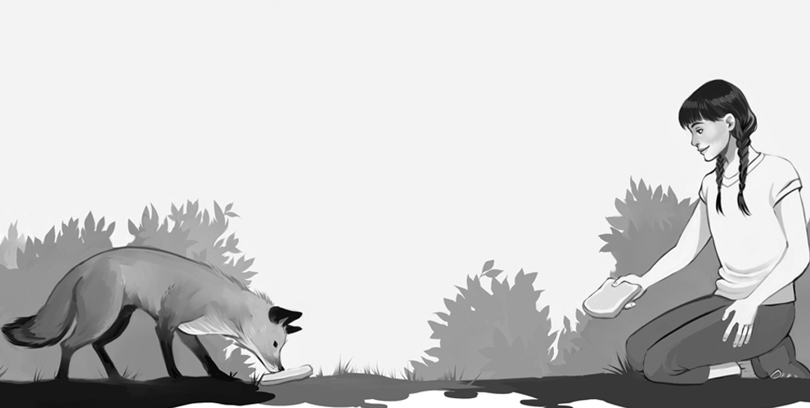Stories for the Classroom
Junior Certificate School Programme
Paddy Kirwan

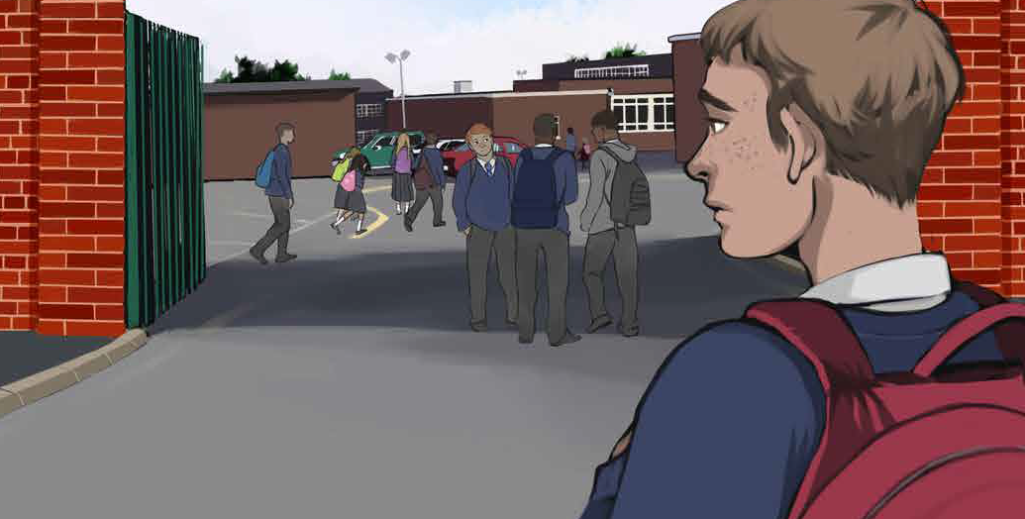

Stories for the Classroom
Published by
Professional Development Service for Teachers (PDST) Junior Certificate School Programme
Blackrock Education Centre, Kill Avenue, Dún Laoghaire, Co. Dublin Phone: 01 2365000
Email: jcsp@pdst.ie First Published 2015 Copyright ©PDST, JCSP.
The Professional Development Service for Teachers (PDST),
The Junior Certificate School Programme (JCSP), the Literacy and Numeracy Strategy,
the Demonstration Library Project and the Delivering Equality of Opportunity in Schools (DEIS)
Action Plan are funded by the Teacher Education Section of the Department of Education and Skills (DES).
All rights reserved
The purpose of this publication is to enhance teaching and learning within the Junior Certificate School Programme.
No part of this publication may be reproduced, stored in a retrieval system or transmitted in any form or by any means for commercial gain without prior written permission of the publisher.
Every effort has been made to ensure that this book contains accurate information. However, PDST, JCSP, its agents and the authors shall not be liable for any loss or damage suffered by readers
as a result of any information contained herein.
Author
Paddy Kirwan Illustrator Julie Doherty Designer
Karolina Smorczewska
Editor
Denise O’Flanagan

CONTENTS

Jack’s New School 4
The Fox 12
Nana 23
Bicycle Madness 32
Horse Mad 41
Cruelty 51
The Bird Woman 60
A Mystery 69
Hallowe’en Nightmare 78
The Rat Catcher 86
It’s a man’s world 94
Grandad 102
Danny’s Dilemma 112
Do you know your neighbour? 121
The Night before Christmas 128
Birthday Memories 137
The Green Flag 146
Old George 154
Newgrange 165
The Snow Fight 176
My First Kiss 184
The Wheelchair 193
Our Maths Teacher 201
Gone Farming 212
The Jamaican 223
Verrucas 231
My best friend 241
When I grow up 249
Books 256
Sports Day 265
Derek 274
Nightmare Holiday 282
The Anniversary 290

Unit 1

Jack’s New School

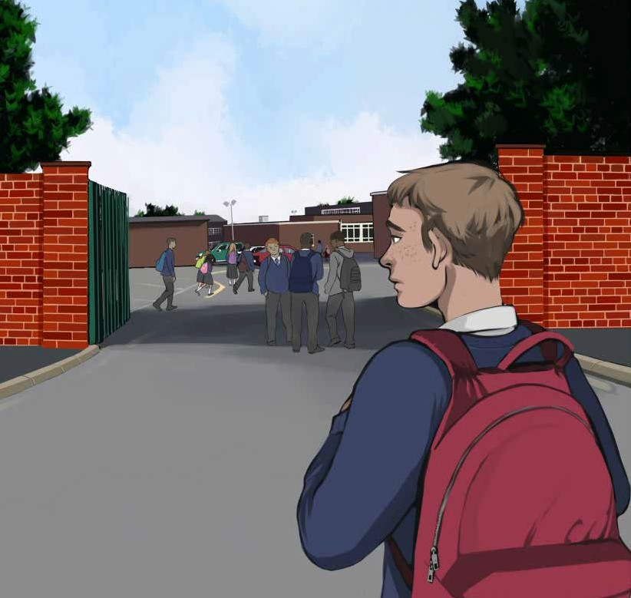

It was Friday, 31st August, Jack’s first day in his new school.
The school is called St. Jude’s Community School. Jack felt
really nervous, but also excited. He didn’t know what to expect, and yet he was looking forward to it all. He looked tall and
handsome in his new uniform.

Jack was going into first year. There were four classes in first year and each class was called after one of the people who wrote the Gospels so the names of the classes were Matthew, Mark,
Luke and John. Jack was placed in a class named after Saint
Mark. Five of his friends from his old Primary School were also in Saint Mark’s. They were Sean, Adam, Paul, Holly and Emma.
School started at 9 o’clock sharp. First class of the day was English, with Mr. Murphy. He looked old, indeed very old. He
looked to be about seventy. He had a head of grey hair and wore a pink shirt with a colourful polka dot tie. He smiled warmly
and welcomed them to his class. Straight away he lectured them about doing some reading every night.
He spoke about the importance of using capital letters at the beginning of all sentences and gave them an exercise where they had to write in lots of capital letters. For homework, he asked
them to do some reading and told them they could read anything: newspapers, magazines, books, anything. He said it didn’t
matter, so long as they were reading and warned that they had
to get our journals signed every night by their parents - as proof that they did the reading.
The second class of the day was Science. The teacher’s name was Miss Abbey. She was young and good looking and smiled a lot. She enthusiastically talked about Science being all around
and gave lots of examples of Science in action. She also gave homework.
The third class was History. The teacher’s name was Miss Kennedy. She didn’t smile and displayed a serious stern face, a face that would turn milk sour, as Jack’s Granny would say.

She explained that History is the study of the past, something
they already knew. She then read from the book and gave us lots of homework.
At 11 o’clock we had a ten minute break. It was a warm day, with the sun beaming down late Summer heat. Jack met up with his best friend, Sean, who had been placed in a different class.
Jack felt disappointed about this, as they had been together all
through Primary School. They now chatted as if they hadn’t seen each other for years.
After the break Jack had double P.E. The teacher’s name was Mrs. Brady. She wore a tracksuit and looked strong and athletic.
She was the first teacher to talk about having fun and enjoying
ourselves. Jack felt he was going to like this subject. Mrs. Brady also talked about safety. Afterwards two teams were picked and the students had a superb game of football.
The last class before lunch was Religion and everyone was sweating after the football. The teacher’s name was Mrs. Joyce and she started the class with a prayer. She talked about herself and asked each student to say something about themselves. It was mad interesting and she didn’t give us any homework.
At five to one, the Principal came on the intercom and
said everyone was getting a half day. There was a big rousing
cheer, which was audible throughout the school. He said he was delighted with the way everyone was working and behaving.
Jack was happy, and as he cheerfully skipped out through the front gates, he felt as content as a young lamb in Spring sunshine.

Questions

- What was the name of Jack’s new school?
- How did Jack feel about going to his new school?
- What were the names of Jack’s friends from his old Primary School who were in the same class as him?
- Describe the English teacher, Mr. Murphy.
- What did Mr. Murphy speak about?
- Describe the History teacher, Miss Kennedy.
- What was the name of Jack’s best friend?
- What teachers gave no homework?
- What teacher gave a lot of homework?
- Do you think Jack enjoyed his first day in his new school? Give reasons and use quotations from the text. A quotation is direct evidence (words) from the story – used to back up your answer, or point of view.
- Draw or describe one image which you can see in the above story.

Listening and Speaking

Talk about your first day in secondary school.
Was it what you expected? Were there any surprises? Talk about some of your memories from primary school.

Vocabulary from the story

- A Community School
- The Gospels
- A colourful polka dot tie
- He smiled warmly
- He lectured us
- We had to get our journal signed every night
- She enthusiastically talked about science being all around us - enthusiasm
- She displayed a serious stern face – a face that would turn milk sour
- The sun was beaming down late Summer heat
- Primary – Secondary
- He looked athletic
- The Principal came on the intercom
- There was a big rousing cheer which was audible throughout the school
- He felt as content as a young lamb in Spring sunshine

Focus on - Capital Letters

A capital letter is used:
- At the beginning of every sentence.
- For the pronoun “I”------ “I” on its own is always a capital letter.

- To begin first names and surnames, e.g. John Murphy.
- For days, months and holidays, e.g. Tuesday, February, Hallowe’en, etc.
- For the names of places, e.g. Dublin, New York, Russia, etc
- For brand names, e.g. Toyota Corolla, Kellogg’s Cornflakes
- To begin key words in all titles, e.g. Harry Potter and the Philoso- pher’s Stone.

Exercise

Rewrite the following text and put in all the capital letters and full stops. last saturday my friends and i went to naas to see a play called romeo and juliet my friends are jennifer and catherine the theatre is called the playactor it is beside st joseph’s church derek lannigan was the lead actor and geraldine maher was the lead actress the play finished at 10.30 we went to a restaurant afterwards called the hungry traveller we got the last bus home

Dictionary Work

Explain what the following words mean and write them in sentences which clearly show their meanings.

- alphabet
- vowel
- geography
- arrival
- departure
- wicked
- generous
- surgery
- paragraph
- frustrated

Writing

- Write a story about, or describe your first day in secondary school.
- Write the names of your school subjects into your copy.

Scaffolding - My New School

Paragraph 1 – Explain why you choose to go to this particular school! Do/ did you have any brothers or sisters already attending the school? Did any of your parents attend this school? What did you hear about the school? Did you have to do an entrance test? What was that experience like?

Paragraph 2 – The preparations – getting the uniform? Where did you get your uniform? What do you think about the uniform? Where did you get your books? Are they heavy? Was there an open day in the school – while you were in sixth class? What do you remember about that?

Paragraph 3 – Your first day. Write about your feelings – excitement or anxiety? How did you get to school? Who did you go to school with? What is the Principal like, or the Year Head or your class teacher? Are there many new people in your classes? Do you know many of them? Are you looking forward to making new friends?

Paragraph 4 – Write about some of your new subjects? Describe some of your teachers. Are they kind? Do they explain new information well? Are

any of them really tough or severe? Which subjects do you think you will like best?

Paragraph 5 – What are the best things about your new school? What facilities has it got – art rooms, science rooms, home economics rooms, woodwork rooms, P.E. halls, basketball courts? Compare it to your primary school. What would you change about your new school, if you could? What are you really looking forward to? Finally, what do you miss from your old primary school?

Please read over everything you have written, and check that you put in all the full stops and capital letters. Also try to enrich and improve your vocabulary.

The Fox

Unit 2

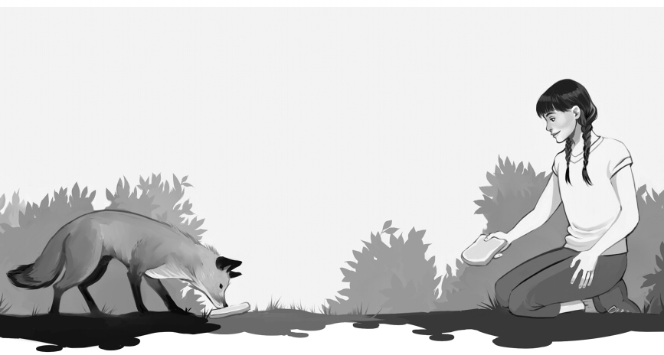

We live next door to the Parish Hall and during the Summer months we use it to practise our music. We play traditional music and are part of a traditional group. Altogether, there are fifteen of us in the group and have the best of fun. I play the fiddle and my sister plays the traditional flute. Miss Carmody is our hard-working teacher.
We practise from two to four o’ clock on Sunday afternoons and last year, on one of those afternoons, in the month of July, we had an unusual experience with a fox. It was hot and humid, both outside and inside, so Miss Carmody left the front doors open in order to create a bit of a breeze and as we merrily played our music, a fox just strolled in. I genuinely think she was curious.
We were sitting in a semi-circle at the top of the hall and we couldn’t believe our eyes. Most of us simply stopped playing,

and as we pointed, with our mouths hanging half open, Miss
Carmody sternly instructed us to concentrate. She had her back to the open doors and assumed we were messing. We kept on
pointing and when she did turn around, she got the shock of her life. The fox stood perfectly still, quietly staring at her, and Miss Carmody stood perfectly still, staring back in total disbelief.
I don’t know if it was a male fox or a female fox, but as it looked petite and pretty, I decided it must be female. She had
reddish hair and alert pointed ears. She looked thin, even a little anorexic.
When Miss Carmody finally came to her senses, she swiftly chased this sociable fox back out of the front
doors. I immediately felt a combination of both relief and
disappointment. After all, I had heard some nasty stories about foxes, and yet it was so bizarre to see a real fox inside our hall.
After class, we excitedly hurried home and couldn’t wait to
tell our parents, and as I enthusiastically rushed round the corner into my garden, there again was the same fox, contentedly sitting on our gravel driveway. We instantly froze and just stood there
gawking. She calmly looked up at us, as if to say, “What’s all the fuss?” Eventually, we carefully walked around the edge of the
garden, and rushed in to tell Mam.
At first, she didn’t believe us, but when she peeked out she obviously had to. We all went out for a better look.
Mam informed us that foxes are great survivors and that there are lots of them now living in urban areas. She said they adapt
to their environment and are usually seen at night, especially

around rubbish bins searching for leftovers.
Mam then retreated back into the house and returned with a camera, and even while she was taking the couple of photos, the fox still didn’t budge. She lay stretched out, indeed almost
stretchered out, with her pointed nose tucked cosily in between
her front feet. At one point, she lazily yawned. Mam said she had never seen a fox to be so eerily relaxed and laid back.
Mam then moaned about all the housework she had to be
getting on with; but before she went back in, she warned us not to get too near the fox. She claimed that some foxes are full of fleas.
I felt somewhat sorry for this fox and when Mam wasn’t
looking, I sneaked out two slices of creamy buttered bread and threw them over to her. I stood there dumbfounded, observing
her, as she quickly gobbled them down, and afterwards she again stretched out in the warm evening sunshine, passing absolutely
no heed of me. Then I was called for dinner and when I came back out she was gone.
The following afternoon, she returned. It was another
beautiful sultry day and she lay in almost the exact same spot. I gave her more buttered bread and when I had eaten my dinner, she had again scarpered.
That summer was particularly sunny and every afternoon
the fox came into our front garden, ate the bread and eventually disappeared.
I used to walk right up to her, and give her the bread, but I never touched her. She gradually became less and less thin and

her red hair developed a lovely glossy shine. As time went on,
she became more daring. You see, we have an old Labrador dog, called Buddy, and the fox cheekily started going up to her bowl and stealing her food, but Buddy didn’t mind and neither did I.
That September, after I’d returned to school, the fox
completely stopped visiting us. Whether it was because I wasn’t there to feed her or something else happened, I don’t know.
Whatever the reason, I felt quite lonesome.

Questions

- What kind of music did the children play?
- How many of them were in the group?
- What was the name of the music teacher?
- What walked into the hall?
- Describe the fox.
- What did Mam say about foxes?
- How do we know the child liked this fox?
- Why do you think the fox stopped coming?
- Did you like this story? Explain why you either did or didn’t like it.
- Draw or describe one image which you can see in the above story.

Listening and Speaking

- Have you ever seen a fox? Describe what you saw.
- What do you know about foxes?
- Do you know what traditional music is?

Vocabulary from the story

Explain the following words
- The Parish hall
- Traditional music
- I play the fiddle and my sister plays the traditional flute
- It was hot and humid, both outside and inside
- We were sitting in a semi-circle at the top of the hall
- As we pointed, with our mouths hanging half open
- Miss Carmody sternly instructed us to concentrate
- She assumed we were messing
- Staring back in total disbelief
- It looked petite and pretty
- Alert pointed ears
- She looked thin, even a little anorexic
- When Miss Carmody finally came to her senses
- She swiftly chased this sociable fox back out
- I felt a combination of both relief and disappointment

- Nasty
- It was so bizarre to see
- As I enthusiastically rushed around the corner
- Contentedly sitting on our gravel driveway
- We instantly froze and just stood there gawking
- Eventually
- There are lots of foxes now living in urban areas
- They adapt to their environment
- Retreated back into the house
- She had never seen a fox to be so eerily relaxed and laid back
- I stood there dumbfounded
- It was another beautiful sultry day
- She had scarpered – to scarper
- She gradually became less and less thin
- A lovely glossy shine
- I felt quite lonesome

Focus on -The Full Stop

The full stop is used at the end of every sentence. If you are not sure about where a sentence ends, then say the words out loud and you will hear where one sentence ends and the next one starts Sometimes a sentence may consist of only one word such as “Hello” or “No”.
The full stop is also used in some abbreviations, e.g. V.I.P., R.S.V.P.

Exercise

Rewrite the following passage, putting in the full stops, commas and capital letters where necessary.
last thursday my mam and i went shopping in tesco on our way up to tesco it rained heavily we had no umbrella with us we got very wet our
clothes were soggy and uncomfortable we first went to the vegetable section we bought potatoes carrots and broccoli next we bought a loaf of bread and a chocolate cake we bought yogurt and two litres of milk before we left we bought the evening herald and a lottery ticket when we came out the rain had stopped the sun was shining

Poetry – Betty Botter

Betty Botter bought some butter, But, she said, this butter’s bitter; If I put it in my batter,
It will make my batter bitter, But a bit of better butter Will make my batter better. So she bought a bit of butter Better than her bitter butter, And she put it in her batter,
And it made her batter better, So ‘twas a better Betty Botter Bought a bit of better butter.
Anonymous
(this means we don’t know who wrote this poem)

Questions

- What is batter?
- What is it made from?
- What is batter used for?
- What is butter made from?
- Write down another word for bitter.
- What made Betty’s butter bitter?
- How did Betty solve her problem?
- Did you enjoy this poem? State why / why not.
- What does the word anonymous mean?

To do
Learn this poem off by heart.

Recommended Poems

I recommend you also read “On the Ning, Nang, Nong” by Spike Milligan.
It is quite humorous.

Dictionary Work

Explain the following words and write them in sentences which clearly show their meanings.

- optician
- pharmacy
- public
- private
- community
- discount
- eager
- humorous
- rash
- confused

Writing

- Write your own story about a fox, or describe how to care for and look after a pet animal.
- Write your address in your copy.
- Write your address on a postcard, fill in the postcard and send it home to your parents / guardians. Tell them about how you are get- ting on at school.

Scaffolding - How to care for / look after a pet animal!

Paragraph 1 – Do you have any pets? What kind of pets are they? What are their names? For this story you can pretend to have pets – what pets would you love to own? A dog – what breed? - a cat, a rabbit, a guinea pig, a tortoise, a snake, some mice? Say when and where you got your pet, and how much you paid for him/her.

Paragraph 2 – Where does your pet sleeps! Does your pet sleep much? Does your pet sleep inside the house or outside in a shed? Do you have a special kennel or shed for your pet. Does your pet have a soft blanket or a bed of straw.

Paragraph 3 – Looking after your pet – known as animal husbandry. Whose job is it to look after your pet? Who feeds him/her? What kind of food does your pet eat? Who buys it? What shop do you buy it in? Where do you get the money? How often do you give it clean drinking water? Who cleans your pet? How do you clean your pet? How does your pet get exercise? How do you dispose of the poo?

Paragraph 4 – How do you keep your pet healthy? Did you ever have to bring your pet to the vet? What kind of diseases could your pet get? Does your pet have to get some vaccinations? Write a little about cruelty to pets. Did you ever see or hear about pets being abused? In what ways were they abused. How did you feel? What did you do? What are your opinions on the people who abuse pets?

Paragraph 5 - To conclude - write down five reasons explaining why you
love pets or why would love to have a pet.

Please read over everything you have written, and check that you put in all the full stops and capital letters. Also try to enrich and improve your vocabulary.

Nana

Unit 3

My Nana is a small plump woman, who seldom gets angry,
loves chatting and has an infectious laugh. She is a hard worker, having reared six children and still looks after some of her
grandchildren. Thank God, she has excellent health and I feel lucky to be living under the same roof as her.
She devotedly fusses over us, making our dinners and
listening attentively to our cares and worries. If we are hungry and ask for a few sausages, no matter what time of day or night, she has the frying pan sizzling in a matter of seconds. If there
is a school tour or a little holiday coming up, she always slips a few bob into our hands. To me, she is unique, one in a million, like a precious diamond.
She also loves farming. She was reared on a farm and married into a farm. Her husband, my grandfather and a farmer, could be described as a big stout beefy man, but a true gent.
Nana says that farming is in her blood. We live on a dairy farm and each spring there are lots of newborn calves, and its Nana’s job to look after them. As soon as we are packed off to
school, she heads straight to the farmyard to feed her calves. She feeds them twice a day, morning and evening.
Sometimes we help her, mostly in the evenings. The calves are fed on milk made from powder. The powder has to be
carefully measured and cold water added. Each calf has its own bucket and its own cubicle. It’s delightful watching them with

their tails waggling, as they greedily suck up the milk.
After feeding them, Nana makes sure to rinse each of their buckets in boiling hot water. She claims it’s an important task, because it keeps away the germs, “If the feeding buckets are
dirty, they can get diarrhoea.” She also maintains they can get diarrhoea if we give them too much milk.
After drinking their milk, each calf gets a clean bucket of
water and a little hay. It is laborious and wearisome, but for me the best part is putting my hand in the baby calves’ mouths and revelling in them ravenously sucking it.
The other thing Nana loves, apart from us children and
feeding her calves, is singing. She contentedly sings to herself
as she goes about her daily chores. She sings and hums all kinds of songs, but Country and Western is her favourite. She has an
angelic voice and every Sunday she can be found singing in the Church Choir. Sometimes she gives a solo performance, her
favourite song being The Ave Maria.
Believe it or not, she never went on a foreign holiday,
“How could I leave the farm?” she’d protest. She once went up to Donegal, to a Daniel O’ Donnell concert and afterwards
proclaimed, “The journey was too long, but Daniel’s concert was magical. I even got his autograph.”
Nana’s one little vice, if you could call it a vice, is drinking a little too much on a Saturday night. Grandad teases about this and implies that Nana lets him down in public. Most Saturdays they walk up to the lounge in the village, where she drinks a
glass or two of Guinness and then commences the singing. The

locals love her and before long she is often leading a right jolly sing-song.
On more than one occasion, I have witnessed Nana and Grandad sauntering home, arms linked, singing rowdy rebel
songs. We’d often be out in the field playing football and she’d usually shout over to us, “Don’t get cold” or “Mind the damp.”
But no matter how late Nana stays out on a Saturday night, she is always up bright and early on Sunday morning, looking after her children and her calves.

Questions

- Describe Nana.
- What does Nana do for her grandchildren?
- What does Nana love doing?
- Describe how the calves are fed.
- Why does Nana wash the buckets with boiling water?
- Why do you think Nana never went on a foreign holiday?
- What was Nana’s favourite song?
- Why do you think Grandad said that Nana lets him down in public?
- What evidence is there to suggest that Nana and Grandad have a good relationship?
- Draw or describe one image which you can see in the above story

Listening and Speaking

- Are any of your grandparents alive?
- Are you particularly close to any of them?
- Describe your grandparents. Are they unique and special?

Vocabulary from the story

Explain the following phrases or words.
- A small plump woman
- She seldom gets angry
- She has an infectious laugh
- Lucky to be living under the same roof as her
- She devotedly fusses over us
- She has the frying pan sizzling in a matter of seconds
- She always slips a few bob into our hands
- To me, she is unique, one in a million
- A big stout beefy man, but a true gent
- Dairy (not diary)
- Each calf has its own cubicle
- It’s delightful watching them with their tails waggling
- Nana makes sure to rinse each of their buckets in boiling water
- She claims that it keeps away the germs – they can get diarrhoea
- Each calf gets some hay

- It’s laborious and wearisome - weary
- Revelling in them ravenously sucking it
- She contentedly sings to herself as she goes about her daily chores
- Country and Western songs
- She’d give a solo performance, her favourite song being The Ave Maria
- “How could I leave the farm?” she’d protest
- Nana’s one little vice
- Grandad implies that Nana lets him down in public
- They walk up to the lounge in the village
- To commence – she commences
- I have witnessed Nana and Grandad sauntering home – to saunter
- Singing rowdy rebel songs
- “Mind the damp,” she’d shout

Focus on - The magic “e”

Study the words below and notice how the “e” at the end of the words, changes the way the words are said. Say each of the words out loud.
Say the sound of the middle letter | Say the name of the middle letter
mad | made
tim | time
mat | mate
rat | rate
hop | hope
pin | pine
cut | cute
kit | kite
rod | rode
hid | hide
can | cane
win | wine
pop | pope
cub | cube
bit | bite
man | mane
twin | twine
sit | site
mop | mope
fin | fine
not | note
lick | like
tub | tube
quit | quite
rid | ride
tap | tape
rip | ripe
ton | tone
rob | robe

Recommended Poetry

Granny, by Spike Milligan

Dictionary Work

Explain the following words and write them in sentences which clearly show their meanings.

- autograph
- automobile
- biography
- autobiography
- automatic
- archaeologist
- emergency
- technology
- stubborn
- disgusted (with)

Writing

- Describe one of your grandparents, (or an old person you know,) and write a story about him / her. Say who you are talking about and de- scribe him / her. Describe what they do, places they visit, etc.
- Write a story with the title, “Someone Special in my Life”.

Scaffolding - Writing about My Nana, or Granddad or Someone Special

Paragraph 1 – Name the person, say how he/she is related to you, maybe give their age and write about where they live.

Paragraph 2 – Write a description of the this person - Is he or she tall or small, pleasantly plump or thin, with grey hair, or no hair, or dyed hair, has a wrinkled old tired face or a fresh young face. Say if they have any ailments
- does he/she have a persistent bad cough, does he/she walk briskly or with a limp, does he/she have frequent small naps?

Paragraph 3 – Write about the things you do together. Having meals together, having great chats? Maybe this person does all the cooking for you and washes and irons your clothes? Going shopping together – name the shops and say how you help each other. Maybe this person often picked you up from school? Maybe this person helps with your home work and maybe this person helped with your reading?

Paragraph 4 - Write down some of the things which this person says.
Does he / she ever talk to himself or herself? Have they got any funny stories about when they were at school or growing up? What advice does he
/ she give you?

Paragraph 5 – Write about the fun you have with this person or any

special occasions you’ve shared. Sharing birthday memories, and Christmas memories and Easter memories! Going on holidays together – name the places you visited and write about what you did. Do you ever play any tricks on each other?

Paragraph 6– To conclude (finish) say how much you love this person and,
why you love and admire this person.

Please read over everything you have written, and check that you put in all full stops and capital letters. Also try to enrich and improve your vocabulary.

Bicycle Madness

Unit 4

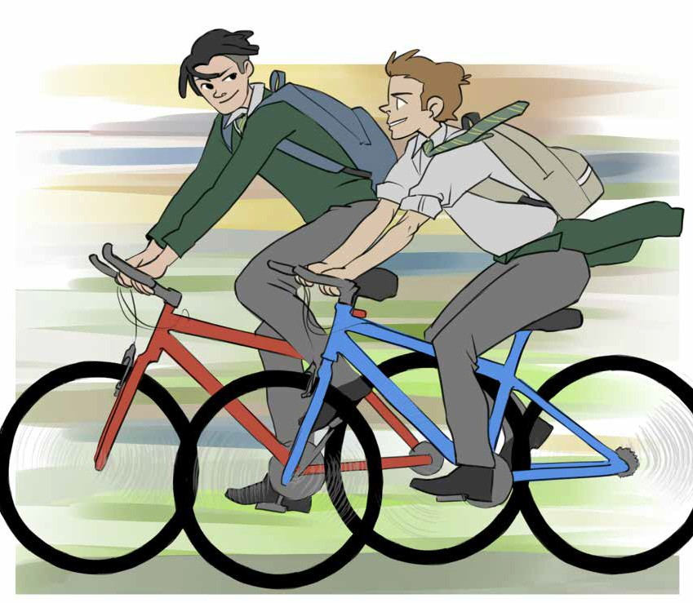

It happened at exactly 8:47, on Wednesday morning, 21st October. I know the precise time because my watch stopped at
that time. I took it to the Jeweller to see if I could get it repaired and when he examined it, he explained the hands were stuck and it wasn’t worth fixing. He said the watch must have taken one
hell of a fall. “Not half as big a fall as I got,” I retorted.

Conor and I were best friends and hung around together an
awful lot. For Christmas we got two fantastic new bicycles, two stunning Raleigh Highlanders. They were expensive, costing
over €400 each. Conor’s was bright red and mine glossy white.
Every morning and evening, cycling to and from school, we endlessly chatted. We were careful, because Dad had taught us well. He had warned us about going around corners too fast,
especially on wet or frosty mornings, and warned us about
skidding on damp, mushy leaves. He told us to watch out for motorists backing from their driveways and urged us to treat
all motorists as if they were total idiots. He asked us to use the cycle lane, wherever there was a cycle lane, and if we had to
go on footpaths, he advised us not to get too close to the edge and to cycle cautiously past pedestrians. Finally, he insisted we always wear a helmet.
However we didn’t always heed his advice. When we left our houses we had our helmets on, but as soon as we met up, we took them off, and stuffed them into a plastic bag. We
didn’t think it was cool to be wearing a helmet, not at our age! Obviously Dad didn’t know about this little arrangement.
It was a normal school morning. It was cold and it was dry, and as usual, the traffic was heavy. We took great pleasure in
passing out long queues of motorists sitting in their cars, one or two of them biting their nails and wearing impatient, frustrated looks.
Recently, we had started having a race for the last two
hundred metres, finishing at the school gates. It was fabulous

fun and we sprinted as fast as we could, each of us desperately trying to be win - I forgot to mention that we are both highly
competitive.
And that’s when it happened! We crashed. Somehow or
other, we clipped each other’s bicycle and both of us went flying over the handlebars. I ended up sprawled across the road, and
Conor hit his head off the kerb. Lucky for me, there were no cars coming, but I somehow or other did succeed in damaging
my front teeth. A small trickle of blood started oozing from my mouth.
Conor wasn’t so lucky. He lay on the ground, curled up in a heap, and when I did manage to pick myself up and go over to
him, I actually thought he was dead. People rushed over to assist and someone called an ambulance.
Our bicycles didn’t seem too badly damaged. That’s what I
was really worried about and what Dad would say when he found out we weren’t wearing our helmets. I was given a handkerchief to mop up the blood from my mouth and when the ambulance
arrived I was ordered into it, in spite of my protests that I was fine.
Conor wasn’t dead, but he was unconscious and he was cautiously and carefully lifted into the ambulance, still
unconscious. I had no idea how serious his injuries were until much later.
After the accident I had to attend the dental hospital and was made wear braces to try to straighten out my teeth.
However, Conor had brain damage and I had to ask what this

meant. I was told in no uncertain terms exactly what it meant, and each time I visited him in hospital I discovered for myself exactly what it meant.
For starters, it took him almost a week to regain
consciousness, and when he did begin to speak, it was in a
slurred, apathetic manner. For many months thereafter, as he lay in his bed, he had a blank look in his sad, lifeless eyes and when he did succeed in getting out of bed, he lacked any real sense of purpose.
I couldn’t believe my eyes and gradually began to realize
that Conor would never be the same again. The old competitive, dynamic Conor was gone and all because of a few stupid
moments of madness!

Questions

- What happened at 8:47, on Wednesday, October 21st?
- When did the two boys get their bicycles?
- What was the brand name of the bicycles?
- List four of the things Dad taught them to be careful about, as they cycled to and from school?
- Why did the boys not wear their helmets?
- Explain how the accident happened.
- How was the author of this story hurt?
- How did the brain damage affect Conor?
- Draw or describe one image which you can see in the above story

Listening and Speaking

- Do you have a bicycle and if you do, do you wear a helmet?
- Were you ever involved in a serious accident? Tell your story.

Vocabulary from the story

- I know the precise time
- I retorted
- Two stunning new Raleigh Highlanders
- Mine was a glossy white
- We chatted endlessly
- Damp mushy leaves
- To cycle cautiously past pedestrians
- He insisted we always wear a helmet
- We didn’t always heed his advice
- Wearing impatient, frustrated looks
- We are both highly competitive
- We clipped each other’s bicycle
- I ended up sprawled across the road
- Conor hit his head off the kerb
- A small trickle of blood started oozing from....
- People rushed to assist
- In spite of my protests that I was fine

- He was unconscious
- He was cautiously lifted into the ambulance
- The dental hospital
- I was made wear braces to try to straighten out my teeth
- Conor had brain damage
- It took him almost a week to regain consciousness
- He spoke in a slurred, apathetic manner
- A blank look in his lifeless eyes
- He lacked any real sense of purpose
- The old competitive, dynamic Conor was gone

Things to do

Make out a big banner on some aspect of road safety.

Random Poems

My Dog, Spot, by Rodney Bennett

Focus on – Adjectives

Adjectives are describing words. It is important to include lots of adjectives in your writing. Put the following adjectives into sentences.

- beautiful
- delicious
- bizarre
- delightful
- enormous
- nasty
- amazing
- stunned
- eerie
- grumpy
- naughty
- enthusiastic
- fabulous
- furious
- glamorous
- shattered
- wonderful
- spectacular
- adorable
- energetic
- powerful

Dictionary Work

Explain each of the following words and write them in sentences which clearly show their meanings.

  - reduce
  - recycle
  - stunning
  - hideous
  - hostile
  - artefact
  - respectful
  - indignant
  - envious
  - flammable

Writing

- Write a story about a trip you made on your bicycle.
- Make up a list of rules for cycling safely – maybe work in pairs or groups of three.

Scaffolding - Write a story about a trip you made on your bicycle.

A possible plan for this story!
Paragraph 1 - Say where you were going to! – Maybe to the Phoenix Park or up to Tallaght or around Brickfield Park. Name the people who went with you. Were you going on an adventure, or a picnic or just out to have some fun?

Paragraph 2 – Describe the condition of your bicycle – Make it up. Was it a brand new shiny bicycle or was it rusty. Did you have to pump up the tyres? Did you have a basket or a rucksack for water or chocolate or sandwiches?

Paragraph 3 – Say what time you set off at. Describe the weather – glorious sunshine or sticky and humid or dull and cloudy? Describe what you see as you cycled – at least three lines!

Paragraph 4 – Something terrible or something amazing happened! A serious accident or a discovery or you witness something? Describe it in detail – at least five sentences. State how you felt and what you did.

Paragraph 5 – Did you call your parents or the Gardaí? Did you end up in hospital? Describe it. Did you end up being a millionaire? If so say how
you spent all that money? How will you conclude your story? Will it have a happy or a sad ending? What happened to the bicycles?

Please read over everything you have written, and check that you put in all the full stops and capital letters. Also try to enrich and improve your vocabulary.

Horse Mad

Unit 5

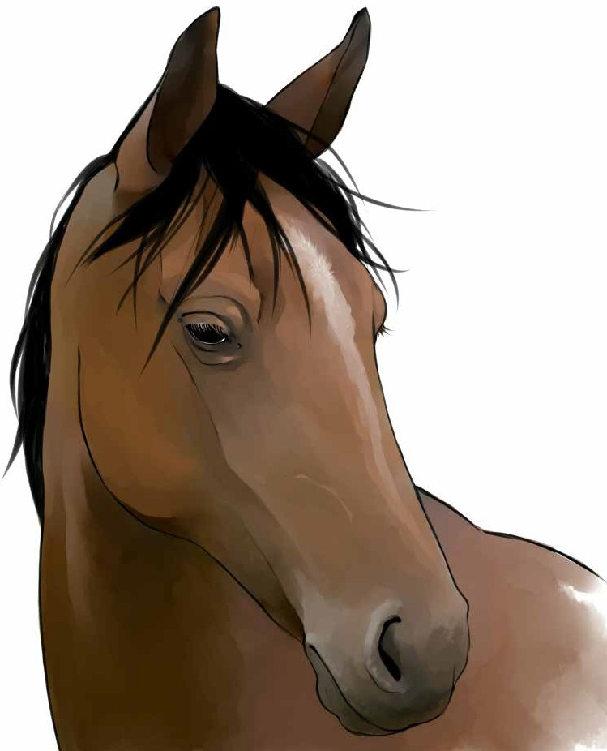
People didn’t call him by his Christened name which was
Patrick, instead they shortened it to Pat, and he was simply mad about horses. His best friend was Brian and he too, was manic

about horses. Each of them had his own horse; Pat’s was a grey and white piebald mare, Brian’s a lovely chestnut coloured
stallion.
Pat and Brian lived right next door to each other. They both had large back gardens, and broke a gap in the hedge, which
meant they could bring the horses in and out of each other’s gardens. Each had made a six metre wide track around the
perimeter and it was ideal for exercising their horses. The track wasn’t long enough for racing, but they could gently gallop
around it.
Pat and Brian spent endless hours looking after and
exercising their horses. It was enjoyable and gratifying, and they knew how to take good care of them. They bought the hay, the
straw and the oats from local farmers. The straw was used for
bedding, and every morning before going to school, they cleaned out the stables and gave the horses a fresh bed of straw.
Pat’s Dad was a dedicated gardener and used the horse
manure from the stables to enrich the soil in both his vegetable
and rose gardens. He maintained that horse manure was great for the roses.
The horse track ran around his vegetable garden and as he toiled in it, he proudly monitored the two youngsters trotting
around and figured that one day they might be rich and famous jockeys.
The Mammies sarcastically remarked that the two boys
looked after the horses better than they looked after themselves.
The horses were fed on hay and oats and each day the boys

made sure they had fresh, clean water. A man called Patsy Mc Garry, a farrier from the local village, called every two months or so, in order to put new shoes on the horses. He also reckoned that both boys had the potential to be excellent jockeys.
One dreadfully wet Tuesday, the worst thing that could happen, did happen. Both horses were stolen. Everyone was either at school or at work and everyone was absolutely
horrified. They understood how much the horses meant to the boys.
The Gardaí thought it was a professional job and figured
the thieves had been watching the houses. They broke the locks of the gate, at the side of Pat’s house to gain entrance and they wore gloves, because the scene of crime Garda could find no
fingerprints, only smudges.
The thieves were utterly stingy and despicable, because as well as the horses, they stole their saddles, the halter ropes and even some sacks of oats and bales of hay. The neighbours were questioned, but no one saw or heard anything.
There was just no consoling either Pat or Brian. They hung
around moping, becoming more grumpy and depressed with each passing day, without any sighting of their horses. Everyone tried to cheer them up and their parents promised to buy them new
horses, but it would probably take up to six months to gather enough money.
Their story made the local paper and a photograph of the two boys, along with an old photograph of the horses was included - the boys looking glum and sad. The headline read, “Local Boys

Left Heart Broken by Callous Thieves.”
Three weeks after the robbery Pat’s Dad received an
unexpected phone call. The caller wished to remain anonymous, but he was sure there were two horses, like the ones in the paper, in a field up at the back of Mulachmore Mountain.
The Gardaí were immediately alerted and the boys and their Dads jumped straight into a car and hastily sped off towards
Mulachmore.
They arrived at Mulachmore at the same time as the Gardaí.
The boys instantly recognised their horses, they would know them anywhere and they were almost overcome with emotion.
The farmer who owned the land on which the horses were grazing claimed to know nothing and he was never charged, as the Gardaí said there was a lack of evidence.
When the horses were safely stabled back home, Pat’s parents suggested a little holiday was in order, for everyone! They could use the money they had been saving. However, the two boys
bluntly refused to go anywhere, saying they would never leave their horses.
The best part of the story was that Pat’s horse was now
pregnant. Patsy Mc Garry said he knew a pregnant mare when he saw one, and sure enough, the vet said he was right. Pat wondered what colour the new foal was going to be. He couldn’t wait.

Questions

- Describe Pat’s horse.
- Describe Brian’s horse.
- Why did Pat and Brian break a gap in the hedge between their gardens?
- Where did they get the straw, hay and oats from?
- What is the difference between straw and hay?
- What was the horse manure used for?
- Apart from the horses, what else did the thieves steal?
- What evidence is there to suggest that it was a professional theft?
- What was the headline in the local paper?
- Where were the horses found?
- What was the surprise at the end of the story?
- Did you like this story? Say why / why not.
- Draw or describe one image which you can see in the above story.

Listening and Speaking

- Do you have any pets at home?
- What are your favourite animals?
- Are there any animals you dislike?
- In what ways are people cruel to animals?
- What society tries to prevent cruelty to animals?

Vocabulary from the story

- His Christened name was
- He was manic about horses
- A grey and white piebald mare
- A lovely chestnut coloured stallion
- They broke a gap in the hedge
- They made a six metre wide track around the perimeter
- It was ideal for exercising the horses
- They could gently gallop around it
- It was enjoyable and gratifying
- Hay, straw and oats
- A dedicated gardener
- He used the horse manure to enrich the soil
- As he toiled in it, he proudly monitored the two youngsters trotting
around
- The Mammies sarcastically remarked
- A farrier
- He reckoned that both boys had the potential to be excellent jockeys
- A professional job
- The scene of crime Garda
- Only smudges left behind by the gloves
- The thieves were utterly stingy and despicable
- Halter ropes
- There was no consoling Pat or Brian

- They hung around moping, becoming more grumpy and depressed
- The headline – callous thieves
- The caller wished to remain anonymous
- They hastily sped off towards
- The Gardaí were immediately alerted
- They were almost overcome with emotion
- The two boys bluntly refused to go anywhere
- The new foal

Writing

- Write a story about your favourite animal or about cruelty to ani- mals.
- Write your home address on an envelope and tape it into your copy.

Focus on-Some Social Sight Vocabulary

Read these words out loud.

name | address
date of birth | looked
ladies | school | beware of dog
gents | tea | hot
gentlemen | milk | cold
entrance | ice cream | up
no entry | sugar | down
exit | bread | garda
fire exit | butter | men
danger | open | pull closed
women | restaurant
café | push | shop
cafeteria | people
doctor | please ring | on
waiting room | open here | off
dentist | keep right | no
no smoking | cinema
private | keep left | poison
keep out | litter | full
public | staff only | turn
over | friend | came
police | could | stayed
shopping centre | should | emergency exit
because | come | automatic door
before | which | ascend
didn’t | like | descend
little | cross here | end

Dictionary Work

Explain each of the following words and write them in sentences which clearly show their meanings.

  - forlorn
  - restaurant
  - carvery
  - auction
  - toxic
  - vexed
  - cul de sac
  - anxious (about)
  - cemetery
  - undertaker

Writing

- Write a story about your favourite animal or about cruelty to animals.
- Write your home address on an envelope and tape it into your copy.

Scaffolding - Write an essay about cruelty to animals.

A possible plan
Paragraph 1 – Start off by stating how much you love animals – make it up if necessary. Write about animals being great company – man’s best friend! Write about how animals don’t give out to you or don’t moan.

Paragraph 2 – Write about any pets you have or had. Describe them. Name them. Write about how you look after them – who buys their food, who feeds them, who looks after them, who cleans them. When and where did you get them?

Paragraph 3 – Write about how you witnessed something terrible last week and how you are utterly traumatised as a result of it! Make it up. Say where you were and who you were with. You saw:
  - Someone throwing acid over a small defenceless dog
  - Or someone cruelly kicking a dog or cat or
  - Or someone mercilessly hitting a pony or donkey with a large black- thorn stick
  - Or someone throwing a dog onto a bonfire
  - Or a dozen horses in a field completely emaciated
Describe it all in detail and write how you felt – at least five sentences.

Paragraph 4 – Write down what you did – did you call the Gardaí or the
D.S.P.C.A. Did you tell your parents? Did you confront the cruel bullies?
Did you start a fight? Describe it. Did the bullies go to court or to jail?

Paragraph 5 – Is this story going to have a happy or a sad ending? Will the animal be all right or will the animal have to be put down? Write your own personal opinion about cruelty to animals.

Please read over everything you have written, and check that you put in all the full stops and capital letters. Also try to enrich and improve your vocabulary.

Cruelty

Unit 6

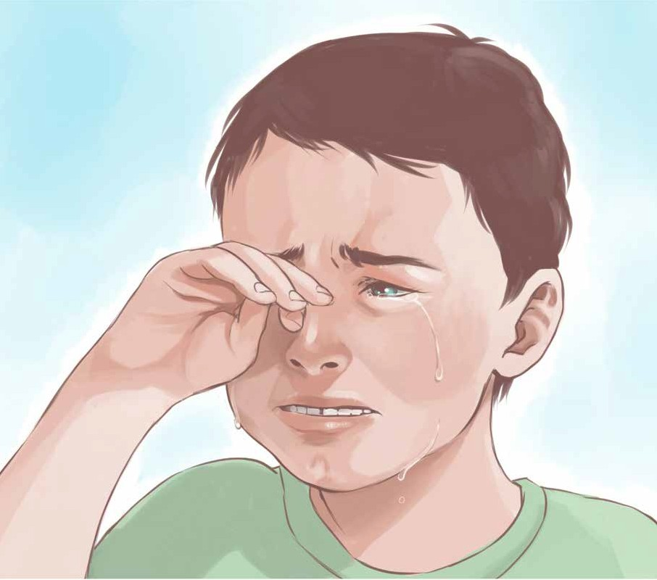
One day Ryan was going to play for Manchester United. It was his dream. He played for the under 14s at St. Finbar’s, and his Dad reckoned he was simply the best. Naturally he was
biased, but Ryan was a neat little footballer and was outstanding at chasing, tackling and heading. He was an attacker and scored some spectacular goals.

There were sixteen players in total in the squad and training was held every Wednesday at seven o’ clock sharp. The training was tough and exhausting. The manager, Gerry, roared and
shouted at his squad, and always insisted they could do better. Games were played on Saturday mornings.
Competition for places was intense. Ryan didn’t start for
every game and this saddened him, but he always played for at
least half of every game. He was particularly accurate at passing the ball and when he came on, he nearly always created or
scored a goal. His nick name was Super Sub.
St. Finbar’s won most of their matches. They won the semi
final of the championship, and were now to play Galway United in the final. Ryan had scored the winning goal in the semi final and was feeling proud.
The club hired a thirty seater bus to take them to Galway. It was a long journey, so they stopped for breakfast in Athlone.
Most of the players were quiet and somewhat tense. Gerry had encouragingly spoken to Ryan at Wednesday’s training, telling
him he was playing well and asked if he was ready for Saturday.
Despite his nerves, Ryan was excited and really looking forward to the game. He hoped he would start on the first eleven. However, when the team was announced, his name wasn’t on the starting line out. He was really disappointed, but said nothing.
Obviously he was going to come on in his usual role, as Super Sub.
It was a physically tough, aggressive game and by half time there was no score from either team. Two subs were put on for
St. Finbar’s, but not Ryan. About fifteen minutes into the second

half, St. Finbar’s scored a brilliant goal and ten minutes later, the ball was again volleyed into the back of Galway United’s net, which made it two – nil. Ryan was getting more and more impatient and worried. Why wasn’t Gerry putting him on?
Five minutes from the end, he watched in disbelief, as the
final substitution was made. He immediately realised he wasn’t going to be allowed to play at all and when the final whistle
went, everyone sprinted onto the pitch; everyone except Ryan. There was much cheering and screaming and hugging, but
Ryan felt like crying. He felt utterly miserable, but he knew he couldn’t show it. Speeches were made and the cup handed over.
On the long journey home, there was lots of high spirits and good humour and Ryan pretended to join in. No one explained to him why he wasn’t let play. It wasn’t fair; he had played in every single game up to the final.
The following Wednesday, at training, Gerry shouted at Ryan to put in more of an effort. Ryan said nothing; he just walked off the pitch, went to the clubhouse, got his things and went home.
That was over a year ago. Now Ryan doesn’t play for any team.

Questions

        - What was Ryan’s dream?
        - What football team did Ryan play for?
        - What position did Ryan play in?
        - How many players were in the squad?

        - What was the name of the manager?
        - What was Ryan’s nick name?
        - Who was the final being played against?
        - Why did Ryan feel miserable at the end of the game?
        - Do you think Ryan was bullied? Explain your answer.
        - Is “Cruelty” a good name for this story? Give your reasons.
        - What is your opinion of Gerry as a manager?
        - Draw or describe one image which you can see in the above story.

Listening and Speaking

- Why do you think Ryan wasn’t asked to play in the final?
- What would you have done, if you were Ryan?
- Do you think Ryan was right to completely give up playing football?
- Have you ever been left out of anything? How did you feel?

Vocabulary from the story

- Naturally his Dad was biased
- Ryan was a neat little footballer
- He was outstanding at chasing, tackling and heading
- He was an attacker
- He scored some spectacular goals
- There were sixteen players in the squad

- He always insisted they could do better
- Competition for places was intense
- His nick name was super sub
- The players were somewhat tense
- Gerry had encouragingly spoken to Ryan
- It was a physically tough, aggressive game
- The ball was volleyed into the back of the net
- Ryan was getting more impatient
- He watched in disbelief as the final substitution was made
- Everyone sprinted onto the pitch
- There was lots of high spirits and good humour

Recommended Poems

I was brave and I was bold

Focus on -The comma (,)

Commas are used:
- In writing, to show a brief pause
- In lists, e.g. I bought apples, bananas, pears and oranges in the shop.
- To separate the speaker from the direct words spoken, e.g. Jack said, “Did you do that?”
- It is ok to put in a comma before the letter “and”, in order to slow
down the pace of reading and to introduce a brief pause.

Write the following sentences into your copy and include the commas:
- The sky was a mixture of colours: red orange yellow purple and rust.
- Claire said “Eat up quickly because we are going to the sea.”
- In the shop we bought bread milk butter sugar tea and coffee.
- The Principal announced “We will be staying inside today because the weather is too wet.”
- First of all we went to the cinema then we went to the restaurant.
- In the clothes shop we bought two dresses four pink tops two pairs of socks and a pair of blue trousers.
- Erica said “I bought a cool creamy ice cream.”
- All my favourite programmes were on the TV: Coronation Street Eastenders and Emmerdale Farm.
- After the concert we went to the train station got our tickets and waited.
- Before the match I ate two rashers three sausages an egg and fried bread.

Dictionary Work

Explain the following words and write them in sentences which clearly show their meanings

  - delicatessen
  - laundrette
  - auctioneer
  - reception
. • vacancies
- chauffeur
- ancient
- keen
- disrespectful
- exasperated (with)

Writing

- Write a story in which you are treated unfairly.
- Write a letter home to your parents telling them how well you are getting on in school – see below

Focus on - Writing letters

Always include the following:
  - Your address - on the right hand side of the page, with a new line for each part of your address
  - The date - under your address, on a new line

  - The greeting - on a new line, all on its own, on the left hand side of the page
  - Three or four paragraphs - each one starting on a new line
  - The farewell - again on a new line
  - Your signature - at the very end, on a new line, on its own

Scaffolding - Practise writing letters.

Include the following:
- Your address, on the right hand side of the page.
- The date, under your address.
- The greeting, on a new line, on the left hand side of the page.
- The first sentence, on another new line.
- Paragraphs, each one starting on a new line.
- The farewell, on a new line.
- Your signature, at the very end, on a new line, on its own.
  - First write in your address on the right hand side.
  - Each part of your address goes onto a new line.
  - For example, Mourne Road, would go onto only one line.
  - Please note that Road is spelt with a capital “R”.
  - Drimnagh, - Goes onto a new line.
  - Dublin 12. – Goes onto a new line.
  - The date goes onto a new line.
  - The greeting goes onto a new line all by itself, on the left side of the page. For example, Dear Sir/Madam, or Dear Pen Pal,
  - Write a letter to an imaginary pen pal living in New York.
  - A possible plan for writing a letter:

Paragraph 1 – Tell the person that you are looking for a new pen pal, about the same age as yourself. Tell him or her your age and say whether you have ever had a pen pal before.

Paragraph 2 – Tell them about your family, - brothers, sisters, parents, - who lives at home – including the dog! Write down some of the things you do together and list all of your own hobbies.

Paragraph 3 – Describe your local community – Drimnagh, Crumlin – beside the Grand Canal, beside Our Lady’s Hospital for sick children, on the south side of Dublin. Explain what the Luas is and how close you live to the Luas. Write about the Bosco Club and Brickfield Park and the Phoenix Park.

Paragraph 4 – Describe your school. Write about your favourite subjects and teachers. Write about the subjects you don’t like. Are you able to inject some humour into your writing? Write about the Principal and Deputy Principal.

Paragraph 5 – Ask lots of questions. How many people in your new pen pal’s family? What they work at. Do they live in an apartment or a big house? How does he / she travel to school? What is school like in New York? What is New York like? Can you go over to visit?

On the second last line, write - Farewell for now,
And on the last line, all on its own, sign your name.
Please read over everything you have written, and check that you put in all the full stops and capital letters. Also try to enrich and improve your vocabulary.

The Bird Woman

Unit 7

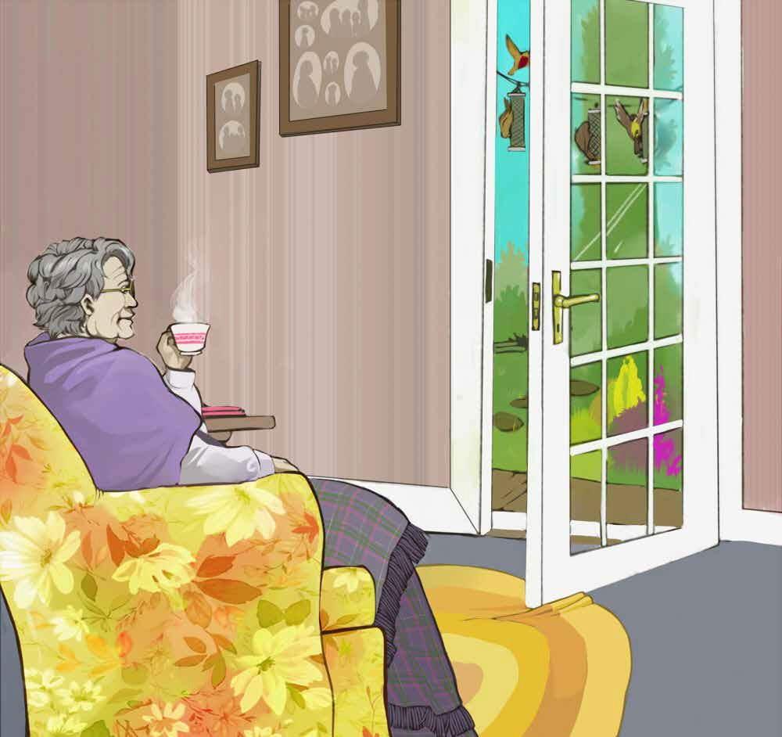
Mary Kate lived alone in a row of small terraced houses in Donnybrook. She enjoyed living in Donnybrook, having lived
there all her life, and had some very kind neighbours. Her husband John had died seven years ago.
It was a modest, but comfortable house, certainly big enough for

someone living on their own. The kitchen was large enough, as was the living room, but the two bedrooms were small.
Their only child, Adam, emigrated to Australia shortly after
the death of his father and hadn’t come back, not even for a short holiday. He met and married an Australian girl, called Victoria,
possibly after Queen Victoria. Mary Kate was unable to attend the wedding, on account of the rheumatism, “It hurt too much,”
she declared. She now had a little grand-daughter, and her name was also Mary Kate.
Mary Kate was well used to living alone. She had her daily
routine. She got up at the same time every morning, always 7.30, even on weekends. She put on the kettle and made herself a cup of tea. At exactly 8 o’clock she turned on the radio and listened
to the news. Next she had her shower, put on her creams and did her hair. If there were some clothes that needed washing, it was always done before ten.
At ten o’ clock she again listened to the news, took her daily tablets with another cup of tea and a single slice of toast. At
about 10.30 she walked to the local shops, where she usually met someone for a chat and she bought the daily paper, not for the news, but the crosswords which she enjoyed. Such was her routine, and it seldom wavered.
Mary Kate didn’t eat a lot. Dinner normally consisted of a
fried egg, or a small bit of fish, or a pork chop. She was a small, light, almost frail woman and a strong breeze would possibly
blow her away.
The radio stayed on for most of the day, but at six o’clock,
the television was compulsively turned on, but only for a couple

of hours! Mary Kate said she preferred listening to the radio,
claiming it was better company. She especially enjoyed listening to Joe Duffy.
Sometimes her next door neighbour Helen called in to see her. Helen was good to her and kept an eye on her. Mary Kate realised Helen was watching out for her and appreciated it.
Once, Helen asked her if she ever felt lonely, “Ah sure, how would I be lonely?” replied Mary Kate. “Haven’t I my birds to be looking after.”
Mary Kate spent a considerable amount of time looking at, and looking after those birds. She had a small garden out the back, and after her husband died she bought three bird feeders
and hung them from the clothes line. On a fortnightly basis she bought bird food and almost every day from early October to
the beginning of May she filled up the feeders. Then from her armchair in the kitchen, she spent hours watching and admiring
the comings and goings of her birds. When chatting with Helen, she always called them “my” birds.
The sparrows and the robins were her favourite birds, and the little coloured ones, whose names she didn’t know. Blackbirds
also visited, and she was happy enough with that, but it was the magpies and the crows which she hated. She called them bullies, because they chased away the smaller birds. Sometimes, Mary
Kate went out to chase the bullies away, shouting and ranting at them, calling them all kinds of disgusting names. Some of the
local children heard her, and christened her the mad bird woman.
On November the thirteenth, Helen found Mary Kate lying
immobile in her back garden, crying and shivering with the cold.

She had been chasing away the magpies when she slipped and
fell. Helen immediately called an ambulance. At the hospital she discovered that her hip was broken.
She never did return to her terraced house, and now resides in a home for old people. Frequently, she can be seen sitting by her window, silently staring out at the birds.

Questions

- Where does Mary Kate live?
- When did her husband die?
- Where did her son Adam, emigrate to?
- Describe Mary Kate’s routine.
- What does Mary Kate normally have for dinner?
- Why was Mary Kate not lonely?
- Name some of the birds which ate from the bird feeder.
- Where is Mary Kate now?
- What does she spend her time doing?
- Did anything surprise you about this story?
- Did you enjoy this story? Why/why not?
- Draw or describe one image which you can see in the above story.

Listening and Speaking

- Do you know anyone like Mary Kate or do you know anyone who lives alone? How do you know him / her? Describe his or her daily routine.
- Why should we help people who live alone? How?
- Do you know anyone who feeds the birds? Talk about them.

Recommended Poems

Who Will Take Grandma, by Craig Reid

Vocabulary from the story

- She lived in a row of terraced houses
- It was a modest, but comfortable house
- He emigrated to Australia
- Rheumatism
- She had her daily routine
- It seldom wavered
- Dinner normally consisted of a fried egg
- The television was compulsively turned on
- On a fortnightly basis – every fortnight, she bought bird food

- Shouting and ranting at them
- Christened her the mad bird woman
- She found Mary Kate lying immobile in her back garden
- Now resides in a home for old people

Focus on - Verbs

Verbs are action words. It is important to choose the correct verb for what you want to say. Think before you write. Put the following verbs into sentence.
Present Tense Past Tense
- shouting shouted
- snoring snored
- shaking shook
- considering considered
- glaring glared
- crying cried
- strolling strolled
- creeping crept
- racing raced
- stretching stretched
- stuffing stuffed
- speeding sped
- whispering whispered
- fighting fought
- dozing dozed
- trembling trembled

Some Adverbs

Put the following adverbs into sentences. (The adverbs are underlined)
- Waited patiently
- Spoke roughly
- Anxiously enquired
- Rapidly sprinted
- Violently punched
- Silently tip-toed
- Screamed loudly
- Nervously ate
- Finally decided
- Tenderly caressed
- Reluctantly walked

Dictionary Work

Explain each of the following words and write them in sentences which clearly show their meanings.

- nutrition - nutritious
- malnutrition
- dialogue
- malicious
- beneficial
- hysterical
- abandoned
- enthusiastic
- majority
- minority

Writing

Write about an old person who lives alone. Imagine their daily routine and describe it. Imagine their fears, their joys and their hopes.

Scaffolding - Write a story about
“A Day in the Life of an Old Person”

Paragraph 1 – Introduce yourself – give your name. Say where you live and how you ended up living all alone. Say if you are happy or unhappy to be living alone.

Paragraph 2 – Describe your typical morning – what time you normally get up at – what you normally have for breakfast – Have you any ailments? - Do you have to take any tablets? - Write about how you pass the time – do you find the morning long? Are you lonely? Are you bored?

Paragraph 3 – Do you make your own dinner? What do you normally have for dinner? Maybe you get meals on wheels! Who comes to visit you? Have you got children/grandchildren? Are they kind towards you? Have you got excellent mobility? Do you go to the shops or the park? Are you able to drive?

Paragraph 4 - Write about your fears – about growing old – what sort of things can you not do for yourself? Are you afraid of answering the door –of

being mugged – of falling down? Of ending up in a home – having to leave your own house?

Paragraph 5 - Write about your joys – do you like watching television – what programmes do you watch – do you watch the soaps – do you like reading? Do you go to the bingo – do you go to day care centres – do you go dancing? Do you go to the pub?

Paragraph 6 – Write about your memories – about when you were a child – about growing up – about “wild” things you did – about what you worked at
- about what made you happy. Can you think of one interesting sentence to
finish off the whole story?

Please read over everything you have written, and check that you put in all the full stops and capital letters. Also try to enrich and improve your vocabulary.

A Mystery

Unit 8

The woman next door died about six months ago. Her name was Rose Jennings. I used to do little jobs for her, like cutting
the lawn or carrying in her shopping and she always gave me €5.
She was a thoughtful and compassionate woman, and I always felt guilty taking the money, but I still took it.
She had no relations that we know of, and we knew her house had been empty since the funeral; which was why we found it
really unusual when we heard strange noises coming from her house, noises like someone dragging heavy furniture.
Our houses are semi-detached and the dividing walls paper
thin, so we can hear an awful lot; and we used always hear Mrs.
Jennings moving around. She had a television upstairs in her
bedroom and I could sometimes even tell what programme she was watching.
Night after night we heard the same unexpected, unexplained heavy noises. They mostly came from upstairs and normally
started after midnight. It was a genuine mystery to us. There had been no “For Sale” sign erected outside her house and if it had
been rented, surely we would have noticed the tenant going in and out. We didn’t even know who owned the house and we did wonder what would become of it.
When Dad ventured outside to check, he discovered there
was a light on in the front bedroom, and someone had closed the curtains. He immediately rang the doorbell several times, but no

one answered. At the very least he wanted to introduce himself to our new neighbour!
And the following morning the curtains were reopened. This
indeed was strange, a real mystery and we resolved to investigate further!
I decided to keep watch, to kind of act like a detective. So the following night I went up to our front bedroom at about ten o’
clock, just as it was getting dark. I left the light off to ensure that no one could see me and pulled back the curtain a little. I pulled over a comfortable chair, kept peeking out and patiently waited.
At close to twelve o’ clock, I unexpectedly heard someone walking about next door. I immediately dashed downstairs and rushed out to the front of the house. The curtains were again
closed and the lights on in the front bedroom. How did he or she get in without me seeing them? Who could it be?
I now honestly began to wonder if the house was haunted, or maybe the ghost of Mrs. Jennings had returned?
Or maybe our mysterious stranger had come in through the
back door, after all I hadn’t been watching out at the back of the house. So the following night I again resolved to keep watch, but this time from the back upstairs bedroom window.
And sure enough, at about five to midnight, I saw someone in a black hooded anorak easily vault over the back wall and
suspiciously walk towards the house. I quietly opened my
window and peeped out. He or she took a key out of their pocket and entered Mrs. Jennings house, via the back door.
I again rushed downstairs and excitedly informed Mam and

Dad of my discovery – Dad knew what I had been up to and had given his approval. We considered the situation for a brief while and knew there was no point in ringing the front door bell. We
even considered calling the Gardaí, but decided instead to set a trap, for the following night.
The following night was freezing, really bitterly cold, and both Dad and I put on layers of clothes for our mission. We
picked a good hiding spot in the shadows of Mrs. Jennings back garden, and right on time, just before midnight, the mystery
person once more appeared on top of the wall. When he or she jumped down, both Dad and I pounced in unison.
We awkwardly tried to wrestle this mystery intruder onto the frost covered grass and I positively thought I had a good grip
around the neck, but he or she was too agile and too slippery for us, and quickly twisted out of our grasp. Like a young gazelle
he or she swiftly regained composure and vaulted back onto
the wall, but not before punching poor old Dad very hard in the mouth. Almost immediately, blood spouted out.
The mystery person escaped and Dad definitely lost one
of his front teeth. We finally called the Gardaí and when they
arrived, they entered Mrs. Jennings house, but found no evidence whatsoever of anyone staying there.
For his troubles Dad had a few painful visits to the dentist.
The mystery person never returned, and so the mystery continues.

Questions

- When did Rose Jennings die?
- What jobs did the author do for Rose Jennings?
- Explain what a semi-detached house is.
- What do you think caused the heavy noises coming from next door?
- At what time did the mysterious person enter Rose Jennings’ house?
- What was the mysterious person wearing?
- How was the mysterious person getting into Rose Jennings’ house?
- Where did the author and his Dad hide in the back garden?
- What happened to the author’s Dad?
- Who do you think the mysterious person was? Explain your answer.
- Draw or explain one image which you can see in the above story.

Listening and speaking

- Do you know any mystery stories? Will you share them with the class?
- Do you help any of your neighbours? In what ways?

Recommended Poetry

Someone, by Walter de la Mare

Vocabulary from the story

- She was a thoughtful and compassionate woman
- Semi-detached houses
- There was no “For Sale” sign erected outside her house
- A tenant
- When Dad ventured outside to check
- He rang the door bell, several times
- We resolved to investigate further
- I decided to keep watch, to kind of act like a detective
- I left the light off to ensure that no one could see me
- I kept peeping out and patiently waited
- I immediately dashed downstairs
- I saw someone in a black hooded anorak
- He or she easily vaulted the back wall
- Suspiciously walk towards the house
- He or she entered Mrs. Jennings house, via the back door
- Dad had given his approval
- We considered the situation for a brief while
- We put on layers of clothes for our mission
- We picked a good hiding spot in the shadows
- Dad and I both pounced in unison
- We awkwardly tried to wrestle this mystery intruder to the ground
- I positively thought I had a good grip around the neck

- He or she was too agile and too slippery for us
- Like a young gazelle, he or she swiftly regained composure and vaulted back onto the wall

Focus on - Our or Are?

Write the following sentences in your copy and fill in the blanks with either
our or are.
- We love school.
- What age you?
- _____ you coming round for dinner tonight?
- You can come round to _____ house on Saturday.
- Why _____ you laughing?
- When _____ we going to the cinema?
- Why can’t we take car?
- _____ library is open every day, except Sunday.
- Where ____ you going for your holidays?
- ______ school is very big.
- ______ lunch is between 1 and 2 o’ clock.
- Where _____ the bargains in this supermarket?
- It’s _____ club, but you are welcome to join.
- _____ kitchen has no smoke alarm.
- There _____ lots of smoke alarms around school.

Dictionary Work

Explain the following words and write them in sentences which clearly show their meanings.

  - arson
  - sadistic
  - manufacture
  - agriculture
  - horticulture
  - forestry
  - mature
  - immature
  - derelict
  - obsessed (with)

Focus on Adding “ing” to words which end with the letter “e”.

The rule is – drop the “e” and add “ing”
Come changes to coming. | Write changes to writing.
Have changes to having. | Smoke changes to smoking.
Make changes to making. | Take changes to taking.

Writing

- Write a scary story.
- Write a letter home to your folks, pretending you are on holiday in a

different country. Tell them where you are and write about the we- ather, the food, the amenities, your friends and what you do every day and night.

Scaffolding - A plan for a scary story

Paragraph 1 – Where are you? Who are you with? Are you in the house on your own? What time is it? Is it a creaky old house?

Paragraph 2 – What’s the weather like? Is it frosty and cold? Is it windy and stormy? Is it wet and damp? Is there thunder and lightning? Is there a power cut? Are children going round trick or treating? Are there any bonfires lit? Are kids letting off fireworks? Are there lanterns floating in the air? Are dogs barking?

Paragraph 3 – Something scary is going to happen? What noises do you hear - creaking doors, something scratching, banging and knocking, footsteps, taps being turned on, doors slamming, crying scary noises. How do you feel - worried, anxious, afraid, scared, terrified? You get an eerie feeling.

Paragraph 4 – What do you do? Do you shout out? Do you scream? Do you call someone? Do you open the door? Do you run? Do you trip and fall?

Paragraph 5 – You see someone - a man with a long knife, a thief, a mugger, a ghost? Describe him or her. Have they really long, dirty hair?

Have they rotten black teeth or no teeth at all? Is he she tall or strong or small. What clothes is he/she wearing? What do they say? Do they chase you and shout at you? Does he / she stab you? Does he /she try to choke you and you then realise he/she has metal hands?

Paragraph 6 – How does it end? Someone is going to get murdered? Blood everywhere! Parents come back – do they also get murdered? Does the murderer escape or did the Gardaí catch him / her?

Please read over everything you have written, and check that you put in all the full stops and capital letters. Also try to enrich and improve your vocabulary.

Unit 9

Hallowe’en Nightmare

Last year, Hallowe’en night turned out to be the worst night of my life. It was ghastly, it was horrible, and I don’t even want to talk about it, but I will try to write about it. I should never
have gone into them damned awful woods.
Every year my friends and I go trick or treating. It’s fabulous

fun. However, last year, my over-protective parents wouldn’t
let me out, because the legendary, deranged serial killer, Bruce
Barrington, had escaped from prison, which is located only about four kilometres from our house. Dad works in the prison, and he made it quite clear to us just how dangerous and depraved Bruce Barrington really is, and it was rumoured he was hiding out in
our neck of the woods.
I know what you are thinking. I should always obey and respect my parents, but I was bored and fed up being stuck inside. Everyone was out having a ball. So, at around seven o’clock I snuck out through my bedroom window, perfectly dressed for the occasion, as a ghost.
My friends were waiting at the bottom of the lane; we had been texting, and we cheerfully headed off around the village,
knocking on every door, trick or treating for a few goodies. If a house gave us nothing, we threw eggs at their cars or walls and quietly cursed them. It was great crack.
Time moved far too rapidly, and I knew I’d have to get home before my parents discovered that I’d disobeyed them. However, my friend Roberta implored me not to go home. She had been
drinking alcohol and dared me to go into the forest with her. I really didn’t want to, honestly, but rebellious Roberta wouldn’t take no for an answer. Silly girl and stupid me!
The forest was dark, dense and dismal. Deeper and deeper we ventured in. It was bleak and eerily quiet, and I was scared, literally terrified out of my wits. A cold sweat trickled down my spine.
Looking back on it now, I realise I shouldn’t have left her.

I know I was cowardly, but it all happened so fast. One second we were holding hands, and a moment later we were furiously running, practically for our lives.
Out of nowhere Bruce Barrington had come at us, with a
long, sword like knife. His eyes blazed with a crazed madness and his untamed wild hair only added to his villainous brutish appearance. His thunderous roar tore through the air and his
heavy awkward body moved surprisingly fast. At first I froze, and then I ran and ran and ran, never once glancing back.
When I reached the edge of the forest, I screamed and
shouted for help as I speedily sprinted towards the village. I was almost breathless, and shaking with fear. People hastily emerged from their homes and one or two rushed towards me.
We were too late. Roberta’s body was found, covered in blood, a grim and ghastly sight. Now I often have terrible nightmares and never ending guilt.

Questions

- When was the worst night of the author’s life?
- Why would the author’s parents not allow him out on Hallowe’en night?
- What was the author dressed as when he went trick or treating?
- Why did some of the young people throw eggs at peoples’ cars or walls?
- What is your opinion of the actions of these young people?

- Why do you think Roberta was called rebellious?
- The author calls Roberta a silly girl? Do you agree with his opinion? Explain your answer.
- How was Roberta killed?
- How did the author feel at the end of the story?
- Do you think things like the above really happen? Explain your thinking.
- Draw a picture of Bruce Barrington

Listening and Speaking

- What do you do on Hallowe’en night?
- Have you ever told lies to your parents? Do you want to talk about it?
- Have you ever thought about running away from home? Do you want to talk about it?

Recommended Poems

- The Witch, by Percy H. Ilott
- Who’s Afraid, by John Foster

Vocabulary from the story

- It was ghastly
- We go trick or treating for a few goodies
- My over protective parents wouldn’t let me out
- The legendary, deranged serial killer
- A depraved man
- It was rumoured he was hiding out in our neck of the woods
- Everyone was out having a ball
- I was perfectly dressed for the occasion
- It was great crack
- Roberta implored me not to go home
- She dared me to go into the forest with her
- Rebellious Roberta – a rebel
- The forest was dark, dense and dismal
- Deeper and deeper we ventured in
- It was bleak and eerily quiet
- I was literally terrified out of my wits
- We were furiously running, practically for our lives
- His eyes blazed with a crazed madness
- His untamed wild hair
- Added to his villainous brutish appearance
- His thunderous roar tore through the air
- His heavy awkward body moved surprisingly fast

- I speedily sprinted towards the village
- People hastily emerged from their homes
- A grim and ghastly sight

Focus on - Blending letter sounds

Read the following words aloud Blend – ch
chips chops child children cheese chocolate chat chair cherry chess chicken chin chimpanzee check choose chill chair chum Christ Christmas

Blend – dr
dry drab drag dragon drain drama draw dream dress drill drink drip drive driving drop drug drown drum

Blend – gr
grab grace grade grain graffiti gram granny grand grandfather grape graph grass gravy grateful great green grey grill grip groan ground grow group grubby grumpy gruff

Blend – ck
luck duck muck truck peck deck neck pack sack Jack rock sock lock tick pick clock click flick brick black back tick chick pick quick trick stick stuck crack snack smack stuck jacket pocket packet rocket bucket

Dictionary Work

Explain the following words and write them in sentences which clearly show their meanings.

- deny
- guilty
- veteran
- professional
- amateur
- permanent
- temporary
- banter
- grotesque
- tormented (by)

Writing

Write about your Hallowe’en

Personal Profile

Copy and fill in this personal profile in your copy
1. Name__________________________________________________
2. Date of birth _____________________________________________
3. Address ________________________________________________
_______________________________________________________
_______________________________________________________ 4. Your School Address ______________________________________

_______________________________________________________
_______________________________________________________ 5. Name of my class tutor ____________________________________ 6. My favourite subjects in school ______________________________
_______________________________________________________ 7. The best things about this school______________________________ 8. My hobbies are __________________________________________
_______________________________________________________ 9. My friends’ names are _____________________________________
_______________________________________________________
10. One of the best things about my family is______________________
_______________________________________________________ 11. I have improved greatly at __________________________________ 12. I would like to improve ____________________________________ 13. A book I loved reading was _________________________________
_______________________________________________________ 14. A film I really love ________________________________________ 15. One of my favourite colours is _______________________________ 16. I feel sad when ___________________________________________ 17. My favourite foods are _____________________________________ 18. I love going to ___________________________________________
19. I hate __________________________________________________
20. I am happiest when _______________________________________
21. Three people I admire and respect ____________________________

The Rat Catcher

Unit 10

The rat catcher lives at the top of our road. His name is
Billy Fitzgerald and he owns a small white van with the words “RODENT EXTERMINATOR” printed on the side of it. I never know what that meant, but I certainly do now.
I didn’t even know there was such a job as a rat catcher. Imagine working at catching rats, all day, every day - huge, wicked, dirty furry rats! It was only when Dad went up to
Billy Fitzgerald looking for advice on how to catch a rat, that I realised catching rats is actually what he does for a living.
This story started when a rat took lodgings in our back
garden. One dark evening in the month of November Dad was bringing out some vegetable peelings to the composter - he is a superb cook and normally makes us gorgeous dinners - and on
opening the lid, he got the shock of his life. He caught a glimpse of a huge grubby, coffee coloured rat, contentedly nibbling on
some vegetable leftovers.
This big gigantic man truly has an awful fear of rats, and when he sees one, he usually freaks. On this occasion he
screamed so loudly I’m sure he could be heard all the way up to the local supermarket. We definitely heard him inside the house and we genuinely thought something dreadful had happened.
I imagine the rat also got a shock, because the echo from
Dad’s scream would put the fear of God into the devil himself. Dad didn’t just scream, he ran as he screamed. Actually, sprinted

would probably be a better verb, and as he sprinted he flung the green bucket from his hands, scattering its contents all over the place, and he somehow or other tripped over himself, falling flat on his face.
When he came back into the safety of the house, blood was dripping from his left nostril and he looked really shook up.
He was almost as white as chalk, having the appearance of
someone who has just seen a ghost, but he also appeared a little embarrassed. He pointed out the window towards the composter and indignantly commenced babbling something about bloody
rats being all over the place.
Believe it or not, Mum initially burst out laughing, but quickly recovered her composure, and pretended to take the
whole thing seriously. She then tried to comfort and treat her distressed and wounded husband.
A couple of hours later, when Dad had regained his courage, he went up to Billy Fitzgerald and asked for guidance with his
rat problem. Billy suggested he buy rat poison, and told him how to lay it.
Next day Dad marched straight to the hardware shop, a man on a deadly mission. He bought a kilogram of rat poison, which was compressed into small blue cubes and was advised to wear gloves when handling it.
He got a few old slates, diagonally placed them against the base of the wall at the back of the garden, and put three or four cubes of poison behind each one.
The following day, when he checked, the cubes were gone.

The rat had eaten them. He then put in more cubes and when these weren’t eaten, he knew the rat was dead.
Nowadays, whenever Dad goes to empty something into that composter, he treads very carefully. He always brings a
sweeping brush with him, and gives the bin a few hard bangs
with the brush before tentatively opening it – just in case there is another unwelcome visitor inside. It really is an incredible sight
to witness how this giant of a man cautiously opens the lid of our composter, and Mum still calls him, “Her Hero!”

Questions

- What was the name of the rat catcher?
- What did he have written on the side of his van?
- What has Dad got a fear of?
- Where did he discover the rat?
- When Dad saw the rat, what happened?
- How did Dad kill the rat and how did Dad know the rat was dead?
- Nowadays when Dad is going to open the composter, he first gives it
a few hard bangs. Why do you think he does this?
- Do you think the Dad is or isn’t a hero? Give your reasons.
- What kind of things do people put into a composter?
- Draw or describe one of the images which you can see in the story.

Listening and speaking

- Are you afraid of rats or mice?
- Do you have any fears/phobias? What are you afraid of? Name the kind of fears /phobias that people can have.

Vocabulary from the story

- A rodent exterminator
- A rat took lodgings in our back garden
- Dad was bringing out some vegetable peelings to the composter
- He caught a glimpse of a huge grubby, coffee coloured rat
- Contentedly nibbling on some vegetable leftovers
- This big gigantic man truly has an awful fear of rats
- He usually freaks out – to freak out
- We genuinely thought something dreadful had happened
- The echo from Dad’s scream
- It would put the fear of God into the devil himself
- Scattering the contents of the bucket all over the place
- He tripped over himself
- He looked really shook up
- He indignantly commenced babbling
- Mum initially burst out laughing
- She pretended to take the whole thing seriously
- Then she quickly recovered her composure

- She tried to comfort and treat her distressed and wounded husband
- When Dad regained his courage
- He asked for guidance
- A hardware shop
- He was a man on a deadly mission – my mission is …
- A kilogram
- The rat poison was compressed into small blue cubes
- He placed a few old slates diagonally at the base of the wall
- He treads very carefully
- He tentatively opens the lid – he cautiously opens the lid
- It really is an incredible sight to witness

Recommended Poetry

Mice, by Rose Fyleman

Dictionary Work

Explain the following words and write them in sentences which clearly show their meanings.

- anonymous
- unanimous
- determined
- orphan
- pompous
- emotional
- ominous
- function
- audience
- temperature

Writing

Write a list of the different kinds of phobias people can have. Pretend you have one of these phobias and write a story about it.

Focus on - Was or were? ...... is or are?

You use “was”, which is the past tense, when it is only one person or one thing you are talking about. You use “were”, which is the past tense, when it is more than one person or thing you are talking about.
Examples: there was a man in the office; but there were men in the office. You use “is”, which is the present tense, when it is only one person or thing you are talking about. You use “are”, which is the present tense, when it is more than one person or thing you are talking about.
Examples: there is a man in the office; but there are men in the office. Write the following sentences into your copy, but insert one of the above four words was, were,is,are into the blank space. Write carefully and choose the correct word.
- There six people in the Post Office when it was robbed yesterday.
- There .......... some brilliant teachers in this school.
- My English teacher amazing.
- The film I saw last night fantastic.
- I .......... the worst in the race. I came last.
- We .......... the best class in the school.
- We got very wet and we miserable.

- You saved that man’s life! You .......... very brave.
- She .......... beautiful when she was young.
- They .......... beautiful when they were young.
- Today my exam results superb.
- When I ......... small, I went to the circus every year.
- When we ........ bold yesterday, we grounded.
- There .......... a 50% reduction in the shop today.
- There ......... a 50% reduction in the shop yesterday.
- There .......... a fly in my soup.

Scaffolding - Write a story about things I hate – “my phobias!”

Paragraph 1 – Start by writing a list of all the things you hate – make it up if you have to!

Paragraph 2 – Describe the creatures and animals you hate - Alsatian dogs or snakes or rats or spiders or ants or sharks? Say why you hate them and tell a little story, for example when there were mice under the floorboards or the time a spider got stuck in your hair or the time you were bitten by a dog.

Paragraph 3 – Write about the things you hate doing in school – all the writing you have to do, all the homework you get, some teachers shouting at you, the subjects you hate, not being able to do the maths or Irish or French, getting bullied. Fear of failure. Write down what you would change if you were in a position to do so.

Paragraph 4 – Write about the things you hate at home – having to wash up or do the hovering, having to always do what you are told to do, not being able to watch your favourite television programmes – like Match of the
Day or Coronation Street - fighting with brothers and sisters, fighting with
parents. Fear of sickness or illness.

Paragraph 5 – Write about the things which scare you in the night – having to go out in the dark on your own, being home alone when the electricity goes off, being in the middle of a storm with massive thunder and lightning, being mugged – in town, or on the Luas or on a bus – fear of getting into trouble with the Gardaí.

Paragraph 6 – A conclusion! Maybe write about two or three things which make you happy – to ensure that your fears do not get the better of you!

Please read over everything you have written, and check that you put in all the full stops and capital letters. Also try to enrich and improve your vocabulary.

Unit 11

It’s a man’s world

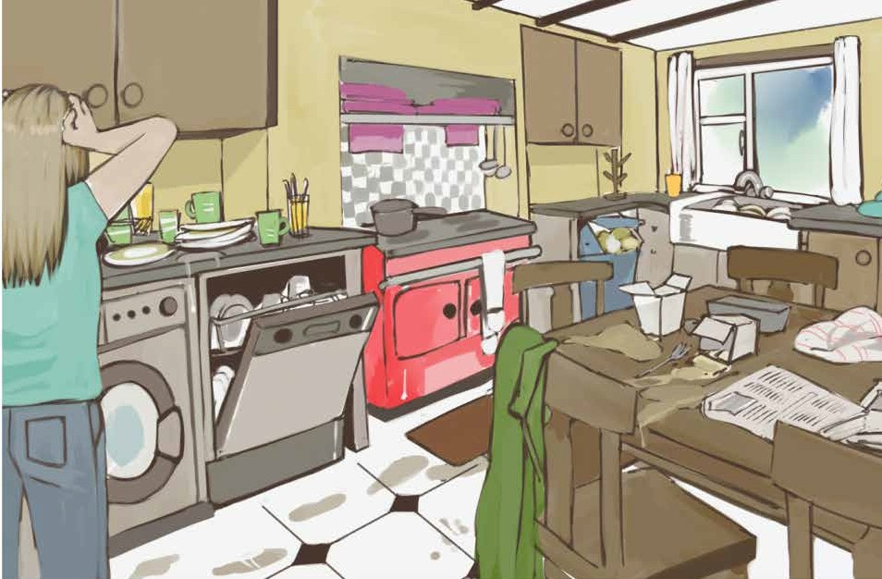
Sinead has six brothers and no sisters and is the youngest in her family. She adores her Dad and her brothers, but often gets frustrated and annoyed with them, because they do absolutely nothing to help around the house.
They never pick up after themselves, they never bring
their empty plates over to the sink, and they never empty the dishwasher. They wouldn’t know how to turn on the washing
machine and hardly know what an ironing board looks like! They never do the hoovering and they never make the dinner. In fact
they wouldn’t even know when potatoes are boiled.
Sinead’s Dad works in the creamery and when he comes

home, Mum always has his piping hot dinner ready on the table for him. After dinner, he stretches himself out on the sofa and
just watches television. Talk about being treated like royalty!
Sinead’s Mum is a nurse in the local hospital and sometimes has to work night shifts. Sinead really feels sorry for her, and
does her best to help her. Sinead keeps on moaning that, “It’s simply not fair” but her Mum usually mutters something like;
“It’s a man’s world” or “Life never was fair!” Infuriating stuff! When Sinead complains to Dad, all he says is, “That’s life,
my little darling”. She had liked him calling her “My little darling” when she was younger, but definitely not now!
Last year, Sinead and her Mum went to London for five
whole days. Her Mum declared it was “Women’s time out” and the men were told to fend for themselves. Sinead and her Mum
had a marvellous time, but they felt a bit lonesome – without the men. That’s because there was always fun and frolics at home;
someone was always messing, someone always having a strong opinion about something or other.
Sinead and her Mum were positively sure that Dad and the boys would never cope without them, and sincerely hoped that the men in their lives would see the error of their ways and see
all the work which had to be done around the house. They hoped they would change and start pulling their weight.
However, nothing changed. The whiff of stale foul air hit them the very second they opened the front door. A window
probably hadn’t been opened for the last five days and the house definitely hadn’t been hoovered. Out in the back kitchen, two

baskets were piled high with dirty clothes and the rubbish bins were full to the brim.
No cooking was ever done, because every evening the men ordered in their dinner, from the fish and chip shop, or the
Chinese restaurant. They weren’t even bothered about turning on the dishwasher, and when Sinead saw it was completely full with dirty dishes, she was close to exploding. They all said they were waiting for Mum and Sinead to come home and they asserted
that they missed them a big big bunch. Sinead silently fumed!
The unfairness of Sinead’s situation was discussed in
her C.S.P.E. class. The teacher was talking about justice and explained the word meant being fair. As soon as Sinead heard
that word, she blurted out everything. She hadn’t meant to talk about her family situation. It all just came tumbling out.
All of Sinead’s brothers had gone to the same school, and
had been model students, so the teacher knew them well and was stunned at what Sinead said about them.
She asked the class what Sinead should do to improve her
situation and the suggestions were plentiful. She was told not to put up with it, not to do any of their work, to start fighting with them, and some even suggested that she run away from home.
However, at the end of it all, there were no practical suggestions. Her Mum had already tried everything, or so she said.
Her Mum seemed to have accepted her lot in life and
sometimes proclaimed, “An Irish Mammy will always love her sons, no matter what they do, or don’t do”. Whenever Sinead
heard that sentence, she felt like screaming.

Questions

- How many brothers has Sinead got?
- In what ways do Sinead’s Dad and brothers not help around the house?
- How would you know when potatoes are boiled?
- When Dad comes home from the creamery, what does he do?
- What does Sinead’s Mum work at?
- When Sinead complains to her Dad, what does he call her?
- Where did Sinead and her Mum go to last year?
- Where did Sinead’s Dad and brothers get their dinner from, when Sinead and her Mum were away?
- What suggestions did Sinead’s C.S.P.E. class come up with?
- According to Sinead’s Mum what will an Irish Mammy always do?
- How do you feel about Sinead’s situation? Explain your thinking.
- Draw or describe one image which you can see in the above story.

Listening and Speaking

- What would you do if you were in Sinead’s situation?
- Who does most of the work in your house?
- What work do you do around the house?
- What does the word justice mean?
- Can you think of situations which are unjust?

Vocabulary from the story

- She often gets frustrated and annoyed with them
- They never pick up after themselves, they never do the hoovering
- Dad works in the creamery
- Talk about being treated like royalty
- She sometimes has to work night shifts
- “It’s a man’s world”
- The men were told to fend for yourself
- Fun and frolics
- Sinead and her Mum were positively sure
- They sincerely hoped that the men in their lives would see the error of their ways
- They hoped they would start pulling their weight around the house
- The whiff of stale foul air hit them as soon as they opened the door
- They all asserted that they missed them a big big bunch
- She silently fumed
- C.S.P.E. – Civic, Social and Political Education
- Justice – an unjust situation
- She blurted everything out
- They had all been model students
- She was stunned
- There were no practical suggestions
- She sometimes proclaimed

Recommended Poems

Claims, by David Kitchen

Focus on - Witch or which?

Read and copy the following into your copies.
The wicked witch didn’t know which way to get to the pitch. Which witch shall I hitch a lift from? Which witch was hiding in the dirty ditch? The witch which was on the mitch was very rich. The witch which was in the kitchen was mitching from the witches’ school, because she needed a stich in her cloak. The witch on the pitch has a very bad itch before she got hitched to wizard.

Exercise

Make up a few of your own sentences which contain words ending in ich or itch. Also write a description of a witch and then draw her.

Dictionary Work

Explain each of the following words.
- migration ...(migrate)
- immigration ...(immigrant)
- emigration ...(emigrant)
- glacier
- robust

- spectacular
- precarious
- thermometer
- tolerant
- devoted (to)

Writing

Write a story about an unfair situation. It can be real or imaginary. In your story, say if a solution was found. You can have a happy ending, an angry ending or a sad ending.

Scaffolding - An Unfair Situation

Paragraph 1 – Think about something unfair that happened to you. Say what it was and write it down. Maybe you would be better off writing about a real situation.
  - Being bullied at home?
  - Being made do all housework – the washing, hovering, making the dinner, minding the babies, doing the shopping.

  - Not being allowed to watch your TV programmes.
  - Not being allowed to go where you want.
  - Being verbally (or physically) abused.
  - Bullied in school? - Being called names, being pushed around, be- ing ignored, being threatened, and receiving horrible texts. From the teachers or the students?

Paragraph 2 – It all started when …….. What age were you …… Where were you when it started ……..Who was involved ………… Write exactly how it started and exactly what happened ……. Who did what and who said things?

Paragraph 3 – Describe your feelings …… Were you sad or angry or crying? Could you use these words – shattered, devastated, broken hearted, terrified, anxious, frustrated, shocked? Did you call Childline or The Samaritans?

Paragraph 4 – What did you do? Did you start a fight? Who did you go to? Did you tell your parents or teachers or relations? What did they do? Did you go to the Gardaí or the doctor or the social workers?

Paragraph 5 – The conclusion. How did it all end? Is it still happening? Is it a happy ending or a sad ending?

Please read over everything you have written, and check that you put in all the full stops and capital letters. Also try to enrich and improve your vocabulary.

Grandad

Unit 12

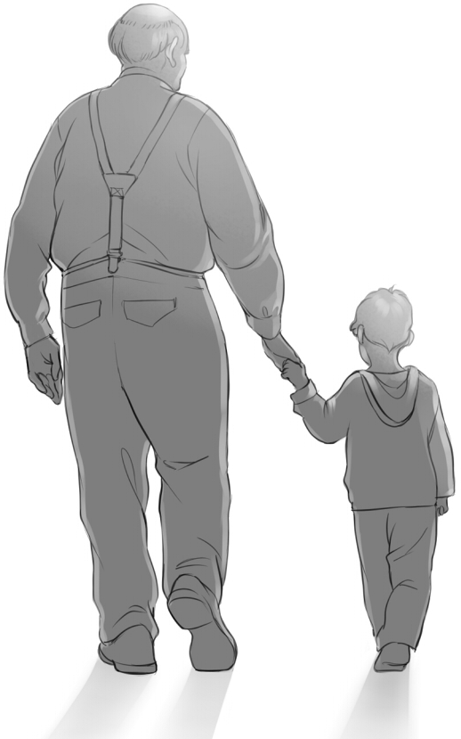
Grandad died last year. He was eighty two years of age and died in his sleep. Mum gently tip toed into his room to wake
him, and he was dead. We were not expecting it, he hadn’t been sick. He was absolutely fine the night before. In fact he was in

great form, giving out about the politicians, one of his favourite pastimes! He always liked talking about politics and enjoyed
nothing more than a good rant about the deplorable rulers of our country. He was a proud, opinionated and hardworking man and was hostile towards anyone who tried to reduce his weekly
pension.
You could argue that Grandad was lucky, because till the day he died, his mind was as sharp as a razor. He had been blessed with excellent health and drove his old battered Volkswagen
Beetle up to the day he died.
Grandad brought us to school every morning and collected us in the afternoons. That was his job. He enjoyed it and was
always punctual. He waited for us at the school gate and greeted us with his big smile. He even carried our bags for us.
Each day he asked what we had done in school and what we had learned. We had to answer with a minimum of three
things. He enthusiastically taught us new words and often gave us little tests. I remember him teaching me words like parasite and vandal and graffiti. He particularly liked giving us maths
questions, for example, What is three quarters of sixteen?; or If a man spent €2.55, how much change would he get from €10.00?
Our Grandad was a fine cook. Mam and Dad both work, and Nana died before I was born, so when we got home from school, Grandad always had a scrumptious dinner ready for us. He kept it hot in the oven, and there was wonderful variety; sometimes it was mince, sometimes chicken and mashed potatoes. On Fridays we usually had fish and homemade chips, with beans. Grandad

also cooked spaghetti Bolognese, lasagne and pasta with all kinds of extras, which was my favourite. I just love pasta!
Grandad had his routines and his rules and we diligently followed them, for example, we were not allowed watch T.V. until dinner was eaten and the homework done. Grandad
usually signed our homework journal, not Mam or Dad, and he
sometimes refused to sign it, if he thought the effort wasn’t up to his high standards.
At exactly six o’ clock every evening, Grandad walked up to the pub. It was only a five minute walk. Normally he had a pint of Guinness, but if the company and the crack were
good, he would have a second pint. He often took us with him, especially in the summer and I enjoyed sitting on those high
stools, listening to the chat. The landlady’s name was Jane. She sometimes gave us a free packet of crisps, and a glass of blackcurrant juice. At Easter she always gave us a large chocolate egg, and at Christmas a variety box.
Grandad was a great gardener and was extremely proud of his garden. He spent hours in it and kept it really neat; indeed you
would be hard pressed to find a weed in it. He grew potatoes,
cabbage, carrots, parsnips, beetroot, turnips, parsley and lots of rhubarb, which he shared with the neighbours
As much as Grandad loved his gardening, he loved working in the bog more. Around Easter, he went up to the bog to clear away any vegetation from the place where he would be cutting the turf. Grandad was a big strong man and he sliced into that bog and threw out those wet sods with ease and accuracy. Our

job was to spread them so they would get the chance to dry.
Three or four days later we put them standing into little
stacks. It was back breaking work and a few weeks after that, depending on the drying conditions, we gathered those sods of
turf into bigger clamps, each one carefully constructed, to ensure the rain flowed easily off.
The best part was definitely bringing home the turf, because on the way up to the bog, we always got to ride in the open car trailer. It was a thrilling sensation and I will forever cherish
those happy times.
I have a picture of Grandad on the locker beside my bed, and in that picture he is up in the bog, sitting on a bank of turf with a contented smile on his face, smoking his pipe, with Jess our
terrier dog by his side. To me, Grandad is not dead, because I always carry him in my memory.

Questions

- What age was Grandad when he died?
- According to the story, what was Grandad’s job?
- What questions did Grandad ask the children when he collected them from school?
- List the types of dinner which Grandad cooked.
- What was the name of the Landlady in the pub?
- What did she give the children at Easter and Christmas?
- What did Grandad grow in his garden?

- What did Grandad love doing more than his gardening?
- How was the turf cut and saved?
- Do you think the children had a good relationship with their Granddad? Support your answer with references from the text.
- Draw or describe one image which you can see in the above story.

Listening and Speaking

- Have you lost anyone close to you?
- Are you able to talk about what happened?
- List some of the good memories you have of that person.

Vocabulary from the story

- Giving out about the politicians – one of his favourite pastimes
- He enjoyed a good rant about the deplorable rulers of our country
- He was a proud, opinionated and hardworking man
- He was hostile towards anyone who tried to reduce his weekly pension
- His mind was as sharp as a razor
- He still drove his old battered Volkswagen Beetle
- He was always punctual
- We had to tell him a minimum of three things we did in school
- He enthusiastically taught us new words
- Words like parasite and vandal and graffiti

- A scrumptious dinner waiting for us
- There was wonderful variety
- Mince meat
- I just love pasta
- Grandad had his routines and his rules and we diligently followed them
- His high standards
- If the company and the crack were good he would have a second pint
- A Christmas variety box
- Around Easter he went to the bog to clear away any vegetation from where he would be cutting the turf
- He sliced into that bog and threw out those wet sods with ease and
accuracy
- Each clamp carefully constructed to ensure the rain flowed easily off
- It was a thrilling sensation
- I will forever cherish those happy times

Focus on – Were or where or we’re?

“Were” is a verb, e.g. we were at school yesterday.
“Where” is a question or a place, e.g. where were you going? “We’re” is the short for we are, e.g. we’re all going on a picnic.
Copy the following sentences into your copy, but insert one of the three words above into the blank space.
Write carefully and choose the correct word.
- We .......... at the circus.

- .......... going to the match tomorrow.
- .......... has my phone gone?
- My shoes are over there, .......... that bag is. 5. .......... were you?
- .......... you at school yesterday?
- .......... did I leave my pencil? 8. .......... do you live?
- When we .......... in Scotland, it rained cats and dogs.
- Next year .......... going to Spain.
- When the exams .......... finished, we delighted.
- Place that phone .......... I can see it.
- When you .......... a baby, you .......... the best child in the whole world.
- We .......... late because I couldn’t find my keys any...........
- The teacher said .......... all going to fail.
- I left my Adidas jacket in here some...........
- We came in very late and we .......... in serious trouble. 18. .......... you on time?
19. .......... did you go?
20. .......... never going to be late again.

More Adjectives

Put the following phrases into sentences. (The adjectives are underlined)
- A magical time
- A grumpy old man
- A nasty little girl
- A glamorous young lady
- A squeaky voice
- An awkward silence
- Vibrant colours
- A cold, bleak night
- Early evenin
- A delightful smile
- A miserable, pathetic little man
- Shattered glass

Dictionary Work

Explain each of the following words.
  - erosion
  - passionate
  - tolerate - intolerant
  - diligent
  - solemn

- demonstrate
- barometer
- rhyme
- legal - illegal
- legible - illegible

Writing

- Write a story about a funeral you attended.
- Write a story with the heading, “My Wonderful Family”.

Scaffolding - A Funeral

Paragraph 1 – Name the person who died and give the cause of death. Say how you know them and write down how you feel about their passing.

Paragraph 2 – Start writing about all the happy times you had together. Name all the places you used to go to and describe the fun things you did. Did he/she love singing or walking or shopping or gardening or watching football? Did he/she spoil you and if so, give examples.

Paragraph 3 – Go back to when the person who died was young. Do you know what school he/she went to? Did they ever talk about it? Did they do exams? Did they like reading? Describe what he/she worked at. Say who they married and where they got married. Write down how many children they had and say if they lost any children.

Paragraph 4 – Write down the hardships the dead person experienced in his/her life. Did he/she suffer much with sickness or did he/she suffer much towards the end of their life? Name and describe the sicknesses. Did he/she have good mobility? Say who used to help them. Was money scarce? Did he/ she have to work really hard?

Paragraph 5 – Describe the funeral. Describe your personal sense of shock, or sadness or broken heartedness when you heard the news. Write about people coming to visit the house. Was there a mass or a service? Was he/ she buried or cremated? Describe your memories of that day. Say how you are feeling now and to conclude write about one of your all time favourite memories or images of the dead person.

Please read over everything you have written, and check that you put in all the full stops and capital letters. Also try to enrich and improve your vocabulary.

Danny’s Dilemma

Unit 13

Danny is a very clean chap. He is really particular about how he looks and about how he smells. Everything and anything to
do with grooming, cleanliness and hygiene is taken seriously.
In fact you could say that Danny is almost obsessive about his
cleanliness, so obsessive, that one day he actually sprayed some of Mam’s really expensive Atlantic Aromas Perfume on himself; just to smell good, before going to school. And that’s when all Danny’s troubles started!
As soon as he walked into the kitchen, Mam immediately
sniffed him out. She knew what he had sprayed and she hit the roof. She demanded to know what in the name of God he was
doing using her lovely Atlantic Aromas Perfume. Danny limply replied he wanted to smell good at school.
“Smell good, smell good, at school!” she exploded, “It’s bad enough having to put up with you grooming your hair
every minute of every day, and now, you’re using my expensive Atlantic Aromas Perfume! Do you know how much it costs? Do you, do you?”
Poor Danny hung his head, in shame. What could he say?
And every morning of the following week, Danny was
taunted and teased by his mother for using her perfume. It was more like a daily rant than a teasing, and all this happened about a month before Christmas. So when Danny innocently asked his mother what she wanted for Christmas, of course the reply was – Atlantic Aromas Perfume.
His Mam claimed she had never had such an expensive
perfume and it had been a gift from her dear departed mother.

She also claimed that because it was so precious, she had seldom used it, and even then, only sparingly.
The pressure was now on, and Danny knew he simply had to buy Atlantic Aromas Perfume. He looked up the internet, started checking the prices and got a mighty shock. It was going to cost over €100, and how on earth was he going to get that kind of
money!
However, Danny was really determined to give his Mum
the surprise of her life and get her exactly what she wanted for Christmas day.
So he decided to enlist the help of his Dad, and offered to do all kinds of jobs – in exchange for money. He offered to hoover the house, he offered to bring in the coal and the sticks, he
offered to empty the dishwasher and he even offered to do extra homework! His Dad was taken aback and knew something was radically wrong.
And when Danny eventually told his Dad what he was up to, he promised to escort him to the new shopping centre and bail him out with some extra cash, but only after a hearty burst of
laughter at Danny’s dilemma.
When they went to the department store where the perfumes were sold, they were greeted by a beautiful young glamorous
shop assistant and Danny enquired if they sold Atlantic Aromas. He insisted it had to be Atlantic Aromas and no other brand.
The young assistant showed him the bottle and wholeheartedly declared he was definitely buying the right perfume. She smiled at Danny as she said this, and he instantly blushed.

They decided to buy the 100ml. bottle, as it was far better
value than the 50ml. The 100ml bottle cost €129, while the 50ml. bottle cost €99. Danny contributed the €65, which he had saved, and his Daddy generously contributed the balance.
The young lady offered to gift wrap the present and while she was doing this Danny intelligently asked what ingredients
were in it which made it so expensive, and where it was made? The young shop assistant was not only glamorous, she was also bright; and informed him it was first made in 2001, in Lahinch, in County Clare and some of the ingredients come from the
beautifully scented flowers of the Burren. Danny was greatly impressed.
As they were about to depart, another young glamorous
female assistant who was observing the conversation, exclaimed with a smile, “Every woman loves Atlantic Aromas.” Again
Danny blushed, but walked away from that store with a huge happy grin.
On Christmas morning, Mam really was surprised. She impulsively grabbed her son and gave him the biggest hug
ever. And as she did so, she uttered, “I love you son.” All was forgiven!

Questions

- What did Danny spray onto himself before he went to school?
- How did his Mam react when she realised what Danny had done?

- Who gave Mam the Atlantic Aromas Perfume in the first place?
- What was the mighty shock which Danny got?
- What jobs did Danny do to earn some extra cash?
- Where is Atlantic Aromas Perfume made?
- Where do some of the ingredients come from?
- What size bottle did Danny and his Dad buy?
- How much did it cost them?
- How much did Danny contribute?
- What was Danny’s dilemma?
- What can you learn from this story?
- Describe Danny – in about five or six sentences.
- Do you agree that this is a close family who get on well together? Support your answer with quotes from the text.
- Draw or describe one of the images which you can see in the story.

Listening and Speaking

- Do you think Danny has a good relationship with his Mum?
- Did you ever buy anyone an expensive gift? Talk about it.

Vocabulary in the story

Explain the following words and write them in sentences which clearly show their meanings.

- He is really particular about how he looks
- Everything and anything to do with grooming, cleanliness and
hygiene
- Danny is obsessive about his cleanliness and appearance
- That’s when all Danny’s troubles started
- Mam immediately sniffed him out!
- She hit the roof -she exploded
- He limply replied
- Grooming your hair every minute of every day
- Danny was taunted and teased by his mother
- It was more like a daily rant
- Her dear departed mother
- She had seldom used it and even then, only sparingly
- The pressure was now on
- He got a mighty shock
- He decided to enlist the help of his father
- Dad was taken aback and knew something was radically wrong
- He promised to escort him to the new shopping centre
- And bail him out with some extra cash
- A hearty burst of laughter at Danny’s dilemma
- They were greeted by a glamorous young shop assistant
- He insisted it had to be Atlantic Aromas Perfume and no other
brand
- Daddy contributed the balance
- Some of the ingredients come from the Burren
- She uttered, “I love you son.”

Focus on - Compound Words

A compound word is when you join two words together to make a new word. Join words from Box A with words from Box B, to form compound words. Write them into your copy
Box A
grand tea dish head paper jam school traffic tooth shoe egg fairy tea fire day tomb apple post pan mouse night

Box B
pot clip book father pot cloth warden lace ache paste tale guard cup stone office owl trap cake pot break tart

Dictionary Work

Explain each of the following words.

  - illuminate
  - resplendent
  - famine
  - famished
  - protractor
  - relentless
  - appropriate
  - dejected
  - elated
  - solicitor

Writing

Write a story around the theme of Christmas shopping. Describe the shops.
Do you like shopping for Christmas gifts? What will you buy for your parents, brothers / sisters, grandparents?
Where will you get the money?
It can be a real story or it can be fictional.

Scaffolding - Christmas Shopping

Paragraph 1 – Introduction – either you love going Christmas shopping or you hate Christmas shopping. When do you normally do your Christmas
shopping? (Everyone does some Christmas shopping – we can’t be like Mr. Ebenezer Scrooge!) Where do you get the money for the presents? Do you go shopping on your own or do you bring someone with you? Do you ask people what they want or is it always a surprise? Do you make a list? Do you get excited at the thoughts of going Christmas shopping? Do the large crowds bother you?

Paragraph 2 – What are you going to buy for your parents / guardians? What shops will you visit? Describe these shops and their decorations, and the crowds, and the carol singers.

Paragraph 3 – What are you going to buy for the rest of your family? Who do you really love buying for or who is easy to buy for? What exactly will

you get him/her? Is there someone in your home who is really spoiled and always gets too much?

Paragraph 4 – What do you hope to get for yourself? What would be your overall favourite present? What was your best ever Christmas present and what was your worst Christmas present?

Paragraph 5 – Are you normally exhausted after your Christmas shopping? Do you wrap up the presents yourself or do you get someone to do it for you? Do you have to hide your presents or do you put them under the tree? Finally describe the excitement and delight of giving and receiving the presents on Christmas morning.

Please read over everything you have written, and check that you put in all the full stops and capital letters. Also try to enrich and improve your vocabulary.

Unit 14

Do you know your neighbour?
I see him almost every day on my way to school. He slowly shuffles along with his black walking stick, as I fly past on my bike.
He has a bit of a limp in his left leg and quite an irregular,
disfigured looking left hand. Perhaps he had a stroke, or maybe it’s arthritis. I know about strokes and arthritis from my Nana.
She lives with us and suffers from severe arthritis and was unfortunate enough to also have a mild stroke.
He looks old. Indeed he is old; Dad reckons he is at least
seventy years of age. He is slightly stooped and rather thin and I wondered if he gets enough to eat. Each day he wears the same
long black woollen overcoat and the same tattered unpolished shoes.
And I am ashamed to say it, but I never say hello or greet him in any way, though I do know where his house is. He lives alone in the very last house, beside the Green. The front garden hasn’t been cut for years and is home to a bountiful abundance of
dandelions. I know he lives alone because when we are playing
football, you’d never see anyone going into, or coming from that house – apart from himself.
Sometimes, on Saturday mornings I watch him from my bedroom window, walking up to the shops, pulling a light
trolley with his crooked, arthritic hand and using the stick for
support with his good hand. I don’t think he buys a lot, because

whenever I observe him on the return journey, the trolley always seems half empty. Even in heavy rain, he makes the same
journey, at roughly the same time. A creature of habit, I guess.
When we were smaller we used to kick football against
the gable wall of his house, just for the devilment of it and on one occasion he ventured out to chastise us. We just ran away, knowing he couldn’t possibly catch us and when he went back in, we continued kicking against his wall. As he got older and more feeble, we got more sense and stopped tormenting him.
At Hallowe’en we always visit his house, for the trick or
treating, and we always get a warm welcome; in spite of the way we treated him. He gives us bags of sweets, chocolates, apples
and nuts. And when we’re looking for stuff for our bonfire, he’d have bits and pieces stashed away waiting for us.
Last week was bitterly cold. Dad said the wind would skin a cat. It was a north-easterly wind, blowing all the way from Russia and Siberia. All week long I haven’t seen that old man tramping the pavements, and I’m worried. It’s so unusual, he
used to go for his morning walk, regular as clockwork he was; so I’ve made up my mind that I’m going to visit him. I’m going to knock on his door and ask if I can help in any way.
After all, Christmas is getting closer. It’s a time for neighbourliness and good cheer. It’s a time for helping.

Questions

- Describe the old man.
- Why is the author ashamed of himself?
- Why does the author think that the old man lives alone?
- Why does the author think that the old man doesn’t buy a lot?
- Why did the children kick football against the side of his house?
- What did the old man give the children at Hallowe’en?
- Why do you think the old man hasn’t ventured out this week?
- What sort of things could the young person do to help this old man?
- Do you think the young person in this story is a sensitive person or an insensitive person? Support your point of view with quotations (evidence) from the story.
- The old man was feeble. Explain what feeble means?
- “The old man shuffles along with a stick.” Draw that picture.
- Draw or describe one of the images which you can see in the story.

Listening and Speaking

- Do you know anyone like this old man? Describe him / her.
- Do you know all your neighbours?
- Are you a good neighbour? Explain how.
- What makes a good / bad neighbour?

Recommended Poems

Mr. Smith, by David Kitchen

Vocabulary from the story

- He slowly shuffles along with his black walking stick
- He has a bit of a limp
- And quite an irregular disfigured looking left hand
- Perhaps he had a stroke – a mild stroke
- Severe arthritis
- The same tattered unpolished shoes
- His garden is home to a bountiful abundance of dandelions
- He pulls a light trolley
- Whenever I observe him on his return journey
- A creature of habit
- We used to kick football against the gable wall of his house
- Just for the devilment of it
- He ventured out
- To chastise us
- As he got older and more feeble
- We stopped tormenting him
- When we go trick or treating at Hallowe’en
- He’d have bits and pieces stashed away, waiting for us

- Dad said the wind would skin a cat
- A north easterly wind, blowing all the way from Russia and Siberia
- All week long I haven’t seen that old man tramping the pavements
- Regular as clockwork, he was
- It’s a time for neighbourliness

Writing

- Write a story about a good neighbour.
- Write an imaginary story about “The Neighbours from Hell”.

Focus on – To or too or two?

Write the following sentences into your copies and fill in the missing words,
using the above three words.
- I am going ... the shop to buy .... bottles of coke. Do you want to come...
- I am buying ..... bottles of coke ......
- Can I go ..... the toilet please?
- I have ..... much money, what will I do with it?
- The teacher said there was ..... much talking in the classroom and not enough work.
- I have ..... go to the ..... matches in Croke Park, because it is .....
boring to sit at home.
- Can I go to Lifestyle ..... buy jerseys?

- My mother says I have ..... many jerseys already.
- Drinking ..... much is not good for your health.
- I have .... go .... the dentist .... get .... fillings because I eat many sweets.
- I’m going ..... the zoo tomorrow. Will you come ?
- I have got into trouble ..... many times with the Principal.
- I have only ..... Euro left.
- How do I get ..... the hospital?

Dictionary Work

Explain each of the following words and write them in sentences which clearly show their meanings.

  - jubilant
  - celebrate
  - weary
  - wary
  - energetic
  - perimeter
  - area
  - expenditure
  - income
  - delightful

Scaffolding - Write a story titled “My Neighbours”.

The story can be made up or it can be real. You might have fantastic delightful neighbours or you might have the neighbours from hell!

Paragraph 1 – Write down who lives on each side of you. (Remember to put in all the capital letters.) Say whether you get along with them or whether you don’t get along.

Paragraph 2 – Write this paragraph about one set of your neighbours. Describe their house or apartment. Describe their front and back gardens. Say how many live in the house or apartment. Describe the nicest person or the worst person in that house. Describe the sort of things he or she does. Do you talk to each other? Do you help each other? In what ways do you help each other?

Paragraph 3 – Now describe the neighbours who live on the other side of your house. Do you give each other Christmas presents? Do you ever visit each other’s house? Do you talk over the garden wall? Do you help each other? Or are there bad relations between you? Did you have a big
row? What started the row? Do they play their music too loud? Do you put rubbish over their back wall? Were the Gardaí called?

Paragraph 4 – Write one memorable story about one of your neighbours? Write the details of the story, for example what exactly was said? Does the story have a happy ending or a sad ending?
How could you conclude this story? (P.S. the conclusion is the ending.)

Please read over everything you have written, and check that you put in all the full stops and capital letters. Also try to enrich and improve your vocabulary.

Unit 15

The Night before Christmas
Sofia is seven years old. She has no brothers or sisters and lives in a large stone cottage about two kilometres outside
Dingle, in County Kerry.
It was Christmas Eve and people were getting ready for Jesus’s birthday.
Sofia’s Mum made seven Christmas cakes. She is a fantastic cook and simply loves cooking. They weren’t all for her, of
course. She gives the cakes to her relations, in return for which she gets other gifts. For example, her brother Peter gives her a plump, oven ready turkey, as he is a farmer and rears free range turkeys.
The Christmas tree had been up and decorated for over a
week. Twelve years ago, Sofia’s Dad planted a small plantation of Christmas trees in a boulder-strewn rocky field at the back
of the cottage and about three weeks before Christmas he
cuts a dozen or so of these trees and sells them to his regular
customers. He usually reserves the most shapely and attractive tree for his own home.
On this special evening, before Christmas day, Dad was home early from work. The fire was lit, not because it was cold, but
just to add atmosphere to the house. The lights on the tree, which had been placed in a corner, twinkled off and on and added to the magical feeling. Sofia had placed the big woollen sock, which
her Nana knitted two years previously, under the tree.

Mum lit a candle and put it in the window. She claimed it was to show there was a warm welcome for Mary and the baby Jesus in her house. “Céad Míle Fáilte” she declared, and stated it was
an old tradition.
Just before the six o’ clock news, Dad poured himself a little whiskey and told Sofia to sit down and watch Santa and Rudolf heading off from the North Pole.
After tea, Mum insisted that the television be turned off, and everyone was ordered to join in and play a game or two of Junior Monopoly. This included Nana and again this was a tradition.
Around nine, Mum and Dad walked down to the local pub for a drink – another tradition! There was always fun and merriment in the pub on Christmas Eve.
Nana stayed with Sofia, who went to bed shortly after nine thirty. She was warned that if she didn’t go to bed early, Santa
mightn’t come. She knew this wasn’t true because Santa always came. She contentedly fell asleep, seasonably dreaming of
presents.
Later that night, Sofia awoke with a start. Someone was
shouting or talking loudly. At first she felt sleepy and confused, but then she felt afraid. She pushed back the duvet and peeped out the doorway. She started tip toeing down the stairs and saw a Garda in the hallway with her Mum and Dad. He wore an
illuminated yellow jacket and held a helmet under his arm.
Dad looked quite agitated and upset. “All the presents taken, everything, even the turkey!” he sighed. When Mum spotted
Sofia on the stairs, she beckoned her down and hugged her

tightly. “We’ve had a burglary, Sweetie, but it’ll be all right, it’ll be all right,” she reiterated in a reassuring hushed tone.
Nana was sitting on the sofa in the front room, quietly sobbing. The Christmas tree was knocked over.
The Garda had an exploratory look around, asked a few
questions and wrote some details, but everyone was in a state
of shock. Who would do such a thing? On Christmas Eve! Sofia was told to go back to bed and as she trudged up the stairs, she suddenly stopped and shouted back, “What about Santa? Will he still come?”
“Don’t worry Sweetie, Santa always comes,” replied a despondent Dad.
Next morning, Sofia woke up early and went straight
into Mum and Dad’s room. Together they expectantly went downstairs. The Christmas tree was back up and there were presents around it. The woollen sock was full.
Sofia literally hopped with delight, and Dad scooped her up into his arms and gave her a big bear hug. “I told you,” he whispered. “Santa can’t be robbed.”
Later that morning, the whole family put on their new
Christmas clothes and headed off to Mass. Nana and Sofia sat in the back of the car. On the way home, Mum told Sofia she’d be getting a little surprise towards the end of March.
“What is it?” she enquired. “A new brother or a new sister,” blurted her Mum.
“What!” screamed Sofia in disbelief, “Brilliant, that’s absolutely brilliant!”

Uncle Peter brought over another plump, oven ready turkey and it was speedily placed in the oven. That evening at dinner everyone chatted endlessly. And everyone was looking forward to the end of March. As Sofia nodded off to sleep, she was
thinking this was probably one of her best Christmas’s ever.

Questions

- Where does Sofia live?
- What does her Mum do with all the Christmas cakes she makes?
- Where did the Christmas tree come from?
- Why does Mum place a candle in the window?
- When the six o’ clock news started, what did Sofia’s Dad tell her to do?
- What woke Sofia up?
- What was robbed from the house?
- How do you think the presents were replaced?
- Why would someone rob a house on Christmas Eve – give your opinion.
- What was Sofia worried about, as she trudged back up the stairs?
- Why do you think Sofia thought it was probably one of her best
Christmas’s ever?
- Draw or describe one of the images which you can see in the story.

Listening and Speaking

- What do you normally do on Christmas Eve?
- Are there any traditions in your house which you do every year for Christmas?
- Do you like Christmas time?
- Why do some people not like Christmas?
- Describe one of the best Christmas’s you ever had.

Vocabulary from the story

- Dingle
- A plump, oven ready turkey
- He rears free range turkeys
- He planted a small plantation of Christmas trees
- In a boulder-strewn rocky field
- He cuts a dozen or so of Christmas trees
- And sells them to his regular customers
- He usually reserves the most shapely tree for his own home
- A woollen sock which her Nana knitted, two years previously
- “Céad Míle Fáilte” she declared
- She stated it was an old tradition
- Mum insisted that everyone had to play a game or two of Junior Monopoly

- There was always fun and merriment in the pub on Christmas Eve
- She contentedly fell asleep, seasonable dreaming of presents –the season that’s in it
- Sofia awoke with a start
- He wore an illuminated yellow jacket
- Dad looked quite agitated and upset
- “Everything was taken,” he sighed
- When Mum spotted Sofia, she beckoned her down
- A burglary
- “It’ll be all right, it’ll be all right,” she reiterated in a reassuring hushed tone
- Nana was quietly sobbing
- The Garda had an exploratory look around and wrote some details
- As she trudged up the stairs, she suddenly stopped and shouted back
- “Santa always comes,” replied a despondent Dad
- Sofia literally hopped with delight
- “What is it?” she enquired
- “A new brother or a new sister” blurted her Mum
- “What” screamed Sofia in disbelief
- At dinner, everyone chatted endlessly

Group work

Write down as many words as you can which are associated with Christmas. Have a competition to see which group can think of the most words

Recommended Poetry

The Night before Christmas, by Clement Clarke Moore

Dictionary Work

Explain each of the following words and write them in sentences which clearly show their meanings.

  - solitary
  - liberate
  - appropriate - inappropriate
  - exhausted
  - bliss
- theme
- setting
- avenue
- graphic
- occasional

Writing

- Write a Christmas card, and post it home to your parents / guardians. Tell them about how you are getting on in school.
- Write an essay with the title, “Christmas in my House”.

Scaffolding - My Christmas

Paragraph 1 – The preparations – putting up the decorations and the Christmas tree. Is it a real tree or an artificial tree? Whose job is it to put the lights on the tree? Have you any lights outside your house? Who puts up the streamers? Do you have a crib? Do you light candles around the house? Do you send Christmas cards or does your family get many Christmas cards?
Where do you put the cards?

Paragraph 2 – Buying the presents – when do you buy the presents? Is there a big tradition of giving and receiving presents in your house? What are the best presents you have given and got? Who in your family really enters into the spirit of Christmas and all that it celebrates?

Paragraph 3 – Doing the cooking! Do you have Christmas cakes and pudding? Who does most of the baking and cooking? Do you have turkey and ham, or goose or….? Do you have Brussels sprouts and lots of other vegetables? What is your favourite Christmas dessert? Is your family big into listening to the Christmas music?

Paragraph 4 – Christmas Eve – what do you normally do on Christmas Eve? Do you watch a lot of TV? What are your favourite Christmas films? Do you go to Mass – on Christmas Eve or on Christmas morning? Why do you go to Mass or why do you not go to Mass?

Paragraph 5 – Christmas Day – what is your Christmas day normally like? What time do you usually get up at? Does Santa visit your house? What

relations / neighbours visit your house? Who do you visit? What time do you normally have Christmas dinner? Where do you have Christmas dinner? What do you do after the dinner?

Paragraph 6 – Do you like Christmas? Why or why not? Do you ever get bored? Is there anything you hate about Christmas? Is there anything you’d change? Finally write down some of your favourite memories from some of your Christmases in the past.

Please read over everything you have written, and check that you put in all the full stops and capital letters. Also try to enrich and improve your vocabulary.

Unit 16

Birthday Memories

I had a really happy childhood and have wonderful memories of growing up. So in this essay I will describe and share with
you, two of my best memories. They both revolve around birthday celebrations.
I especially remember my fifth birthday. I woke up to find
something bright and bulky, wrapped in lots and lots of colourful paper, standing at the foot of my bed. I can still sense the
surprise of it all, and can picture myself jumping out of that bed, ripping off the paper and uncovering a beautiful shiny, glossy red bike. It had a silver bell, yellow lightning streaks on the frame
and stabilisers, all ready to go. I’m sure I squealed with delight.

On that wonderful morning, I can even recall what the
weather was like - a cloudy, dull morning, with a gentle drizzle of rain falling. But that didn’t dampen my spirits, for even
though I was still in my pyjamas, I rolled my new bicycle down the stairs and out the front door, with neither coat nor jacket
to keep me dry. I hopped on, and cycled off, with my mother anxiously calling after me, protesting.
When I cycled back up the footpath, Mum had the camera
ready and took a wonderful picture of me sitting in my pyjamas, quite wet looking, on the saddle of my new bike. She got
that picture enlarged and today it is proudly displayed on the mantelpiece of our living room.
The following few weeks were fabulous. I cycled
everywhere; to school, to my Nana’s, to the shops, everywhere. At first I was only learning to ride and felt a little unsteady.
However, I got braver, and insisted on the stabilisers being
removed, which meant I fell off a few times and obtained a few bruises, but I quickly got the hang of it. Eventually I mastered the skills involved in riding a bicycle and let me just add, that my bike and I are best friends to this very day!
A second favourite memory occurred on my twelfth birthday.
It was another horrible wet Friday morning and because it was so wet, my parents offered to bring me to school. Dad said he
was coming too, as he had a day off work and I thought this was somewhat strange, considering the fact that Dad likes nothing
better than a good lie-in on any day he has off work
Even before we left the house I sensed something was up,

because they were taking much greater care than normal with locking all the doors and checking everything was secure.
I was in my school uniform, almost asleep, in the back of the car with my bulging schoolbag beside me. I was feeling rather
grumpy and sorry for myself, because I had three tests ahead of me, and I hadn’t slept too well the night before - worrying about them. I was especially concerned about the maths test as it’s one of my worse subjects.
Then I copped that Mam wasn’t driving in the right direction.
She went down the slipway onto the M50 and when I enquired as to where we were going, both parents excitedly shouted back at the same time, with a broad smile on each of their faces, “To Disneyland in Paris! Happy birthday son”
At first I didn’t believe them, but when they reassured me by showing me the plane tickets, I nearly jumped out of my
skin and I can tell you I rapidly woke up. Believe it or not, I’d
actually forgotten about my own birthday - all on account of my worries over those exams! And now I was going to Disneyland!
“But what about passports and clothes?” I suddenly protested, “All I have is my school uniform?”
“Don’t worry son, everything is neatly packed away in the boot. We’ve been planning this for weeks.”
I was still in a state of shock and shaking my head when we arrived at the airport, but when I boarded the plane, I knew all my dreams were coming true.
We spent two nights and three days in Paris and it was a
fantastic vacation. I met all my favourite Disney characters and

had my photograph taken with lots of them. Dad and I went on
every roller coaster, no matter how fast or topsy-turvy it was. He was really into it and had as much fun as me, but Mum, I have
to admit, was a cowering coward - there are no other words for it- claiming she wasn’t into the perilous lifestyle. All she did was
drink coffee, while reading her mushy Mills and Boon books and clutching tightly onto her bag, at the foot of all the rides. She
claimed that she was at peace with the world and told us to leave her alone.
Best of all I missed my school exams. I guess you figured by now that I am an only child and am thoroughly spoiled. I don’t
really care if you think I’m spoiled and I thoroughly enjoy being indulged! Obviously I keep telling my parents, “What’s the point in having a child, if you’re not going to spoil him!”

Questions

- Describe the bicycle which this child got for his fifth birthday.
- Why did the bicycle have stabilisers?
- Why do you think Mum was standing at the door, protesting as the youngster cycled off?
- What do you think the child means when he says “the bike and I are best friends”?
- Why was the child feeling grumpy on the morning of his twelfth birthday?
- What surprise did he receive on the morning of his twelfth birthday?

- How long did they spend in Paris?
- What did the Mum do instead of going on the rides?
- Do you think this child is spoiled? Support your answer with evidence from the text.
- Are you spoiled? Explain your answer.
- Draw or describe one of the images which you see in the above story.

Listening and Speaking

- Describe some of your birthday memories.
- Do you remember when you first learned to ride a bicycle? Tell your
story. Who helped you?
- Which is better, being an only child or having brothers and sisters? Explain your choice.

Vocabulary from the story

- An essay
- My memories revolve around birthday celebrations
- There was something bright and bulky, standing at the foot of my bed
- A glossy red bike
- There were yellow lightning streaks on the frame of the bike
- Stabilisers – for a bicycle
- A gentle drizzle of rain was falling

- That didn’t dampen my spirits
- My mother was anxiously calling after me, protesting
- That picture is proudly displayed on the mantelpiece of our living room
- I insisted on the stabilisers being removed
- I quickly got the hang of it
- I mastered the skills involved in
- I sensed something was up
- They checked that everything was secure
- With my bulging schoolbag beside me
- I was feeling rather grumpy and sorry for myself
- Then I copped that Mam wasn’t driving in the right direction
- She entered the slipway onto the M50
- They reassured me by showing me the plane tickets
- I nearly jumped out of my skin
- “What about passports and clothes?” I suddenly protested
- It was a fantastic vacation
- We went on every roller coaster, no matter how topsy-turvy it was
- Mum was a cowering coward
- Claiming she wasn’t into the perilous lifestyle
- She read her mushy Mills and Boon books
- While clutching tightly onto her bag at the foot of all the rides
- I am thoroughly spoiled
- I thoroughly enjoy being indulged

Writing
- Write about one of your best birthday memories.
- Write a story with the title, “I couldn’t stop laughing”.

Focus on - Tenses of Verbs.
Learn the following:

Today | Yesterday | Tomorrow
I go | I went | I will go
I run | I ran | I will run
I eat | I ate | I will eat
I think | I thought | I will think
I teach | I taught | I will teach
I feel | I felt | I will feel
I see | I saw | I will see
I smell | I smelt | I will smell
I hear | I heard | I will hear
I do | I did | I will do
I sleep | I slept | I will sleep
I wake up | I woke | I will wake
I drink | I drank | I will drink
I swim | I swam | I will swim
I am | I was | I will be (I’ll be)
We are | We were | We will be
I say | I said | I will say
I have | I had | I will have
I get | I got | I will get
I sing | I sang | I will sing
I come | I came | I will come
I spend | I spent | I will spend
I make | I made | I will make
I throw | I threw | I will throw
I wear | I wore | I will wear

Dictionary Work

Explain each of the following words and write them in sentences which clearly show their meanings.

  - competent
  - aching
  - belligerent
  - stout
  - aggressive
  - retaliate
  - volatile
  - ingredients
  - seasoning
  - finance

Scaffolding - Birthday Memories

Paragraph 1 – Write a general introduction, stating how much you love birthdays. (It doesn’t have to be true!) Write about how you always have a cake and candles and decorations and relations calling in. Write about the nice atmosphere and how you feel having special people around you.

Paragraph 2 – Write about one of your all time favourite birthdays. What age were you? Name all the people who visited. Say what presents you got and describe your favourite presents. Describe the party. Were there balloons and streamers and banners? Did everyone sing happy birthday? What was so special about it?

Paragraph 3 – Now write about one of your worst birthdays. Maybe make it all up. Did everyone forget it was your birthday? How did you feel –

miserable, sad, forlorn? Were you in a bad mood for hours or days or weeks?
Was there fighting? What did you do? How did you get revenge?

Paragraph 4 – Now write about a surprise birthday which you attended? Name the person who was getting the surprise and say what age he/she was. Write about all the planning and preparations and talk about how you all had to keep it a secret. Say who did most of the planning and say where the party was held. Did the person get a super surprise or fantastic presents?

Paragraph 5 – Finally, write about how you would love to celebrate your 18th birthday party. What would you most love to do? Would you have a party and where would the party be? Who would you invite to your party? What presents would you love to get? Will there be singing or dancing?
Would there be fireworks?

Please read over everything you have written, and check that you put in all the full stops and capital letters. Also try to enrich and improve your vocabulary.

The Green Flag

Unit 17

Miss McNulty felt like crying. Litter was strewn all over the place. Empty plastic bottles, empty crisp packets, sweet
wrappers and crunched up balls of aluminium foil, packed into
every corner of the yard. After all her effort, after all her talking, after all her pleading, how could they be so mean, so careless, so filthy? Surely it was as easy to put the litter into the bins as it
was to drop it on the ground!
Miss McNulty started the big clean up over four years ago. She courageously banded together a small group of volunteers and called them “The Green Committee”. They were committed

and enthusiastic, and worked hard and energetically at trying to get the students to change their lousy littering habits.
They surveyed all the students and staff about their attitudes and actions in relation to waste and using the bins. They took
photographs of all the rubbish strewn around the school and
showed them to the students. They even displayed some of them on the corridors, in an effort to shame people into action.
They spoke to all the classes and tried to make them aware of their bad habits. They talked about reducing, reusing and
recycling, and clearly articulated their dream of having a cleaner, greener school environment.
They developed an action plan which involved using the proper bins for the different kinds of rubbish. They sourced, purchased, and strategically placed green bins in every
classroom, on every corridor and in the yard. They even spoke about turning off lights and electrical gadgets.
And it worked. Their enormous effort had paid off and two years later the school was awarded the Green Flag. It proudly hung over the front entrance of the school.
Now, however, as Miss McNulty surveyed the scene, it
seemed to have all been in vain, a complete waste of effort and time. The yard was as dirty as ever.
And this year, just getting the first years to join The Green Committee had been a massive struggle. They openly told her it wasn’t “cool” to be part of “that committee”. “If you joined it, you’d only get laughed at and teased.”
Poor Miss McNulty felt deflated and drained. She knew

she needed new ideas, new ways to motivate and inspire. She
brought the issue up at a staff meeting and asked for suggestions.
Someone suggested using bribery. Now I know that wasn’t the right word to use, but it was the right idea. Rewards, prizes and encouragement were what was needed. After all the carrot is
better than the stick!
Sponsorship was needed to pay for the rewards and the
prizes, so Miss McNulty approached the local Credit Union and presented her desperate situation to them. Incredibly, they kindly offered her €500, annually, provided she gave them a report on
how the money was spent.
The idea worked. Chocolate bars, cinema vouchers, book
tokens and even money were given to anyone “caught” using the bins. Phone credit and homework-free nights were other forms
of reward given to students “caught” picking up rubbish and
generally tidying up. Any teacher and any member of The Green Committee had the authority to nominate a student for a reward.
However, it did take time, but little by little most students changed their ways. The school yard again became a litter free zone. Miss McNulty was reinvigorated and again started to
walk tall, with a broad smile on her face. To crown it all, the Principal invited the new mayor of Dublin to the school, to
make a presentation to Miss McNulty and her team. It was well deserved.

Questions

- Why did Miss McNulty feel like crying?
- What kind of litter was strewn all over the yard?
- When did Miss McNulty start the big clean up?
- List four of the things that the Green Committee did.
- Why would the first years not join the Green Committee?
- List the six rewards which Miss McNulty used to “bribe” the students to again start using the bins?
- Who provided the money for the prizes and rewards?
- Who was invited to the school to make a presentation to Miss McNulty?
- Do you know anyone like Miss McNulty? Describe him / her.
- Draw or describe one of the images which you can see in the story.

Listening and speaking.

- Do you throw rubbish on the ground? Why / why not?
- Why do people throw litter on the ground?
- What penalties, if any, should be imposed on students who continue to throw litter on the ground?

Vocabulary from the story

Explain the following words.
- Litter was strewn all over the place
- Crunched up balls of aluminium foil
- After all her pleading
- She courageously banded together a small group of volunteers
- They were committed and enthusiastic, and worked hard and energe- tically
- They surveyed all the students and staff
- Photographs were displayed on the walls
- In an effort to shame people into action
- They talked about reducing, reusing and recycling
- They clearly articulated their dream of a cleaner, greener school
- They developed an action plan
- They sourced, purchased and strategically placed green bins in......
- The Green Flag
- It seemed to have all been in vain
- Miss McNulty felt deflated and drained
- She needed new ways to motivate and inspire
- Someone suggested using bribery
- After all, the carrot is better than the stick
- Sponsorship was needed
- Incredibly, the local Credit Union offered €500 annually

- Any member of The Green Committee had the authority to nominate
- Miss McNulty was reinvigorated and again started to walk tall
- To crown it all

Recommended Poems

- Trees, by Joyce Kilmer
- The Wayfarer, by Pádraic Pearse

Dictionary Work

Explain each of the following words and write them in sentences which clearly show their meanings.

  - incompetent
  - apprehensive
  - national
  - international
  - manuscript
  - manufacture
  - purchase
  - megalithic
  - citizen
  - politics

art work

Make out banners which will try to encourage students to keep their school clean and litter free.

Writing

Write a story with the heading, “It could only happen to me!”

Scaffolding - My Local Area

Write a description of your local area.

Paragraph 1 – State where you live and say exactly where you are located! Do you live in a rural area or an urban area? Are you beside any famous mountains, or rivers, or canals, or railways or roads, or hospitals or historical monuments? Are you beside the sea or close to some lakes? What is the name of your parish and the names of the neighbouring parishes?

Paragraph 2 – Describe in detail, some of the amazing things, and fine sights which are located in your area, for example the local parks. Write down the name of the park or parks. Are these really beautiful, with fantastic walks and trails, or is there some hideous rubbish being dumped around in places? Write down the names of the pubs and shops which are located in your area? Which shop is the best? Is there a post office near? Is there a chipper or a restaurant? Are there churches and if so, say what religions they belong to? Is there a community hall and what is it used for. Give some examples!

Paragraph 3 – What sports are played in your area – G.A.A., soccer, rugby, camogie, hockey, cricket, bowling, tennis, basket ball, clay pigeon shooting?

Do any of these sports have their own grounds and club houses? What other clubs are located in your area – for example, is there a drama club or a club for the old age pensioners? Is there a Credit Union or a bank or a Garda station? Are you a member of any club? Give the advantages of being in a club and write down some of the fun things you do.

Paragraph 4 – The people. A community is made up of people – not buildings! Are the people in your area mostly friendly, generous and kind? Or are there some real odd characters about the place? Describe some of the great characters from your area and write down some of the things they do or say.

Paragraph 5 – What sort of things would you change in your area if you could? Give real clear specific examples. Say why you would change these things and what you would replace them with? For example how close is the nearest swimming pool or hospital? Is there a gym or a place for young people to congregate and socialise? Are there enough trees planted in your
area or is there too much concrete? Are there enough buses going to your area or is it too isolated? Finally give two reasons stating why you really love the place you are living in or, one reason why you’d love to live somewhere else.

Please read over everything you have written, and check that you put in all the full stops and capital letters. Also try to enrich and improve your vocabulary.

Old George

Unit 18

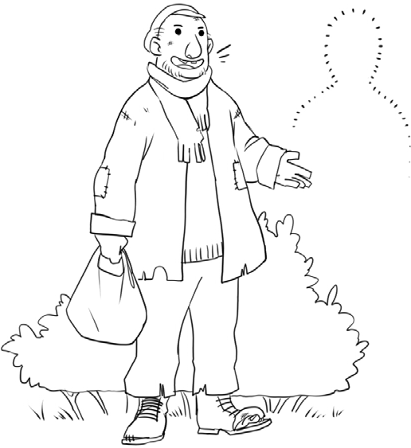
Old George owns a large fertile farm in the heart of
Tipperary. To be precise, he owns exactly one hundred and
twenty eight hectares, so he is quite a wealthy man. However, he doesn’t farm any of this land. Instead he rents it out to
neighbouring farmers and he also rents out his slatted cattle sheds and his hay sheds.
The only thing he has retained for his own use is his house.
It is a large imposing three storey period house, with a long

avenue lined with copper beech trees, leading up to it. It has
impressively long rectangular windows, granite window sills and granite steps leading up to its magnificent front door.
The strange thing is, the only part of the house which Old George sometimes uses is the back kitchen and the downstairs
toilet. Yes, you read it correctly, he only sometimes uses the back kitchen! Stranger still, is the fact that Old George doesn’t sleep
in his big beautiful stately house at all.
His parents died thirty three years ago in a horrific car crash, and George hasn’t slept in his house since that terrible night.
Instead, he sleeps in secluded hedgerows and quiet sheltered woodlands and even in open grassy meadows.
Almost everyone knows Old George and most people now
fondly accept him as he is. Whenever anyone talks of him, it is usually in a gentle, pitying kind of way, often adding that he is a harmless, friendly old devil.
The neighbours are very good to him and maintain a vigilant, protective eye on him. They wash and mend his clothes and
make out a weekly rota for giving him some dinner. By doing this, they know that he gets at least one solid meal each day. They reckon it is the Christian thing to do.
Whenever they meet him tramping the roads, they usually go out of their way to say hello and most parents won’t allow
their children to slag or jeer him. When the children ask why Old George doesn’t sleep in his own big house, they mostly shrug
their shoulders and utter, “That’s just the way Old George is.” When walking his familiar roads, George can often be heard

talking to himself and people don’t really know what he is
saying; however, when talking to one of his good neighbours, he always articulates his sentences in clear and understandable diction.
He talks a lot about the weather and the crops and the cattle in the fields. He talks about the local football and hurling teams and goes to most of the matches which are played at home.
Occasionally he abuses the referees, but they mostly ignore him.
He knows the names of all the players and shakes hands with many of them after each game. They all courteously oblige.
He especially likes talking about his dead parents and talks about them as if they are still alive.
When George first started sleeping out in the open air, people in the parish were deeply concerned. Initially, the priest and the local doctor tried to convince him to start sleeping back in his
own house. They told him that this sleeping rough wasn’t good
for his health, but George merely asked everyone to please leave him alone.
And eventually that is what people did. They left him to his
own ways and fashion. Today, almost everyone takes Old George for granted and accepts him just as he is.
Now I firmly believe that every place, every locality, has its own Old George, and if you should ever see Old George
wandering your streets and roads, your highways and byways, please be kind to him and do say hello.

Questions

- What does Old George own?
- Describe Old George’s house.
- How long ago was it since his parents died?
- Where does Old George now sleep?
- What does Old George like talking about?
- Who tried to convince Old George to go back sleeping in his own house?
- If you see old George wandering the streets and roads, what are you asked to do?
- Draw or write a description of Old George from information in the story.

Listening and Speaking

- Why do you think Old George will not sleep in his own house?
- Do you know anyone like Old George? If you do, describe him/her.
- What causes people to become homeless?
- Can you name any organisations which help homeless people?

Vocabulary from the story

- Old George owns a large fertile farm
- To be precise
- He owns one hundred and twenty eight hectares
- He rents it out to neighbouring farmers
- Slatted cattle sheds and hay sheds
- The only thing he has retained
- It is a large imposing three storey period house
- A long avenue lined with copper beech trees
- It has impressively long rectangular windows
- Granite window sills and granite steps
- A big beautiful stately house
- He sleeps in secluded hedgerows and quiet sheltered woodlands
- Grassy meadows
- Most people now fondly accept him just as he is
- They speak of him in a pitying kind of way
- The neighbours maintain a vigilant, protective eye on him
- They make out a weekly rota for giving him some dinner
- They reckon it is the Christian thing to do
- Tramping the roads
- He articulates his sentences in clear and understandable diction
- He talks about the crops and the cattle in the fields
- Occasionally he abuses the referees, but they mostly ignore him

- They all courteously oblige
- People in the parish were deeply concerned
- Initially, people tried to convince him to .....
- Eventually they left him to his own ways and fashion
- Today almost everyone takes Old George for granted
- Wandering the highways and byways

Poetry – Jimmy Miller

I knew a man called Jimmy Miller A man with curly hair,
He’d beg for a bob And was ready to rob,
But seldom, if ever he’d sob. Of life and people
He knew quite a lot, And a word of kindness He would always spot. He’d pee in his pants
When in a drunken stance, He’d nothing to lose,
But was living for booze.

Questions

- Describe Jimmy Miller
- What was Jimmy Miller living for?
- When Jimmy was drunk, what did he sometimes do?

- Explain the line, “Seldom, if ever he’d sob”.
- Do you think Jimmy Miller was a stupid man? Explain your answer.
- The poet says he knew a man called Jimmy Miller, which is in the past tense. What do you think happened to Jimmy Miller?
- Did you like this poem? Give a reason why / why not?

Writing

Write a story about a homeless peson.
Give him or her, a name and say why he / she became homeless. Describe his or hers appearance.
Describe his or her clothes.
Say where he / she sleeps and what they do all day. Say who helps them and how they help them.

Focus on The Magic “e”

Choose the correct word to fill in the gaps and then write the sentences into
your copy.

- mad or made I got ____ when I ____ a mess of my project.
- rid or ride I want to get ____ of my bike. I don’t want to
____ it.
- quit or quite I am ____ sure I want to ____ the running club.
- Tim or time ____ is never on ____.

- not or note I do ____ have a musical ____ in my head.
- tub or tube I dipped the ____ into the water ____ to see
where the puncture might be.
- cub or cube The lion ____ would not eat the food ____.
- bit or bite I took a ____ of the apple tart, but I only ate a
____ of it.
- cut or cute The ____ little puppy ____ his paw.
- can or cane I ____ walk without the help of a ____.
- hop or hope I ____ I can ____ to the shop on my bad leg.
- pin or pine I stuck a ____ in the tree.
- tap or tape I fixed the broken ____ with a piece of black___.
- rob or robe The thief tried to ____ the _____ belonging to
the king.
- sit or site I am going to ____ down and enjoy the fine ___.
- fin or fine The shark has a _.
- lick or like I do not ____ it when people ____ their plates.
- win or wine I hope I ____ the _.
- twin or twine The ____ got some ____ to tie up the parcel.
- man or mane The ____ stroked the horse’s _.

Dictionary Work

Explain each of the following words Anecdote

  - corrupt… (corruption)
  - agitated
  - telescope
  - amphibian
  - devour
- insurance……(insure)
- compensation
- greengrocer
- sniggering

Scaffolding - A homeless person tells his / her story.

The word empathy means trying to imagine yourself in somebody’s else’s situation – trying to walk in their shoes. It means trying to see the world through their eyes. It means trying to feel what they feel and think what they think. Imagination and sympathy is required. Imagine what it must be like to be homeless.

Paragraph 1 – A general introduction. State your name, your age, how long you have been homeless and say how you ended up sleeping on the streets. A little bit about your background and what caused you to be homeless.

Paragraph 2 – Where do you sleep? Describe the locations. Write about the bitter cold, and the long wet dreary nights. Write about trying to keep your sleeping bag dry, and about how you use cardboard boxes. Say where you

get the cardboard boxes. Write about trying to keep your few possessions safe.

Paragraph 3 - Write about your fears – your fear of being attacked or robbed. Write / describe the filthy looks you get - on a daily basis, and the verbal abuse. What names are you called? Describe some of the aggressive people you meet and the fights! Talk about people crossing to the other side of the street to avoid meeting you.

Paragraph 4 – Write about your daily routine. What time do you wake up at? How do you wash your teeth? Where can you go to the toilet? How do you get breakfast? Do you ever go without food? Where do you wash your hair? How do you wash your clothes? How do you get money? Write about the Gardaí moving you on. How do you pass the time? Do you get bored? Where do you get dinner? Do you have any ailments? What doctor can you go to? What hospital can you go to?

Paragraph 5 – Write about the people you meet. Who do you hang around with? Describe them. Are any of them alcoholics or drug addicts? How do they feed their habit? Are any of them suffering from mental illness? What strange things do they say or do? Write about the people who are kind to you? In what ways are they kind? Do they talk to you? Do they buy you a cup of tea or soup? Have any of your friends died? Say how they died.

Paragraph 6 – Talk about your hopes for the future. Where could you get sheltered accommodation? Who might help you? Maybe the Simon Community, maybe Focus Point. Talk about your family. Do you have any children? Were you ever married? Do / did you ever see any of them?

Were you embarrassed? Do you think you will end up dying on the streets? Describe your feelings as you pound the streets. How could we or the government better help you?

Please read over everything you have written, and check that you put in all the full stops and capital letters. Also try to enrich and improve your vocabulary.

Newgrange

Unit 19

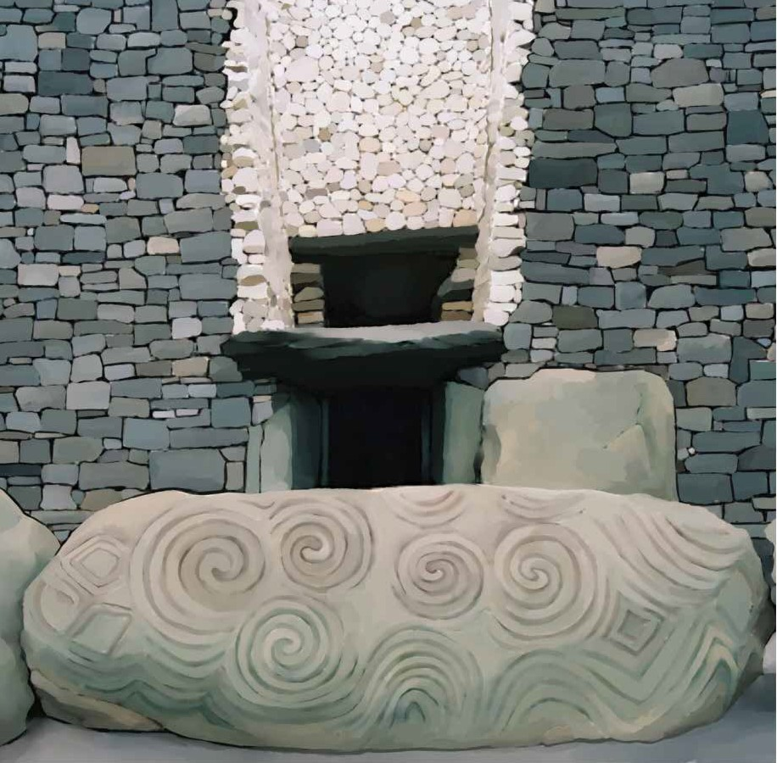
Our history teacher courageously decided to bring our rowdy class to Newgrange, in County Meath. Miss Duffy is her name
and she came to our school over thirty years ago from Ardee in County Louth. She promised that if we behaved ourselves

throughout the year, then maybe, just maybe, she’d bring us to Newgrange.
It was a lot to ask, considering we’re such an unruly bunch, but she did keep her promise, and went ahead and organised the trip, even if a little reluctantly.
She has become quite an expert on Newgrange, because
over the years, she has taken many school groups to visit it, and throughout the course of four or five classes, we learned loads of information about it.
She told us that Newgrange is a prehistoric megalithic
monument, that it was probably a passage tomb, and is located
outside Drogheda, about one kilometre north of the River Boyne.
She told us that it is over five thousand years old, in fact older than the Pyramids in Egypt, and insisted that nobody really
knows exactly why it was built. Some say it was a place for
burying the dead, because bones were found in it, others think it was more like an ancient temple.
Miss Duffy explained that megalithic means big stones, and informed us that Newgrange was ingeniously constructed from
enormous gigantic stones, by Stone Age people. She added that it took them over a hundred years to build, and that the small white shiny stones which adorn it, came all the way from the Sugarloaf Mountain in Wicklow and, the huge round granite boulders,
around the circumference, came from Dundalk Bay.
She reckoned the Stone Age people probably transported
the huge stones on boats, along the coast, and then up the River Boyne – there were no lorries back then.

“Maybe I’m right, maybe I’m not,” she said, “ But that’s the way I imagine it, and there is no evidence to suggest that I’m
wrong.”
The journey to Newgrange took about an hour and a half,
and I sat beside Laura Connolly. I sometimes think she is daft, because she does and says daft things, but she can also be great fun. She wears loads and loads of make-up and gives lots of
cheek to the teachers. She often gets into trouble, and frequently seems to get away with it. I know my Ma would kill me if I
spoke to the teachers the way Laura does.
Laura lives with her Mam, because her Dad left them about three years ago. Laura simply said he was a bad man, and
absolutely refuses to talk about him. She never sees him now.
Our bus took us to the Visitor Centre, as we were not allowed to drive directly to the monument itself. Before we descended
from the bus, Miss Duffy begged us to behave. She asked us to be really quiet and to respectfully listen to everything the guide said. She maintained there would be lots of other visitors in
the centre and we were not to be running around like headless chickens.
On the way in, each of us was given a blue coloured sticker. This was for getting on the mini bus which would bring us from the Visitor Centre up to the monument. Our mini bus wouldn’t be leaving for another hour, so Miss Duffy suggested we first
explore the exhibits, and then meet in the restaurant for lunch in half an hour.
The River Boyne flows beside the Visitor Centre, so Laura

and I ventured out to have a look at it. To be quite honest we needed a cigarette, but didn’t want Miss Duffy to see us. We
slowly ambled half way over the bridge and stood there gazing down at the quiet flowing water. It was tranquil and it was
beautiful.
Laura took out her packet of cigarettes, offered me one and took one for herself. We both lit up, and contentedly puffed
away, while watching little swirling pools forming below us.
There were a few adults around, but we passed no heed. We
spoke little. I was thinking how lovely it would be to live out here, in the country, when Nicola Gibbons ruined it all, by
telling us that Miss Duffy wanted us to immediately go to the restaurant.
In the restaurant everything seemed perfectly normal and I
didn’t understand what all the rush and fuss was for. Miss Duffy told us that we could eat our lunch in the restaurant, as long as we bought a few minerals or something. I bought a packet of
crisps and after lunch, I helped Miss Duffy with the tidying up. She appreciated it.
It took two mini buses to bring the whole class from the
visitor centre up to the ancient monument and when we got there I was a bit surprised. It was much bigger than I had anticipated. There were massive rocks around the base of the hill, and all the shiny white stones attached to the front, were glistening in the May sunshine and really looked impressive, and to think it had
been built so long ago!
Our guide gave us an unexpected frosty kind of welcome.

She seemed strict and spoke really fast. She met us in front of
the entrance to the passageway, which was blocked by a massive stone which had been decorated with spiral designs – we had
seen pictures of them on the internet - and we had to climb over that stone to gain entry to the passageway. Above the entrance
was a rectangular opening, sort of like a window, only it wasn’t a window.
The guide informed us that on the shortest day of the year,
the sun shone through that opening, slowly made its way up the 19 metre passageway and flooded the inner chamber (or room) with light. She also told us to mind our heads as we walked up the passageway, as it is very low and narrow. It was like going into an underground tunnel and it was exciting.
There were large stone slabs on either side of the passageway, many of them beautifully decorated with unusual triangular and
rectangular designs. These Stone Age, Neolithic people were really quite gifted!
And we all managed to fit into the room at the end. The guide enthusiastically told us lots of stuff, but I didn’t understand the
half of it, and she definitely spoke way too fast. The bit I do
remember was when she switched off the lights. She did this so we could experience what happens on the shortest day of the
year, which is the 21st December and it was amazing to witness the light slowly creeping up the passage way.
The lights had only been off for ten to twelve seconds when Laura decided to do something seriously stupid. She sneakily
sprayed her aerosol can of deodorant all over the place. We all

heard it, and smelt it, and the lights were rapidly switched back on.
Our guide was really indignant and our teacher was equally indignant, so much so that the veins on her neck became
enlarged, as her face got redder and redder. She said absolutely nothing, but stared hard at us, as the guide sternly lectured us
about Newgrange being a national monument, almost sacred like! Again, she told us how old it was and talked about how
vandals like us could easily destroy it. I felt a little ashamed and embarrassed, but Laura just stood there, brazen as a peacock,
contemptuously chewing her gum.
And incredibly, on the way out I saw Laura take the gooey gum from her mouth and stick it on one of the large stones in
the passage way. I decided it was best to say nothing. She would only call me names.

Questions

- What is Newgrange?
- Where is Newgrange?
- When was it built and how long did it take to build it?
- What river flows beside Newgrange?
- What kind of designs were on the stone at the entrance?
- What is the shortest day of the year?
- Explain what happens in Newgrange on the shortest day of the year?
- What did Laura do inside the monument?
- What is your opinion of Laura’s behaviour?

- Why do you think Laura behaved as she did?
- Draw or describe one of the images which you can see in the story.

Listening and Speaking

- Have you ever been to Newgrange? Tell what you remember about your trip.
- Why do you think Newgrange was built?
- Study pictures of Newgrange and pick out three or four aspects
which you find interesting. Say why you find them interesting.

Vocabulary from the story

- Our history teacher courageously decided to
- It was a lot to ask, considering we’re such an unruly bunch
- She did organise the trip, even if a little reluctantly!
- She has become quite an expert on Newgrange
- A prehistoric monument
- A megalithic monument
- Older than the Pyramids in Egypt
- It’s more like an ancient temple
- Newgrange is ingeniously constructed from enormous gigantic stones
- Stone Age people – Neolithic people
- The small white shiny stones which adorn it came from Wicklow
- The huge round granite boulders around the circumference came from Dundalk Bay

- There is no evidence to suggest I’m wrong
- I sometimes think she is daft
- The bus took us to the Visitor Centre
- Before we descended from the bus, Miss Duffy begged us to behave
- She asked us to respectfully listen to the guide
- She told us not to be running around like headless chickens
- She suggested we explore the exhibits
- We ventured out to have a look
- We slowly ambled half way over the bridge
- It was tranquil and it was beautiful
- It was much bigger than I had anticipated
- Our guide gave us an unexpected frosty welcome
- A massive stone, decorated with spiral designs, blocked entry to the ..
- A rectangular opening above the passageway
- The inner chamber
- She sprayed her aerosol can of deodorant
- Our teacher was equally indignant
- The guide sternly lectured us
- It was a national monument
- Almost sacred
- Vandals – vandalism
- Laura just stood there, brazen as a peacock
- Contemptuously chewing her gum
- Incredibly

Recommended Poems

Nooligan, by Roger McGough

Focus on - Compound Words

A compound word is made up of smaller words. Match a word from Box A to a word in Box B to make a compound word. Write them into your copy. Box A
break
brief
earth
lumber back moon hair
butter grand
arm water wall night
table door bread
home straw hedge

Box B
case
cup cloth bell
light jack
crumb time
chair ground father worm
paper
brush
hog proof work
berry fast

Dictionary Work

Explain each of the following words and write them in sentences which clearly show their meanings.

  - sarcastic
  - baffled
  - independent
  - dependent
  - architect
  - architecture
  - confidential
  - positive - negative
  - decade
  - satellite

Writing

Write your own story about a trip to a historical site.
Name the site and say why it is important.
Say who you went with and who organised the trip. Say how you got to the historical site.
Describe what you saw and what happened.
State if you enjoyed the trip, and write about the highlights of the trip and the worst thing about the trip.

Scaffolding - A school trip, tour or adventure

Paragraph 1 – Where did you go to on this trip / tour? Was it a geography trip or a history trip, or a P.E. trip? Was it an educational tour or a fun tour or both? Was it somewhere in Ireland or did you go abroad? What teacher or teachers organised the trip? Did it cost much money? How many students went on the trip? What did you have to bring with you on the trip / tour?

Paragraph 2 – The morning of the trip / tour! At what time did you get up at? Were you excited or nervous or anxious? Did you have a hearty
breakfast? How did you get to school? At what time did the bus leave? Who were you sitting beside? Was everyone tired and grumpy or ecstatic and delighted?

Paragraph 3 – Your first stop! Where did you first stop and was it interesting? Tell what you saw and what happened. Have you any memorable tales or funny incidents? Continue on with your journey and tell us where else you went – what you remember – what you learned – what you enjoyed – what happened?

Paragraph 4 – Highlights of the journey. Write down three or four things which were really brilliant! Who did you have the most fun with? Give the names and explain everything. What were the teachers like? Did you get on well together? Where did you get your lunch?

Paragraph 5 – Did anything bad happen on this trip / tour? Tell the story. Did the bad incident have a happy ending or a sad ending? Write down at what time you arrived home - tired and exhausted? Say if you would like to go on the same trip / tour again. What did you learn? And finally say
if you had the best day of your life, or if it was one of the most horrible experiences of your life?

Please read over everything you have written, and check that you put in all the full stops and capital letters. Also try to enrich and improve your vocabulary.

The Snow Fight

Unit 20

Monday morning.
School again. I totally hate Monday mornings!
I tried to rub the
sleep from my eyes and reluctantly lifted myself out of bed. Slowly, I
pulled open the curtains and, to my absolute
amazement, everything was covered in a thick white blanket of snow.
“Yippee! Yippee!” I squealed, like a delighted pig, “This day might not be too bad after all!”
I rapidly pulled on my school uniform, rushed down the stairs and as I grabbed my school bag from the corner of the kitchen,
Mum shouted at me to get some breakfast. I replied I hadn’t
time, snatched three chocolate biscuits from the cookie jar and raced out. I was in such a hurry that I forgot to bring my coat. I was simply too excited.
There was at least ten centimetres of snow on the ground and I couldn’t wait to get to school - to start throwing snowballs.
As soon as I turned the corner into the schoolyard, I noted
the chaos and the bedlam. Some of the first years were building

a magnificent snowman in the bottom half of the yard and I only had a glance of it when a snowball whizzed over my head. It was Spud Murphy.
“Right,” I thought to myself, “Let the fun commence.” For
the next twenty five minutes, I pelted anyone and everyone with snowballs. My hands became raw red and my shoes and trousers got wet, but I didn’t care. We were having the best fun of our
lives. I noticed the Principal watching us through the window;
however, he didn’t call us in until long after the bell went. I was tempted to bring in a snowball, but I figured that might be going too far.
During the first three classes, the snow continued to fall
heavily and we found it difficult to concentrate. And as soon as
the bell for the eleven o’clock break went, it was straight back to the snow fights and the fun.
Mr. O’ Sullivan was on yard duty. He is one of the nice
teachers and is good crack. Declan hit him with a smacker of a snowball and the speed at which he retaliated was amazing.
Again the snowballs went flying in every direction. A couple of the first years were lying flat out and making angels.
The bell signalling the end of break sounded all too quickly and we animatedly trudged back inside. However before I
entered, I scooped up one last handful of snow, quickly formed it into a ball and let it fly at Karl. Bull’s eye! I got him straight in
the face. He wasn’t expecting it.
He instinctively covered his face with his hands and from
the way he was reacting, I knew he was hurt. I hadn’t meant to

do that. After all, Karl is one of my best friends. He is a big,
powerful fellow, built like a ship, not the type to pretend. I ran over to apologise and asked if he was all right. He stammered back, “No, no, my eye hurts, it’s stinging like hell.”
A large group gathered, but Mr. O’ Sullivan ordered us back
to our classes. He took Karl to his office and must have called an ambulance, because I could hear the “Ne-Na, Ne-Na” from my
classroom. Time went slowly. Nobody could tell me anything.
I went to the Principal and told him it was my fault. He was kind and tried to console me, saying it was an accident and if he had any news, he would let me know. He sent me back to class. At lunchtime, I walked home with a very heavy heart.
I didn’t go back in the afternoon, I hadn’t the courage; rather I stayed up in my bedroom, ashamed of myself, hiding. I didn’t even knock round to Karl’s gaff to enquire how he was. Time
moved at an agonisingly slow pace.
That night after eleven o’ clock, the Principal unexpectedly phoned. Karl had been moved from the local hospital to the Eye and Ear Hospital, and it was bad news. The optic nerve of his
left eye was seriously damaged and he would definitely have a visual impairment and, might even lose his sight in that eye.

Questions

- Why do you think the author had no time for breakfast?
- Why is it important to start the day with a good breakfast?
- What did the student take with him for his breakfast?
- How much snow was on the ground?
- What were some of the first years building in the school yard?
- Describe the snow fights in the yard.
- Explain the word chaos.
- What happened to Karl?
- Do you agree that it was an accident?
- Were you surprised by the ending in this story? Explain.
- Draw or describe one of the images which you can see in the story.

Listening and Speaking

- Were you ever involved in a serious accident? Describe it.
- What do you have for breakfast most mornings?

Recommended Poems
Jack Frost, by Cecily Pike

Vocabulary from the story

- I tried to rub the sleep from my eyes
- I reluctantly lifted myself out of bed
- I squealed like a delighted pig
- The cookie jar
- I noted the chaos and the bedlam
- Let the fun commence
- My hands were raw red
- Mr. O’ Sullivan was on yard duty – he is good crack
- The speed at which he retaliated was amazing
- We animatedly trudged back inside
- Bull’s eye – I got him straight in the face
- He instinctively covered his face with his hands
- He stammered back his reply
- The Principal was kind and tried to console me
- I walked home with a very heavy heart
- I didn’t even knock round to Karl’s gaff to enquire how he was
- Time moved at an agonisingly slow pace
- The optic nerve
- A visual impairment

Focus on - Verbs

Write the following verbs in sentences. They are all in the story.
- squealed
- rushed
- grabbed
- shouted
- replied
- snatched
- raced
- whizzed
- pelted
- tempted
- figured
- signalled
- trudged
- entered
- scooped
- reacted
- stammered
- ordered
- ashamed

Dictionary Work

Explain each of the following words and write them in sentences which clearly show their meanings.

  - gallant
  - cynical
  - perplexed
  - century
  - millennium
  - government
  - negative
  - convenient
  - interior
  - exterior

Writing

- Write a story about, “Our Adventures in the Snow”.
- Or write a story about “The Snow Storm”.

Scaffolding - Our Adventures in the snow

Paragraph 1 – Describe the snowstorm. You woke up, pulled back the curtains and it was snowing heavily. Write about how you felt – excited and delighted…. Write about getting dressed really quickly, dashing down the stairs and racing out the front door. Write about your mother or father shouting / calling after you…….

Paragraph 2 – Describe your journey to school – in the snow. Who did you meet up with? What did you do? Describe how the cars were slipping and sliding all over the place. Describe the accidents you witnessed….

Paragraph 3 – Describe the scene as you entered the school yard. What were most of the students doing? Was anyone making snow angels? What was the Principal trying to do? What did you do? Was school cancelled for the day?

Paragraph 4 – Talk about the fun you had…… building the snowman. What size was it? Who helped you build the snow man? Where did you build the snowman? What name did you call it? Who did you get the scarf and the hat from? What did you use for the eyes and the nose?

Paragraph 5 – This paragraph is about your adventures going tobogganing
– sliding down a steep hill at speed on a sack. Where was that steep hill? Talk about the fun and the cold air crashing into your face, and write about the crashes, and write about the tragedy – the broken bones or the broken neck and the ambulance rushing to the hospital….

Paragraph 6 – Write about your sadness that night, as you watched the heavy rain sweeping in across the country and melting the snow. Finally write about collapsing into bed, utterly exhausted after an amazing enjoyable day!

Please read over everything you have written, and check that you put in all the full stops and capital letters. Also try to enrich and improve your vocabulary.

My First Kiss

Unit 21

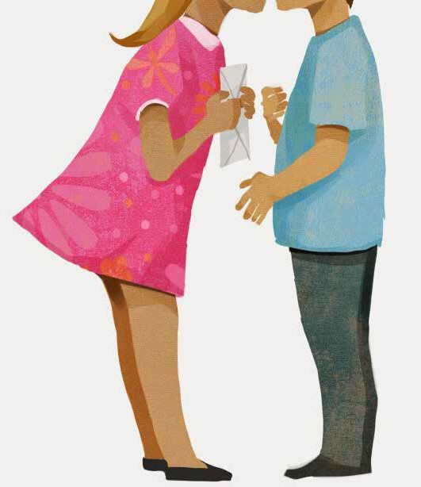

Football was, and still is my first love. I always have a
football close at hand; in the kitchen, in the hall, in the living
room and of course the back garden. Mum gives out and roars at me, “No kicking football inside the house.” I mostly ignore her and keep practising.
One day soon I will be picked for the national team, I can see it. My skills are improving. “PRACTICE MAKES PERFECT”.
That’s what our English teacher says. I know he is talking about practising our reading and writing, but the same motto applies to improving my football.
Football was the most important thing in my life until I met Emma. She came into our school, and into my life, in the middle
of 6th class (in primary school) and it was absolutely love at first sight. I was completely smitten.
The Principal brought her into our room and introduced her. I can still conjure up a mental picture of her on that first day. She had soft long hair which fell about her shoulders and beautiful
blue eyes. She was slender, she was pretty and she was gorgeous.
Unbelievably, Emma was asked to sit beside me, as my mate Jimmy Farrell was absent. I willingly and rapidly tidied up the books on the desk to make room for her and, as she sat down, I felt an overwhelming sense of something. I had never felt like
this before. It was an unfamiliar and lovely feeling.
And for the next few months the teacher actually left Emma sitting beside me. The other guys in the class started to slag, but
I didn’t mind, because I was sitting beside the most beautiful girl in the whole world. We chatted and became friends.

Normally, I hate school and couldn’t wait to be finished
6th class, but now it was different, and each day I went to that school with a great big smile on my face.
More and more, I started to dream about Emma and less and less about football. She invited me to her birthday party on the
14th of June. She would be twelve years old. Most of the girls in the class were going, and even though I was the only boy, I was still delighted with myself.
Before I went I had a long leisurely shower, then put lots of deodorant under my arms and used a fragrant gel to spike up my hair. I smelt better than a fresh bunch of freesias!
I was the first to arrive at the party, and Emma herself
answered the door. To me she looked like an angel. She smiled one of her beautiful smiles and I instinctively felt like kissing her, but alas, I lacked the courage. I gave her the book voucher which Mum had bought and then it happened! She swiftly put her lips to mine and, gave me a big juicy kiss. It was simply
heavenly.
It was wet and gummy, but sort of tasty, and I didn’t exactly know what to do. After all, it was the first time I had ever kissed a girl, but with a little practise I figured I could get used to it.
And just as I was reaching over to return the kiss, Emma’s mother walked into the hall and saw us. The look on her face
said it all. She got the shock of her life and so did I. She shouted something rather abusive at me, speedily re-opened the door and unceremoniously pushed me out.
I was really embarrassed and, for a moment or two, just stood

there, feeling like an idiot, looking at the closed door. I finally turned and bolted home, hoping to save whatever little dignity I had left.
The following Monday, Emma was moved to a new table and would barely look at me. You’d think I had leprosy or measles or both!
We never did speak about what happened and the following September, she went to an all girls’ school. She is now in
Transition Year and I am told she is going out with some big sturdy fellow from a rugby school.
Football is again my first love and I might yet be picked for the national team. My skills have definitely improved and, I am certainly having a lot more luck with football than with girls.
However, I will always remember my first passionate kiss with Emma.

Questions

- What was the most important thing in the author’s life until he met Emma?
- Write a description of Emma.
- When was Emma’s birthday party?
- What did the author do, before going to Emma’s birthday party?
- What had Mum bought for Emma’s party?
- Who pushed the author out of the house?
- Why do you think she pushed him out of the house?

- On the following Monday, why do you think Emma would barely look at the boy she had kissed ?
- What team does the author hope to be picked for?

Listening and Speaking

- Do you remember your first kiss? Do you want to talk about it?
- Discuss your perfect date.
- Name a romantic film which you love watching. Tell the story.

Recommended Poetry

Goodbye, by Carol-Anne Marsh

Vocabulary from the story

- I always have a football close at hand
- I mostly ignore her
- I will be picked for the national team
- Practise makes perfect
- The same motto applies to improving my football
- I was completely smitten
- I can still conjure up a mental picture of her
- She was slender, she was pretty

- I felt an overwhelming sense of something
- It was an unfamiliar and lovely feeling
- The other guys started to slag
- I had a long leisurely shower
- Deodorant
- I used a fragrant gel to spike up my hair
- I smelt better than a fresh bunch of freesias
- I instinctively felt like kissing her
- But alas, I lacked the courage
- A book voucher
- She shouted something abusive at me
- And unceremoniously pushed me out the door
- I just stood there, feeling like an idiot
- I bolted home, hoping to save whatever little dignity I had left
- You’d think I had leprosy or measles or both
- She is now in Transition Year
- She is going out with some big sturdy fellow from a rugby school

Focus on - Feelings

Write the following sentences into your copy and complete them.
- I feel happy when………..
- I feel sad when ……….
- I feel worried when ……….
- I feel lonely when ……….

- I feel angry when ……….
- I feel hurt when ……….
- I feel excited when ……….
- I feel famished when ……….
- I feel frustrated when ……….
- I feel exhausted when ……….
- I feel jealous when ……….
- I feel satisfied when ……….
- I feel depressed when ……….
- I feel joyful when ……….
- I feel anxious when ……….
- I feel proud when ……….
- I feel miserable when ……….
- I feel furious when ……….
- I feel tired when ……….
- I feel annoyed when ……….

Dictionary Work

Explain each of the following words.
- spiteful
- pensive
- principal
- principle
- prejudice

- discrimination
- construction
- destruction
- therapy
- aromatherapy

Writing

- Describe a romantic film you have seen.
- Describe:
  - the characters,
  - the setting,
  - the plot,
  - the ending.
- Write a story with the title, “It was love at first sight”.
- Make and post a Valentine card.

Scaffolding - It was love at first sight.

Paragraph 1 – Describe the setting – where you were. Were you at a party? Whose party was it? Where was the party? Who were you with? What gifts did you bring? Was the music good? Were Ma and Dad at this party? Describe the atmosphere, the decorations, the fun, the banter, the food, the dancing, and the singing. Or maybe you were in school when you first fell in love?

Paragraph 2 – Then the love of your life walked in! You were smitten from the first second you set eyes on him or her. Such beautiful eyes – what colour? And he/she was smiling over directly at you. Describe how handsome/beautiful he/she was. Describe their height, the colour of their hair, their clothes and that radiant face. Describe your feelings – maybe

mention feeling wobbly at your knees and having butterflies in your tummy!
Was he or she standing all alone or in company?

Paragraph 3 – You go over and introduce yourself. What do you say? How does he/she reply? You talk a little – what do you talk about? Then you ask him / her to dance. What are the things which you have in common? You ask him/her out on a date.

Paragraph 4 – Your first date! Where do you take him / her? - To the cinema? - To a restaurant? - For a walk by the canal? Was it romantic or did you have a big fight? How did you get on? Maybe you never want to see him or her again?

Paragraph 5 – Being friends. Are you still friends? Are you still in love? Do you send each other texts? Will you send each other a valentine card? What makes a good friend? Are you too young to be dating? What would your ideal boyfriend or girlfriend be like?

Please read over everything you have written, and check that you put in all the full stops and capital letters. Also try to enrich and improve your vocabulary.

The Wheelchair

Unit 22

Everything was ready: the wheelchair, the balaclavas, and the fake gun.
Colm had lost his job. He had worked in the shoe factory for the last thirty two years, was always punctual and seldom
missed a day. His boss regularly praised him, saying, “If all my
employees were as diligent as you, this factory would never have to close.”
He desperately searched everywhere for new employment. The answer was always the same. At fifty two years of age, he was too old.
Times were hard. Money was in short supply. Trying to pay for the gas, the electricity and the weekly shopping had become extremely difficult.
The children were going back to school in two weeks time.
There were uniforms and books to be bought. The Social Welfare people gave them some money for these, back in May, but it had all been spent on food and rent. It hadn’t been wasted. Colm and his wife Margaret were careful with their money. They didn’t
drink or smoke. Bit by bit, the money trickled away.
They left the wheelchair concealed in the laneway beside the bank. It was a typically quiet Monday morning. Little George
was to keep an eye on the chair. He was eight years old and only about a metre high. He was a good boy and always did what he was told. Colm and Margaret had a careful look around before

putting on the balaclavas. No one saw them. They appeared calm as they walked round the corner and into the bank. Margaret
stayed by the door and surveyed everyone. Colm casually walked over to the counter.
“Money, now, please,” he demanded from the cashier in a
low, semi-disguised voice. He had always been polite and didn’t shout or scream, as he pointed the fake gun at the girl and passed her the canvas bag.
The girl saw them coming into the bank and had pressed the alarm button, which was hidden under the counter. This would alert Garda stations for miles around. She had been trained
to deal with situations like this. However, she now started to
tremble as she nervously opened the drawer with the money. It
contained bundles of ten Euro notes, twenty Euro notes and fifty Euro notes.
“Empty it all into the bag,” ordered Colm.
The manager, who had been sitting at his desk, watching the situation develop, sternly directed the girl to fill the bag.
In total, the robbery took only about thirty seconds. There were two or three other customers in the bank, but the job was
concluded so fast, they hardly knew what was happening. Colm grabbed the bulging bag, ordered everyone to get down on the
floor, then briskly walked out, and was followed by Margaret. Each of them glanced up and down the quiet street. No one had noticed them.
At the corner, they pulled off their balaclavas. George had the wheelchair ready and Colm hopped into it, and spread a

woollen blanket over his legs. He shoved the canvas bag under the blanket, but kept a tight grip on it.
Margaret pushed the chair round the corner and up the main street, as little George held onto the side of the chair. A police car with its siren roaring, raced past. At the top of the town,
another police car was setting up a roadblock. Colm, Margaret
and George smiled over at the busy policemen as they walked by. Their get-away car was parked in a quiet by-road on the outskirts of the town.

Questions

- What had Colm worked at and what age was he?
- What did Colm and Margaret spend their money on?
- Who had given them money for school uniforms and school books?
- How were Colm and Margaret going to get more money?
- Why did they wear balaclavas?
- When Colm and Margaret entered the bank, what did the girl do?
- How did Colm, Margaret and George escape?
- Do you think it was a good escape plan? Give reasons.
- Apart from robbing a bank, what else could Colm and Margaret have done to get money?
- Draw or describe one image which you can see in the above story.

Listening and speaking

- What kind of things do you spend your money on?
- How much money do you spend every week?
- Where do you get your money from?
- Did you ever witness a robbery? Tell the class what you saw.

Vocabulary from the story

- Balaclavas
- The fake gun
- He was always punctual and seldom missed a day
- “If all my employees were as diligent as you, this factory would never have to close.”
- An employer – an employee
- He desperately searched everywhere for new employment
- Money was in short supply and bit by bit it trickled away
- The Social Welfare people gave them some money
- They left the wheelchair concealed in the laneway beside the bank
- It was a typically quiet Monday morning
- Margaret stayed by the door and surveyed everyone
- Colm casually walked over to the counter
- “Money now, please,” he demanded from the cashier in a low, semi-dis- guised voice

- He had always been polite
- He passed her the canvas bag
- She pressed the alarm button which would alert the Garda stations
- The manager sternly directed the girl to fill the bag
- The job was concluded so fast they hardly knew what was happening
- To conclude – the conclusion
- They briskly walked out
- He spread a woollen blanket over his legs
- A police car with its siren roaring, raced past
- Their get-away car was parked in a quiet lay-by on the outskirts of the town

Focus on - Contractions

Contractions are when you shorten two words into one word. When you combine two words into one word, you put in an apostrophe where you omit (leave out) a letter or letters, e.g. is not = isn’t.Write the following words into your copy and change them into a contraction.

- Was not =
- Does not =
- Has not =
- Cannot =
- We are =
- Must not =
- I will =
- You have =
- She is =
- Would not =
- What is =
- Who is =

- She would =
- We would =
- I would =
- I am =
- It will =
- That is =
- Had not =
- There will =
- Could not =
- Did not =
- Do not =
- It is =

Dictionary Work

Explain each of the following words and write them in sentences which clearly show their meanings.

  - democracy
  - dictatorship
  - census
  - hostile
  - illegible
  - illegal
  - litre
  - millilitre
  - accessories
  - guarantee

Writing

Write a story about a robbery.

Scaffolding - Write a story about a robbery.

Paragraph 1 – The setting – who or what is going to be robbed and where? Are you going to be actively involved or are you going to be a witness?
At what time is the robbery going to happen? Will it be dark or will it be daylight? Will the location be quiet or will it be busy? Will the robbery happen inside a building or outside?

Paragraph 2 – Give your reasons for getting involved in this robbery or for being in this particular location, at this particular time? Are you short of money or are you a career thief? Do you feel scared, or worried or anxious
or are you easy going about it all? Have you a young family to care for, with a high mortgage and little income? How did you first get involved in this career? Have you been thinking about doing this job for a long time?

Paragraph 3 – Planning for this robbery? Why this particular robbery and why now? Who is going to help you? How are they going to help you? Can you trust them? Will you have real guns or pretend guns or knives? Will you use them if you have to? How will you overcome the security people and the cameras? How will you make your getaway? Have you a contingency plan in case something goes wrong? What is that plan?

Paragraph 4 – The actual robbery – did it all go to plan? Did you scream and shout? Were people scared? Did anyone get hurt? Did you make people lie face down on the ground? Did you tie anyone up? Did anyone have a

heart attack? Did you hit anyone? Were you violent? Did you get much money? What did you put the money into?

Paragraph 5 – The aftermath – was it worth it all? Was it a successful or unsuccessful robbery? Is your story going to have a happy or a sad ending? Did you make a successful getaway? Did you get caught by the Gardaí or did you escape? Did anyone get hurt or injured? Would you do the same again? Any regrets?

Please read over everything you have written, and check that you put in all the full stops and capital letters. Also try to enrich and improve your vocabulary.

Unit 23

Our Maths Teacher

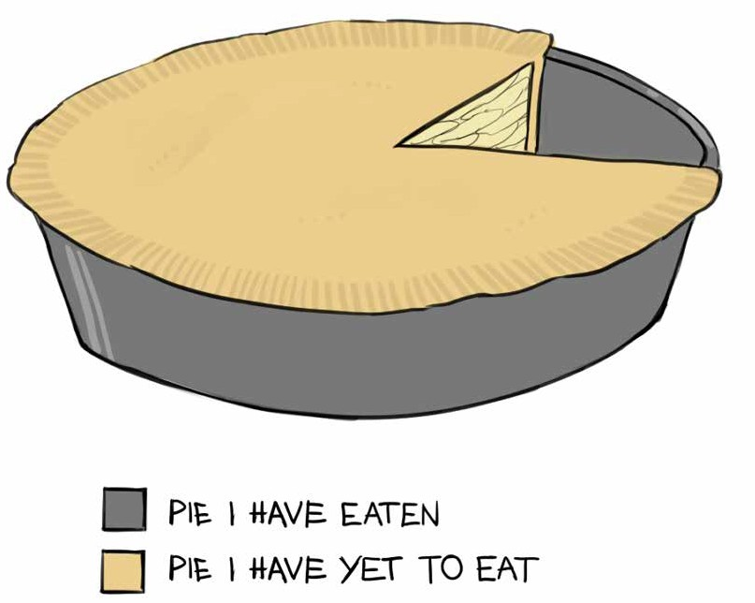
Our Maths teacher was simply the best. He made us do the work, but we also had the fun. I learned so much in his class.
I used to hate doing maths, but all that changed when we
got Mr. Sweeney. He was always impeccably dressed and wore dapper fancy jackets. He had a choice of six jackets, we counted them. His shoes were so polished you could almost see your
face in the shine. Best of all, he was a good humoured, cheerful young man.

I used to find it difficult to say the word perimeter, never mind understand what it meant. Now it’s a word I’ll never
forget, all on account of the way Mr. Sweeney taught it to us. A
perimeter is the outside of an area, the sides, or the edges. Where there was a perimeter in our school, we carefully measured it.
Each student in the class had to measure the perimeter of his desk. We measured all the sides and added them together.
We then proceeded to measure the perimeter of the room, of the corridor, of the yard and of the fence around the school.
He took us to the local G.A.A. pitch and we measured its
perimeter. He took us to the school soccer pitch and he made us measure its perimeter. Then we compared sizes, so we could find which pitch had the bigger perimeter.
Our curious Principal often observed our class wandering
around the school, but once we were with Mr. Sweeney we were well behaved. We would be measuring something, or counting
something or weighing something, or someone! It seems crazy, but we were learning and for whatever reason, we didn’t easily forget what we learned.
One of the funniest things I recall was when we were learning about area. Mr. Sweeney pushed all the chairs and tables back
against the wall, then lay flat on the carpet, and started to crawl all over it, on his belly. As he did so, he kept repeating the word “area”, “area”, “area”, over and over again. This was his way of demonstrating that area was different to perimeter. He informed us that area was the space in the middle, not the distance around the edges. All I could concentrate on was his immaculate clean

white shirt and the dirty chewing gum mashed into the carpet. How could he risk getting it dirty?
And believe it or not, on this occasion, as Mr. Sweeney was sprawled out on the carpet, guess who walked in?
That’s right you’ve guessed it, the Principal! He took a long glaring look at Mr. Sweeney, spoke not a single word, then
turned and banged the door on his way out. I don’t think he approved of Mr. Sweeney’s teaching methods.
Mr. Sweeney found all kinds of ways to teach us. For Venn diagrams and Sets, he borrowed hula hoops from the P.E.
teacher. The chairs and desks were again pushed back and the
hoops put lying across each other. The place where they crossed over, the bits in common to the two or three hoops, he called the intersection.
Next he put numbered skittles standing in the different hoops.
The hoops he called Venn diagrams and the skittles he called elements. Then, as he moved about the different numbered
skittles inside the hoops, and with the aid of the whiteboard, he showed us how to do the sums.
The best part was definitely at the end, because we’d have a competition to see who could keep swinging the hoop on his waist for the longest time, and the winner always got a bar of chocolate.
For learning take away sums, we used a real dart board,
which was hung on the back wall of the room. Mr. Sweeney was really careful about safety, because when someone was throwing a dart, he made us all stand behind a line which he had drawn on

the carpet with a piece of chalk.
For practising multiplying tables, again we played games.
One of them was throwing dice. We used to sit in a circle and
each of us had to throw the dice. Whatever number came up, Mr. Sweeney made us multiply it by another number.
To teach pie charts, Mr. Sweeney actually brought in six
apple pies. He said they were made by his sainted mother. He
drew several pie charts on the board, coloured in different parts or segments, as he called them, and compared them to the apple pies. And to finish that class he cut the apple pies into fractions and shared them out.
For learning how to draw bar charts, we cut cardboard boxes into different heights, and made sure each box was the same
size across the bottom. We then coloured the boxes in different colours and stuck the whole lot onto the wall beside the dart
board. It looked great.
We had the best of fun learning about litres and weight. We went down to the home economics room, got the litre jugs and measured out different amounts of water, milk and orange juice, which we were allowed to drink. We then got the weighing
scales and weighed our lunches, our books, our bags, a bag of sugar, and even Eddie Murphy’s smelly black shoes.
For trying to work out average speed, we got Joey Flynn to cycle around the perimeter of the yard, for exactly half an hour.
Joey didn’t mind because he cycled to school and loved showing us how fast he could go. We measured the distance he travelled, multiplied the answer by two and then knew his speed per hour.

Today, my maths class is but a memory. I am a carpenter and I often have to work out perimeter and area. I have a son aged
eleven. He will be going to secondary school next year and I
hear Mr. Sweeney is now the Principal. I hope he hasn’t changed too much.

Questions

- What was the name of the Maths teacher?
- Describe how he dressed for class?
- List what the students had to measure in order to learn about perimeter.
- Explain how Mr. Sweeney taught the students about area?
- Why do you think the Principal didn’t approve of Mr. Sweeney?
- What did Mr. Sweeney use to teach Venn diagrams and Sets?
- List the other things used by Mr. Sweeney in his teaching of maths?
- Why do you think Mr. Sweeney was made the Principal?
- Draw or describe one of the images which you can see in the above story.

Listening and Speaking

- What makes a good teacher?
- What kind of things could teachers do to help you with your learning?
- What could you do to improve your learning?
- Do you think teaching is an easy job or a difficult job? Explain.

Vocabulary from the story

- He was always impeccably dressed
- He wore dapper fancy jackets
- He was a good humoured, cheerful young man
- Perimeter
- The edges
- We then proceeded to measure.........
- The local G.A.A. pitch – Gaelic Athletic Association
- Area
- I was concerned about his immaculate clean white shirt on the dirty chewing gum which was mashed into the carpet
- This was his way of demonstrating that area was different to perimeter
- He took a long glaring look at Mr. Sweeney
- I don’t think he approved of Mr. Sweeney’s teaching methods
- For teaching Venn Diagrams and Sets he borrowed hula hoops and skittles from the P.E. teacher
- The place where the hoops crossed over each other, the bit in com- mon, he called the intersection
- Next he put the numbered skittles standing in the different hoops
- He called them elements
- And with the aid of the whiteboard, he showed us how to do the sums
- We used a real dart board for learning our take away sums
- We threw dice - for learning our multiplying tables
- To teach pie charts, Mr. Sweeney actually brought in six apple pies

- He cut the apple pies into fractions
- We made bar charts from cardboard boxes
- Litres
- Average speed per hour
- I am now a carpenter and often have to use the maths I learned

Recommended Poetry

Homework! Oh, Homework! by Jack Prelutsky

Dictionary Work

Explain each of the following words.

  - ambivalent
  - metre
  - kilometre
  - constitution
  - referendum

- miscellaneous
- receipt
- security
- insecure
- precious

Writing

Write a description of your school.
Remember, a school is not just made of bricks and mortar!

Start by writing a physical description, and then move on to describing some of your favourite people in the school.
Write about the subjects you love and one subject you dislike. Write about the good and bad in your school.

Focus on - Key Words in Maths

Exercise 1
Match the following key words with their correct meaning and write them into your copy.

- Perimeter
- Area
- Volume
- The sum of
- Subtract
- Divide
- Multiply
- A square
- A rectangle
- A triangle
- An angle
- A protractor
- Has to do with the amount of space or surface. It’s the length, multiplied by the width.
- The total distance around the area of a 2D shape. The sides or outsides.
- To take one number away from another.
- Used for measuring angles.
- The amount of space taken up by a 3D shape, e.g. inside a box or a cyliner
- This is made when two line segments meet at a point ( vertex).
- A shape which has four sides equal in length and four right-angles.
- Means to add all the numbers together.
- A shape made of four sides, with four right- angles and where opposite sides are equal in length and parallel.
- Has three sides and three angles inside it and the sum of these three angles always adds up to 180˚
- Sharing or grouping a number into parts
- When a number is added to itself a number of times.

Exercise 2

Focus on - Key Words in Maths

Match the following words to their correct meaning and write them into your copy.

  - Metre
  - Kilometre
  - Litre
  - Gram
  - Kilogram
  - Percentage
  - V.A.T.
  - Sets
  - Venn diagrams
  - Algebra
  - Statistics
  - Bar charts
    - One thousand metres.
    - One hundred centimetres.
    - A unit used for measuring weight, e.g. meat, sugar, flour.
    - A unit used for measuring liquids, e.g. milk, water, petrol.
    - A well-defined collection of objects.
    - A diagram using circles or other shapes to show the relationship between sets.
    - Value added tax. A government tax added to goods and services.
    - Number out of a hundred.
    - An area of maths where letters ( e.g. x and y ) are used to stand for unknown numbers.
    - The study of information collected as data
    - A diagram used to show data using rectangular bars.
    - A thousand grams.

Scaffolding - My School

Paragraph 1 – Write down the name of your school and say where it is located. Say if you love your school or hate your school.

Paragraph 2 – Write a description of your school. Start with the outside. What material is your school constructed from – bricks or concrete blocks or timber frame or steel and glass? What are the lawns and trees and flowers and shrubs like around your school? Does your school have any football pitches or basketball courts or tennis courts or maybe even a swimming pool?

Paragraph 3 – Describe the inside of your school. Are the corridors wide or narrow? What colours are they painted? What are the classrooms like? Is your school usually cold or lukewarm or lovely and warm? Is there lots of light entering your school or are some of the rooms really dark? Are there many lockers on the corridors and do you have a locker? What facilities has your school got – art rooms, science rooms, kitchens, technical graphics rooms, metal work and wood work construction rooms, an oratory, P.E.
halls, a library, computer rooms, a parents’ room, a music room, etc? What is your favourite room in the whole school?

Paragraph 4 – The atmosphere of the school? Do you feel welcome in the school? Do you feel safe in the school? Why or why not? Have you many friends in the school. Name some of them. Do you enjoy coming to school? Explain why or why not. Are the rules of the school too lenient or too strict?

What rules would you change or introduce if you could? Does your school have a students’ council?

Paragraph 5 – The teachers of the school – are there excellent teachers in the school? What makes an excellent teacher? Name some of your favourite teachers. What subjects do you love studying? What’s your best way to learn?

Paragraph 6 – Extra-curricular activities – sports- basketball, soccer, Gaelic football, hurling, rugby, tennis, table tennis, athletics,
- concerts, debates, quizzes, drama, musicals, poetry recitals, writing competitions………………. Name the extra-curricular activities which you take part in, or which you would like to see introduced to our school?

Paragraph 7 – Say what you would like to study or work at when you leave our school, and then write down one memorable image or picture or story which will probably stay with you for the rest of your life.

Please read over everything you have written, and check that you put in all the full stops and capital letters. Also try to enrich and improve your vocabulary.

Gone Farming

Unit 24

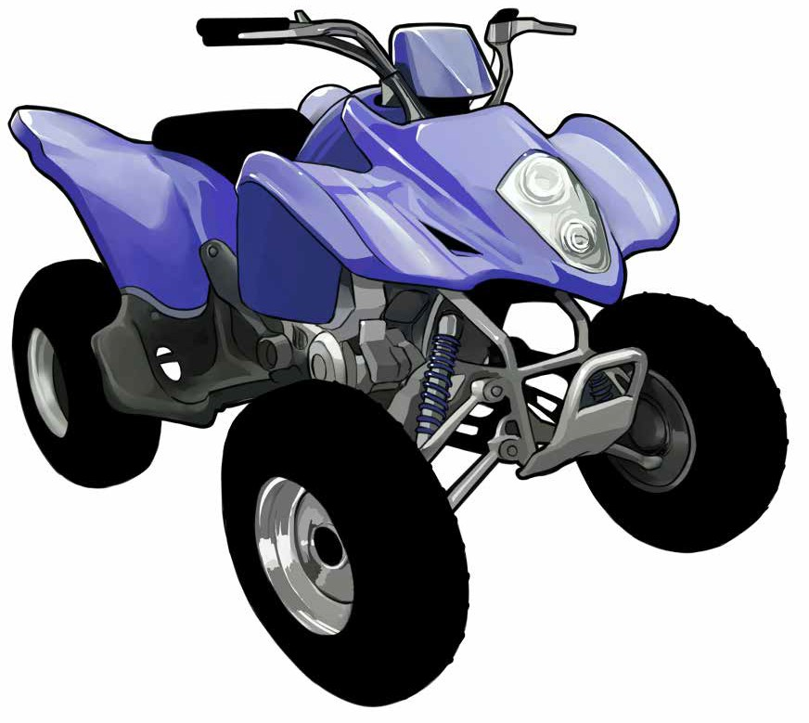
Uncle Patsy is a Wexford farmer. His farm is located about five kilometers outside Enniscorthy and his fertile fields sweep
down to the banks of the Slaney River. He has cattle – cows and calves – sheep, tractors and hens, and lots of fields for us to play in. I thoroughly enjoy going to Uncle Patsy’s.
We go down to his farm at least four times every year. In Summer we usually stay for about four or five weeks, but in

Winter we only stay for long weekends. Patsy and his wife
Maisie, have no children, and I think they love to see us coming because we always get a great hearty welcome.
We’d only be in the door and we’d be offered tea and
sandwiches and chocolate biscuits. My brother and I prefer to go straight to the fields to kick football or start our exploring.
However, Mum always insists we must eat something, whether we’re hungry or not. She says it’s called courtesy, “After all the trouble they’ve gone to!”
Uncle Patsy and Aunt Maisie own a white, mischievous
billy goat, called Jack. They normally keep him tied to an old oak tree, in a paddock, directly behind the house. Uncle Patsy
informed us that if he’s not tied up, he will eat his fruit trees, his vegetables and even his flowers; indeed Uncle Patsy calls him a vandal!
I like Jack, as he’s very playful, but it is really important to be vigilant around him, because when you’re not looking, he
sometimes charges into the back of you and pucks you hard in the behind. He is a real impish rogue, but also great fun.
Uncle Patsy is a dairy farmer, which means he has lots of
black and white milking cows, called Friesians. Sometimes we help him in the milking parlour, which means getting up around six o’ clock in the morning, but I don’t in the least mind getting
up early, because I love that kind of work. Eight cows are milked at a time.
Some of my Dublin friends talk about the smells from the cow poo and the silage, but to me these smells are all natural

and, a normal part of farming life. Silage is the name given to
the dry fermented grass which the cows eat. It’s stored in a huge pit, under black plastic and has a lovely sweet smell.
Uncle Patsy also grows corn and potatoes. Barley is the name of the corn and he says it’s used in the making of Guinness.
Picking the potatoes is definitely hard work, but also good healthy fun and when Patsy isn’t looking, my brother and I pelt each other with them. He grows an early variety of potatoes
called “Queens”. New potatoes with a bit of butter, a fried rasher and some turnip mashed in, is truly divine, and I will forever
cherish that taste. During the Summer, when we’d be returning to Dublin, Patsy always gives us a ten kilogram bag of Queens.
Patsy has two tractors, one a Massey Ferguson, the other a John Deere and I am not allowed to drive either of them on the
road. However if we are collecting the sacks of potatoes or bales of straw from the fields, he lets me drive them and that makes
me feel like a real proud farmer. Of course he won’t let my brother drive as he is too young.
Patsy also has a Quad Bike. It’s kept in the garage beside the house. The key for starting it used to be left in the ignition, but not anymore! That’s because last Summer Joe and I started it up one evening, without asking and drove it up through the back
fields to where the sheep are kept.
We revved up the throttle and dangerously travelled at over
50 kilometers an hour, on quite bumpy terrain. We slowly turned at the top of the field, but as we hurried back, close to the ditch, one of the wheels hit a bit of a stone and I lost control. The quad

flipped sideways and I landed at the bottom of the deep briary ditch with the quad beside me, its engine still running.
It happened so fast. My arms and face were badly bleeding from the briars, but I suppose I was lucky the quad didn’t land on top of me. Joe landed on the bank of the ditch and wasn’t
nearly as bruised as me. I felt like crying.
Joe pulled me out and I limped back to Patsy’s house, feeling very sorry for myself. I looked a right sorry sight and felt
ashamed, as I told them what we did. Patsy and Dad went up the field in the tractor and lifted the Quad out with some rope and
the front loader. Dad was cross, but all Uncle Patsy uttered was, “Boys will be boys”!
This year I am going to ask Patsy if I can take out the
Quad again. After all, I am a year older and now much more
sensible. I am also going to ask if I can come and live with him permanently, when I’ve finished my exams. I’ve made up my
mind; I am going to be a farmer. I hope Joe doesn’t get the same idea.

Questions

- Where do Uncle Patsy and Aunt Maisie have their farm?
- What is the name of the goat?
- Why is the goat tied up?
- What is silage?
- Barley is used for making what drink?

- What sort of jobs do Joe and his brother help out with on the farm?
- What is the brand name of the tractors?
- What is a Quad Bike?
- Describe how the accident with the Quad Bike happened.
- What would the author like to work at?
- Why do you think he hopes his brother Joe does not get the same idea?
- Draw or describe one image which you can see in the above story.

Listening and Speaking

- What do you know about farming?
- Would you like to work on a farm? Why / why not?
- Name different types of farming.

Vocabulary from the story

- His fertile fields sweep down to the banks of the River Slaney
- Cattle
- I thoroughly enjoy going to Uncle Patsy’s
- We always get a great hearty welcome
- She says it’s called courtesy – being courteous
- They own a white mischievous billy goat called Jack
- They normally keep him in a paddock
- Uncle Patsy calls him a vandal
- It’s really important to be vigilant around him

- A puck in the …….
- Uncle Patsy is a dairy farmer
- He keeps Friesian cattle
- Sometimes we help him in the milking parlour
- Silage is the name given to the dry fermented grass
- He grows an early variety of potatoes, called Queens
- They taste truly divine and I will forever cherish……
- A Massey Ferguson tractor
- A John Deere tractor
- Bales of straw
- Patsy also has a quad bike
- The key used to be kept in the ignition – to ignite
- We revved up the throttle and
- Dangerously travelled on bumpy terrain
- I landed at the bottom of a deep briary ditch
- I limped back to Patsy’s house, feeling very sorry for myself

Recommended Poems

The Snare, by James Stephens

Dictionary Work

Explain each of the following words and write them in sentences which clearly show their meanings.

- insolent
- vibrant
- nostalgia… (nostalgic)
- gram
- kilogram
- stigma
- physiotherapy
- regular
- mortgage
- conservatory

Writing

- Write about what you would like to work at, and do explain why.
- Write a story about a trip to a farm, or life on a farm.

Focus on – The silent letter – “w”

write | wrist wrap wrong | wreck | wreath | wrestle | wrangler
wren | wriggle wrote

Write the following sentences into your copy and choose words from the
box to fill in the blanks.
- I broke my ______ playing football.

- I ______ down the _______ address for the Garda.
- I must _____ up the birthday present.
- I only got one spelling _.
- After the accident, the car was a complete _.
- The snake _______d away.
- I should ______ down my homework.
- After the funeral, I placed a ________ on the grave.
- I love to ________ with my brother.
- The name of a small bird _.
- A brand name for a pair of jeans _.

Focus on - Occupations

Select the correct occupation from the list below and then write the full sentence into your copy.
an architect a plumber a farmer an optician a judge a dentist
a mechanic a mid-wife a gardener a detective a miner an editor a garda a journalist a chauffeur a vet

1. This person fixes broken water pipes _________________________
2. This person fixes cars _____________________________________
3. This person designs buildings _______________________________
- This person looks after peoples teeth _________________________
- This person helps to deliver babies into the world _______________
- This person digs coal and iron ore out of the ground______________
7. This person milks cows ____________________________________

- This person plants flowers and cuts grass ______________________
- This person drives cars for very important people________________
- This person looks after peoples’ eyes _________________________
- This person keeps law and order on the streets __________________
12. This person investigates crimes ______________________________
- This person decides if someone is innocent or guilty_____________
- This person writes for a newspaper ___________________________
- This person says what is to be printed in the newspaper __________
- This person looks after sick animals __________________________

Scaffolding - Living on a farm

Write a story about a trip to a farm, or living on a farm.
Paragraph 1 – Say who owns the farm – you can pretend, or you can own the farm yourself, if you wish. Say where the farm is located and who is working with you. Write about how you love working outdoors and never being bored.

Paragraph 2 – spring - write about the days getting longer and warmer. Write about the signs of new life, like the buds bursting forth on the trees and early morning birdsong. Write about the lambs being born and the calves and foals being born. Write about the lambs frolicking and jumping and playing out in the spring sunshine. Write about feeding the young calves with
buckets of milk. Write about ploughing, and tilling the fields, and planting the potatoes and corn. Write about spreading the slurry on the land as a fertilizer and that horrible smell! Write about the snowdrops and daffodils and tulips bursting into flower!

Paragraph 3 – summer – write about the long glorious days of sun shine – about abundant growth of grass and hedges, (and weeds), and about making the hay and the silage. Write about shearing the heavy fleeces of wool off the sheep and then dipping them into water tanks filled with chemicals to ward off those horrible insects. Write about getting up at six o’ clock every morning to bring in the cows for their daily milking, and doing the same again in the evening. Write about spraying the corn crops and the potatoes with fungicide sprays. And write about going around the fields on your quad bike to check that the animals are ok.

Paragraph 4 – autumn – write about harvesting the crops – about the combine harvester cutting the wheat and barley and oats, about those beautiful fields of gold! Write about bringing home the straw as winter bedding - and fodder for the animals. Write about the tractors drawing in trailers filled with potatoes and maybe sugar beet. And if the weather
turns really wet, talk about bringing the animals in off the fields to prevent them getting all mucked up. Talk about the dropping temperature and the slowdown of grass growth.

Paragraph 5 – winter – write about the short days and the cold nights. Talk about the hens laying fewer eggs on account of the long winter’s nights. Write about the darkness and all the lights being on in the farmyard.
Write about feeding the cattle and the cows and the pigs and how you hope it won’t snow because the sheep are still out in the fields - and on the mountains. Write about fattening up the turkeys and geese for Christmas.
And write about the land and the people who work it taking a rest, before the cycle starts all over again.

Paragraph 6 – to conclude, give two reasons stating why you love farming.

Please read over everything you have written, and check that you put in all the full stops and capital letters. Also try to enrich and improve your vocabulary.

The Jamaican

Unit 25

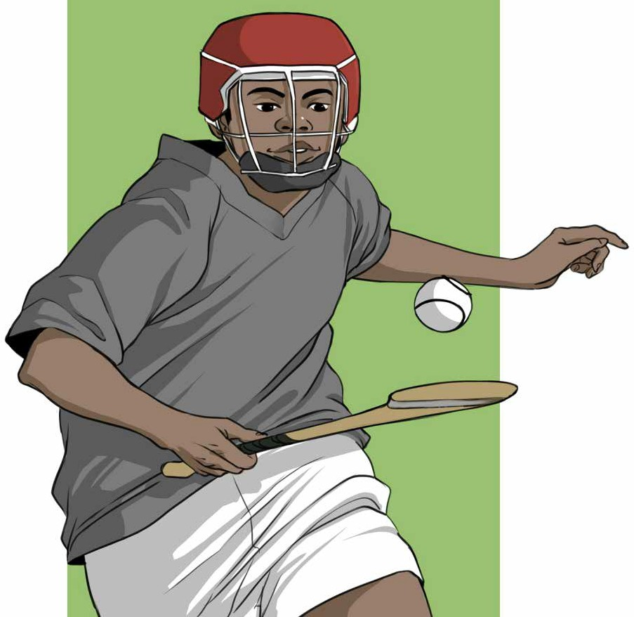

Paulo’s mother is Irish and his father is Jamaican. His mother met his father while on holiday in Jamaica and a short romance led to the birth of a beautiful, bouncing baby, who was named Paulo.
He was reared in Ireland by his mother Ann, who works in

a supermarket in Ennis, County Clare. She has kept the contact with Paulo’s father, at first through letters and in more recent
times through the internet. Paulo grew up happy, healthy and strong.
When she was working, Ann’s parents minded Paulo. Their names are Gráinne and Michael. Gráinne is from Connemara,
speaks fluent Irish and is a gorgeous singer, often going around the house singing old Sean Nós melodies.
Michael, Paulo’s grandfather, loves playing music, especially down in the pub. He plays lively Irish tunes on the fiddle,
and when he started teaching Paulo how to play it, he quickly comprehended that Paulo had a gift for the music. Paulo was definitely a quick learner and was only nine years old when
he won the Fleadh Cheoil, All Ireland fiddle final in Clonmel. People said the music was in his blood.
When he was in sixth class, an inspector from the Department of Education came to the school. He came into Paulo’s classroom and started examining the class through Irish. He asked everyone questions in Irish, and because Paulo’s skin was a little darker
than the other students, he stupidly assumed he couldn’t speak Irish, and asked him a question in English. Paulo answered the
question, in fluent Irish. The inspector turned as red as a tomato and apologised.
Paulo is also gifted at sport. He is brilliant at soccer, but
hurling is his first love. His teacher often proudly commented
that if he had a few more like Paulo, Clare would be winning All Irelands in Croke Park for the next twenty years.

However, Paulo never did get to play in Croke Park. A scout
from Liverpool spotted him and invited him to Anfield for a trial.
Today, Paulo is playing on the first team. He dazzles his team mates with his footballing skills, but even surprises them more when playing beautiful Irish melodies on the fiddle, or expertly whacking a sliotar against a fixed spot on the dressing room wall with his hurley stick.

Questions

- Where is Paulo’s father from?
- How does Paulo’s mother keep in contact with Paulo’s father?
- Where was Paulo reared?
- What three things are we told about Gráinne?
- What instrument did Paulo learn to play from his grandfather?
- What competition did Paulo win when he was nine years old?
- Why did the school inspector ask Paulo his question in English and all the other children their questions in Irish?
- What football team does Paulo play for?
- What is the name of the home ground of this team?
- Did you enjoy this story? Why / why not?
- Draw and describe one image which you can see in the above story.

Listening and Speaking

- Are there any students from foreign countries in your school?
- Can you name the countries they come from?
- Are you good friends with any of these students?
- Do you play any musical instruments?
- Listen to some Sean Nós singing on You Tube.

Vocabulary from the story

- A short romance led to the birth of a beautiful bouncing baby
- Gráinne is from Connemara
- She is a fluent Irish speaker
- She often goes around the house singing old Sean Nós melodies
- He plays lively Irish tunes on the fiddle
- He quickly comprehended that Paulo had a gift for the music
- He won the Fleadh Cheoil All Ireland fiddle competition in Clonmel
- People said the music was in his blood
- An inspector from the Department of Education came to the school
- He stupidly assumed he couldn’t speak Irish
- He maintained that County Clare would be winning All Irelands in Croke Park for the next twenty years
- A scout from Anfield spotted him, and invited him to Anfield for a trial
- Today Paulo is playing on the first team

- He dazzles his team mates with his footballing skills
- He surprises them more when expertly whacking a sliotar against a
fixed spot on the dressing room wall with his hurley stick

Dictionary Work

Explain each of the following words and write them in sentences which clearly show their meanings.

  - verdant
  - radiant
  - integrity
  - indifferent
  - curt
  - fracture
  - porch
  - abbreviation
  - prescription
  - diagnosis

Writing

- Describe a park in your local area.
- Write a story beginning with the words,
- “It was a beautiful sunny evening”. Before you start writing, deci- de if your story is going to have a happy ending, a dramatic ending, or a sad ending.

Focus on - Prepositions

A preposition describes a relationship between words in a sentence e.g. beside, between, before, behind, beneath, in, on, over, under, except, with, from, at, to, above, about, etc.
Write the following sentences into your copy and fill in the prepositions.
- “I am sorry _______ what happened to you,” said the teacher.
- My pencil fell _____ the floor.
- My coat is hanging ________ the door.
- I am going ____ the shop to buy the paper.
- She is angry me.
- The teacher shared the sweets ___________ the ten of us.
- I am able to jump ______ the wall.
- I disagree you.
- I want to complain all the homework we are getting.
- The teacher was getting frustrated _____ the poor behaviour of the students.
- I have a lot of respect _____ my parents.
- My parents are very proud me.
- There are books on the locker ________ my bed.
- There is a lot of dust _______ my bed.
- Everyone passed their exam, Roger.
- My foot got stuck _________ two rocks.
- I am tired ____ doing homework.
- I love to learn history.

- After the death of my Nana, I was filled despair.
- We got blamed ______ the attack.
- We will walk home _______ the match.
- Your schoolbag is similar mine.
- I am ashamed ___ what I did.
- He is guilty ___ the crime.
- According ___ the weather forecast, it is going to rain.
- We take great pride ___ our school.
- “I am disgusted ______ your behaviour,” said the teacher.
- The old lady is afflicted _______ a lot of illnesses.
- I have to apologise ___ the Principal.
- When I was sick, I was confined bed.

Scaffolding - It was a beautiful sunny evening…

Paragraph 1 – It was a beautiful sunny evening and I was out for a stroll. Say who you were with. Say where you were going and give a detailed description of where you were. Were you walking along a canal or by a river, or up the mountains or in a local park? Were there also others out walking or jogging or cycling? Were the birds singing, was there a cloud in the sky, were the midgets out? Were you having fun with your mates or were you all alone?

Paragraph 2 - Now add a bit of drama into your story. Let something sudden and dramatic and unexpected happen. Use action words like -

jumped out of, sprang from nowhere, crashed into, exploded, screams, stunned silence. Describe exactly what happened, and then describe your feelings…scared, shocked, horrified, disgusted, amazed…. Did you find a new born baby, or maybe a dead person? Were you attacked or did you find lots of money? Did a plane fall from the sky?

Paragraph 3 - Describe how you react. Do you fight back or do you run away? Do you call an ambulance or the Gardaí? Do you call your parents? Is there much blood? Do you panic or do you keep a cool head? Do you become practical and helpful or foolish and do silly, stupid things? Explain when and how you get home.

Paragraph 4 – Now you write a reflection on what happened. Was it the most amazing dramatic evening of your life? Did you make any mistakes? Would you now do things differently? What did you learn? How did things work out? Does your story have a happy ending or a sad ending?

Please read back over everything you wrote, putting in all full stops, capital letters and maybe adding in better words or phrases!

Verrucas

Unit 26

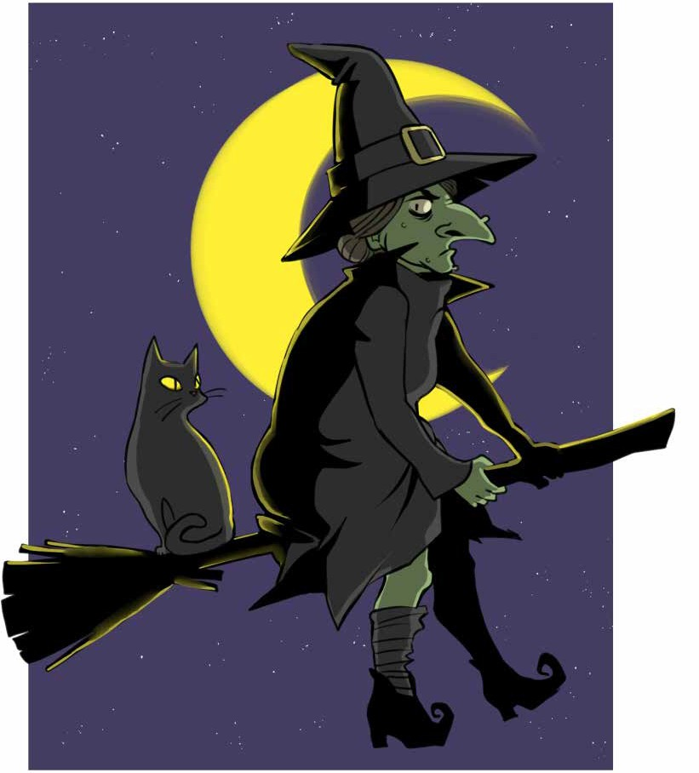
Adam loves swimming. As a young child his mother took him to swimming classes nearly every Saturday morning and he
learned all the different strokes. He was an excellent swimmer

and when he had perfected the strokes, he was asked to join the swimming team. That meant getting up at five o’ clock, two
mornings a week, going to the pool and doing hard training for
over an hour. Adam, unfortunately, is a bit lazy, and this was just too much effort for him.
The other thing Adam picked up from an early age was a verruca. A verruca is like having a wart on your foot. It is the same thing really. They are both caused by a virus, the only
difference is that if you get it on your foot it is called a verruca and if you get it on your hand it is called a wart.
When Adam went swimming he couldn’t be bothered wearing the slippers which his mother had bought him for wearing
around the pool, and that is probably how he picked up his verruca. They are really contagious.
On many occasions his mother visited the pharmacy and
came away with various treatments, but nothing seemed to work.
The lady at the pharmacy told her there was no cure for a virus and that in time, the body would reject the virus itself. That was about seven years ago.
In the last year Adam’s verrucas and warts began to multiply.
He was forever picking at them and now had a total of eleven
verrucas on his feet, three warts on his right hand and two warts on his left hand, one of which, a massive one, was almost under the nail of his thumb. They were ugly looking things and Adam utterly detested them.
The next door neighbour said that the roots go very deep, and he advised Adam’s Mum to visit an elderly woman down

the country, who had an old cure for them. He claimed that she has special healing powers. After all these years, Adam’s Mum
would have tried almost anything, although Adam himself wasn’t so positive about this new unorthodox idea.
So on a dark, drizzly Sunday in November they headed off to meet the elderly woman. She lived alone, up a muddy laneway,
in an old thatched cottage. Adam had never seen a thatched
cottage before and was rather intrigued by it. The roof was made from straw, and such roofs were very common in Ireland decades ago. “Where are you bringing me Mum?” Adam protested in
disbelief.
When Adam’s Mum explained to the old woman why they
had come, she invited them in and said they were most welcome. She seemed to have lots of cats and, as a consequence, there was a strange feline smell about the place, which made Adam wrinkle up his nose. She brought them into the kitchen and asked them to sit on two old chairs.
The woman unexpectedly asked Adam to take off his shoes and socks, explaining that she wanted to examine his verrucas and warts. Afterwards, she silently took out four potatoes from a dark press and quartered them. This indeed was strange, and Adam hadn’t a clue what she was up to.
She then announced that she was going to rub a potato
piece onto each of the verrucas and warts, and as she did so, she muttered some unfamiliar, bizarre words, which Adam
didn’t quite understand. She repeated the same words again and again, as she rubbed a fresh piece of potato onto each of the

verrucas and warts. And every time she did so, a strange tingling sensation raced through Adam’s body. For a second or two he
thought she was trying to cast him under a spell and he actually considered fleeing from that kitchen, even in his bare feet.
His Mum just sat in her hair covered chair, observing, with a perplexed and astonished look on her pale white face.
Finally the elderly woman put all the potato pieces into a brown paper bag and instructed Adam’s Mum to bring them
home and bury them in the clay of her back garden. She claimed it was an important part of the healing process and as the
potatoes rot, so also would the verrucas and warts. Adam was seriously sceptical, and as he pulled on his socks, he became really impatient to quickly leave that house.
Adam’s Mum enquired how much she owed and when the old woman replied, “Nothing at all”, Adam’s Mum objected. The old woman eventually suggested that if she wanted to make a little
contribution, then it was O.K. Adam’s Mum gave the woman €20 and urgently thanked her, because she too couldn’t wait to get
out of that house.
However, sceptical and all as she was, on returning home,
Mum did bury the quartered pieces of potato in the back garden, as requested.
The following week, Adam’s Mum had to visit Dr. Byrne, her family doctor, to renew a prescription. She told him about her
trip down the country and when the doctor heard it, he became extremely indignant; in actual fact he nearly blew a fuse! He called the old woman a quack and advised Adam’s Mum not to be wasting

her money on such foolishness. He told her the only thing that works on verrucas and warts is strong doses of liquid nitrogen.
Though, the unusual thing about this true story is that, about a month after Adam visited the old woman, he noticed the
verrucas and warts starting to disappear, and three weeks later they were gone, completely!

Questions

- What does Adam love doing?
- Why did Adam not join the swimming team?
- What causes warts and verrucas?
- How did Adam probably pick up his verrucas?
- How many warts had Adam on his hands?
- Where did the old woman live?
- What did the old woman do with the potato pieces?
- Why do you think the old woman told Adam’s Mum to bury the pieces of potato in the clay of her back garden?
- What did Dr. Byrne call the old woman?
- What did Dr. Byrne say was the only way to get rid of verrucas and warts?
- What do you think got rid of Adam’s verrucas and warts? Explain your answer.
- Draw or describe one image which you can see in the above story.

Listening and Speaking

- Did you ever have verrucas or warts? If so, how did you get rid of them?
- What other diseases do you know of which are highly contagious?
- Do you know of any other old cures?

Vocabulary from the story

Explain the following words or phrases.
- He learned all the different swimming strokes
- When he perfected the strokes, he was asked to join the swimming team
- A verruca is like having a wart on your foot
- They are both caused by a virus
- Verrucas and warts are really contagious
- His mother came away with various treatments from the pharmacy
- The pharmacist told her that the body would reject the virus itself
- He was forever picking at them
- Adam utterly detested them – to detest something
- He claimed that she had special healing powers
- Adam himself wasn’t so positive about this new unorthodox idea
- On a dark drizzly Sunday in November
- She lived up a muddy laneway in an old thatched cottage
- Adam was rather intrigued by it

- Such roofs were very common in Ireland, decades ago
- “Where are you taking me Mum?” Adam protested in disbelief
- As a consequence there was a strange feline smell about the place
- She quartered four potatoes
- She muttered some unfamiliar, bizarre words
- A strange tingling sensation raced through Adam’s body
- He thought she was trying to cast him under a spell
- He considered fleeing from that kitchen, even in his bare feet
- His Mum was observing, with a perplexed and astonished look on her pale white face
- She was instructed to bury the potato pieces in the clay of her back garden
- Adam was seriously sceptical
- He became really impatient to quickly leave that house
- Adam’s Mum enquired how much she owed
- Adam’s Mum objected
- If she wanted to make a little contribution, then it was ok
- She had to visit Dr. Byrne to renew a prescription
- He became extremely indignant
- In actual fact, he nearly blew a fuse
- He called the old woman a quack
- He told her the only thing that works is strong doses of liquid nitrogen

Focus on - Of or off?

Write the following sentences in your copy and fill in the blanks with either
of or off.
- “Clear ____,” said the security guard to the teenagers.
- We had lots ___ homework last night.
- “Did you switch ____ the light?” asked Dad.
- There were a large group ___ people waiting for the train.
- I can’t get the paint ____ my shoes.
- “I’d like two bags ___ chips please,” said Jim to the assistant.
- “And I want lots ___ ketchup on them!”
- “Buzz ___,” she replied.
- I bought my Mum a box ___ sweets for her birthday.
- “Please turn ____ the television,” said Mum.
- I would love a cup ___ tea.
- “Don’t shout at me, you are putting me ____ my game,” said the player to his manager.
- We have lots ____ beautiful flowers in our front garden.
- My parents told me _____ when I arrived home late.
- “Which ___ you are messing?” said the teacher?

Dictionary Work

Explain each of the following words and write them in sentences which clearly show their meanings.

  - dignity
  - breach
  - elegant
  - baffled
  - vigorous
  - apathy… (apathetic)
  - listless
  - appreciate
  - harmony
  - sentiment

Writing

Write a story beginning with the words,
“If only”, or “Oh No!”
Before you start writing, decide if your story is going to have a happy ending or a dramatic ending or a sad ending.

Scaffolding - An unexpected visit to A&E

Paragraph 1 – Describe the accident. Did you hurt yourself playing sport? Did you fall off your bicycle? Did you have an accident while hiking up in the mountains? You must give lots of detail. For example – who was with you? Where were you? What time did the accident happen? What exactly

happened? Were you crying with the pain? What did your friends do? What was broken? Was there much blood?

Paragraph 2 – Who did you call for help? What did your parents say? Were they long coming? How did you get to the hospital? Who called the ambulance? Were you in much pain? Did you get any painkillers/morphine? Was it a bumpy journey?

Paragraph 3 – Was A&E crowded? Did you have to wait long? Did your friends wait with you? Were there many crying babies? Were there any crazy people there? What did the nurse or doctor say? Did you have to get an x-ray? Did you have to get blood transfusions? Did you have to get
something amputated? - An arm or a leg? Will you be blind in one eye? Did you go crazy?

Paragraph 4 – Were you admitted up to the wards? Were you very sick or in much pain? Did you have to get physiotherapy? How long did you have to stay in hospital? Who came to visit you every day? Did you miss much school? What was the hospital food like? Did you get much sympathy?

Paragraph 5 – To conclude, what is the one thing you will never do again?

Please read back over everything you wrote, checking to see if you put in all full stops and capital letters. Maybe add in better words or phrases!

My best friend

Unit 27

I really enjoy playing football. I was always energetic and athletic, and have really clear memories of running around the front garden chasing after a red football as a very young child.
I recall Mum being there, watching, waving, and shouting encouragement.
Now I play football almost seven days a week. Indeed, I’d play it all day if I could get away with it. Even when I’m in the kitchen I tend to have a football at my feet, weaving my way
around the chairs and tables and anything else I can find. I support Liverpool, and that’s because Mum supports
Liverpool. She is a passionate Liverpool supporter and has
followed them all her life. Consequently, our house is stuffed with Liverpool memorabilia, things like flags and posters and
souvenirs from trips to Anfield, so much so, that it is practically a miniature museum. And as for Liverpool jerseys, I guess Mum has as many of those as she has dresses. I suppose she is just a mad genuine fan. One day I informed her that I would definitely play for Liverpool and she smiled back at me and replied, “Of
course you will son, course you will and I’ll be your biggest fan.” But I knew that already.
Mum used to play football and claims she was quite an
accomplished footballer, indeed one of the best ever! She played as a defender and boasts that she was awarded player of the year for two successive seasons, and has the medals to prove it!

When I was eight, I joined St. John Bosco and like Mum, I started as a defender, but sometimes they moved me out to mid field. I was genuinely tough and very little got past me.
My biggest supporter of course – was Mum. She was always on the sideline, roaring her head off, urging me on. It was almost embarrassing. On one occasion I scored a cracking goal, almost from the halfway line and was delighted with myself, jumping
with joy, when who comes sprinting over, only Mum. She
grabbed me into her skinny little arms and tightly hugged me
right up off the ground, in front of everyone! I was mortified and then, the referee ordered her off the pitch in order to restart the
game.
When I was thirteen, the manager started playing me as a
forward. I think it was because I got some great goals in training. In our final game of the season I scored three wonderful goals.
My good friend Andrew Power set me up for two of them. The
first goal was a perfect pass and I easily side stepped the keeper.
The second goal I headed into the top left hand corner, and for the third, I chipped the keeper. We won the league.
Now I am fourteen and everything is going wrong, horribly wrong. We got a new manager and if we make any little mistake, he roars and shouts and screams abuse at us. For some of the
games he hasn’t even started me.
Worst still is the fact that my best supporter and my best
friend, is no longer on the side line. She is no longer able to be there, but insists that life must go on. She got breast cancer and is bravely battling it. The doctors told her to stay in and keep

warm, as she is easily open to infection, on account of all the medication she is on.
Now it breaks my heart to be going to matches without her, and it breaks my heart when I see how frail and thin she has
become. She is as weak as a kitten and I do all I can to help, but it is really difficult watching her fade away.
I pretend to be strong, but inside, I am totally devastated. I just feel like crying.

Questions

- It’s obvious that this child’s best friend is his mother. Pick out five
pieces of evidence which support this point of view.
- Pick out the evidence which suggests that Mum is a Liverpool fan?
- Why did the referee have to order Mum off the pitch?
- What is your opinion of the new football manager?
- At the end the author says, “Inside I am crying.” Why do you think the author says this?
- Think about one of your best friends. Write down three things you do together.
- Draw or describe one of the images which you can see in above story.

Listening and Speaking

- What makes a good friend?
- Who are your best friends?
- Who is your best friend at home?
- Who do you spend most of your time with?

Vocabulary from the story

Explain what the following words mean:
- I was always energetic and athletic
- I recall Mum being there, watching, waving, and shouting encoura- gement.
- I tend to have a football at my feet, weaving my way round the chairs
- She is a passionate Liverpool supporter – a genuine fan
- Consequently, our house is stuffed with Liverpool memorabilia
- Souvenirs from trips to Anfield
- It is practically a miniature museum
- She claims she was quite an accomplished footballer
- She played as a defender
- She boasts that she was awarded player of the year for two successi- ve seasons
- I joined St. John Bosco
- I was genuinely tough and very little got past me

- She was always on the sideline, urging me on
- I scored a cracking goal
- I was mortified
- I side stepped the keeper – I chipped the keeper
- He roars and shouts and screams abuse at us
- She insists that life must go on
- She got breast cancer and is bravely battling it
- She is easily open to infection, on account of all the medication
- It breaks my heart to see how frail she has become
- Inside, I am totally devastated

Dictionary Work

Explain each of the following words and write them in sentences which clearly show their meanings.

- compassion..(compassionate) humiliation
- contempt
- latitude
- metaphor
- hereditary
- magnitude
- meander
- behaviour
- cyber-bullying

Focus on - Homophones

Homophones are words that sound the same, but have different meanings, and are spelled differently.
1. I can ______ the ______. (sea, see)
- Did you _____ that programme on the television last night? (see, sea)
- Come over _______ and sit beside me. (hear, here)
- Did you ______ the good news? (hear, here)
- Oh ______, I’ve spilt the tea. (deer, dear)
- There are lots of _______ in the Phoenix Park. (deer, dear)
- Jack and Jill went up the hill to fetch a of water. (pale, pail)
- The patient looks very ______. (pale, pail)
- I would never _______ from anyone. (steel, steal)
- The stairs are made from _______. (steel, steal)
- There will be a in the shops after Christmas. (sale, sail)
- When we got in the boat, we put up the ______. (sale, sail)
- We bought _______ ice creams in the shop. (tree, three)
- Joan climbed the big beech _____. (tree, three)
- The bus driver asked me for the ______. (fair, fare)
- The teacher gave Jack all the sweets. “That’s not .” (fair, fare)
- I am going to buy a new _______ of jewellery. (peace, piece)
- I love _______ and quiet. (peace, piece)
- The _______ fell off my shoe. (heal, heel)
- I hope the wound will ______ quickly. (heal, heel)

Writing

- Describe your best friend.
- Write a story about an adventure with your best friend.

Scaffolding - My Best Friend or Friends

Paragraph 1 – Write down the name of your best friend or friends. Say why you are best friends and how well you get on together. Does he or she live close to your house?

Paragraph 2 – How long have you known each other? When did you start becoming friends? Do you hang around together a lot? List and describe some of the things you do together. Did you ever go on holidays together?

Paragraph 3 – Write a description of your best friend or friends. What age is he or she? How tall is he or she – approximately? Does he/she smile a lot or only a little? What is the colour of their hair? What sort of things does he or she say – give examples. Do you text each other often? What sort of clothes does he / she wear? Are they real trendy and modern or does your friend not care about how he / she looks? Does he / she speak in a quiet accent or a posh accent? Is cursing often used between you?

Paragraph 4 – What sort of things do you fight about? Did you ever have a big row? What was it about? Who started it? Describe the conflict – did you

come to blows? Did you spend some time not speaking to each other? How
was this conflict situation solved?
Read back over everything you have written and check if you have put in all the full stops and all the capital letters. Maybe improve some of the words – verbs, adverbs and adjectives!

Paragraph 5 – What are the best qualities of your friend or friends? What makes a good friend? Do you think you will be best friends forever?

Please read over everything you have written, and check that you put in all the full stops and capital letters. Also try to enrich and improve your vocabulary.

When I grow up

Unit 28

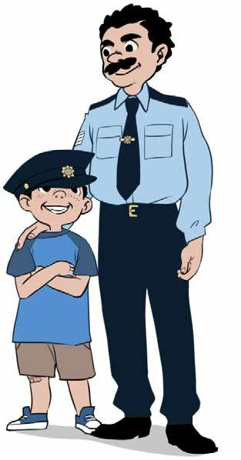
to be a Garda.
When I grow up I think I want to be a Garda. My
dad is a Garda and says he is proud of his profession.
He maintains it is an
honourable job, even if it’s a little dangerous. He calls
himself “A Guardian of the Peace”, but he doesn’t carry a gun. He reckons that guns are deadly dangerous and
firmly believes Gardaí
should not be armed. I am not sure I agree with him, because I love playing with
guns. I also love his uniform and maybe that’s why I want

Every evening I ask Dad if he caught any bad guys today and the answer is always the same. He has almost drilled it into me, “There are no bad guys in the world, just poor unfortunates who have lost their way.” Mum says Dad is too soft and too kind, “He never sees the bad in people!”
Or maybe I will be a teacher when I grow up, like Miss Kerr.

She is lovely, she really is, and she is my teacher. I want to be just like her. Every Friday she gives us sweets, if we are good. She says she will only give them to students who are good, but she always gives them to everyone, even if they are bold.
She loves to sing and dance and I love to sing, but I don’t like to dance. She has the voice of an angel and would do well in the Eurovision. Mum says I don’t have the voice of an angel, but I
don’t agree with her. I think I have an angelic voice. Miss Kerr said so, and I told Mum she said so.
Then again, when I grow up, I might be an archaeologist.
We learned about those people in our history book. They dig
up the ground looking for old bones, old pots and old pieces of history. I’d love that, being outdoors, digging. It sounds like an adventurous life. I’m not scared of skeletons or old bones; I’m
not scared of anything. I could end up in Egypt, in the Pyramids, digging. I might dig up the bones of a famous Pharaoh and then I’d be famous and on the television.
Or perhaps I should be a television presenter. I don’t think
it’s a difficult job. But would I have to do a lot of reading? You see, I don’t like reading. I have some kind of a thing that begins
with the “dys” letters. Teacher said so. This means I have to read out loud for Mum and Dad every night and I hate reading out
loud. My little sister doesn’t have to, so why should I?
Dad is often late home and misses me doing the reading.
However, he always asks if I did it, and says that if I want to be a Garda, I will have to be able to read and write. Life’s not fair! Maybe I won’t be a Garda after all, so there!

Questions

- What age do you think the child who is telling this story is? Explain your answer.
- Why does this young author want to be a Garda?
- Explain the phrase, “There are no bad guys in the world, just poor unfortunates who have lost their way.” What do you think it means?
- Why would the young author like to be a teacher?
- Who would do well in the Eurovision?
- Describe Miss Kerr.
- According to the author, what does an archaeologist do?
- Why does the author hate reading?
- Why do you think the author is asked to read out loud?
- Which of the following words would you use to describe the young person who wrote this story:
  - confused
  - cheeky
  - quiet
Explain your answer.
- Draw or describe one of the images which you can see in the story.

Listening and Speaking

- What would you like to be when you grow up?
- Do you like reading out loud?
- What do you know about dyslexia?
- Do you think Gardaí should be armed?

Vocabulary from the story

Explain the following words.
- My Dad says he is proud of his profession
- He maintains it is an honourable job
- He is a guardian of the peace
- He firmly believes the Gardaí should not be armed
- He has almost drilled the answer into me - there are no bad guys in the world, just poor unfortunates who have lost their way
- She would do well in the Eurovision
- I think I have an angelic voice
- I might be an archaeologist
- I could end up in Egypt, in the Pyramids, digging
- I might dig up the bones of a famous Pharaoh
- Perhaps I should be a television presenter
- Dyslexia

Focus on - Words ending in “ful”

Put the following words into sentences and write them in your copy. Notice that they all end in just one “l”.
- wonderful
- delightful
- powerful
- colourful
- beautiful
- faithful
- grateful
- joyful
- wasteful
- useful
- truthful
- forgetful
- peaceful
- handful
- hopeful
- awful

Writing

Write an imaginary account of where you will be and what you will be doing in ten years time.

  - mortified
  - employer
  - employee
  - benevolent
  - gallant
  - aggression
  - chivalry
  - consequences
  - extractive
  - tourism

Dictionary Work

Explain each of the following words and write them in sentences which clearly show their meanings.

Scaffolding - When I grow up!

Paragraph 1 – Write down a list of the jobs you’d like to work at when you leave school or college.

Paragraph 2 – Start with your number one choice, your favourite job and say why would you love to work in that career? Why are you choosing that job? Who or what inspired you to choose that job? What is so special about it? What makes that job interesting for you? Is it an indoor job or an outdoor

job? Would it involve a lot of travelling? Do you know anyone who works in that job already? What sort of things do they say about it? Is there a good salary?

Paragraph 3 – How would you get into that job? What qualifications will you need? How long will you have to stay in school for? Will you have to go to college? Do you think you have the will power and determination to
achieve your dream job? Will it cost a lot of money to get qualified and if so,
where could you get the money from?

Paragraph 4 – List some other jobs you might be interested in and write the advantages and disadvantages to working in those jobs. Write down some
of the jobs you’d really hate to work at give the reasons why. For example, would you like to be a school teacher or a doctor or a Garda?

Paragraph 5 – Finally pretend you won the lottery and have loads of money. Now you don’t really have to work if you don’t want to. If this were the case, say how you’d really like to spend the rest of your life. Give lots of details!

Read back over everything you have written and make sure you put in all the full stops and capital letters. Maybe write in better words or better phrases.

Books

Unit 29

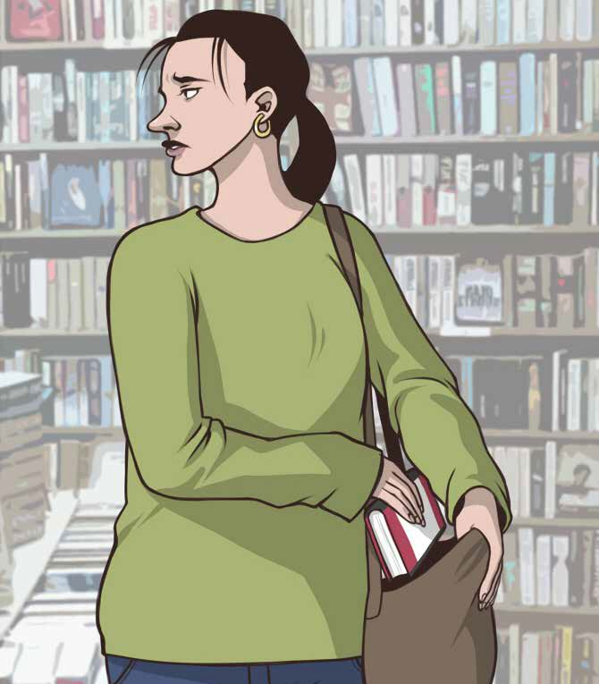

The place in this story has to remain anonymous, which means I can’t name the location. You’ll see why towards the end. The story is set in a bookshop on the second floor of a
large shopping centre. The bookshop has a large opening to the front and the books are prominently displayed in order to entice the reader in. For some reason, unknown to me, the children’s
section is located in the open area at the front of the shop.
I love reading books and spend a considerable amount of time in them. I am a school teacher and am always on the lookout for quality books for my young readers. When my wife heads off to do the weekly shopping, I head for the bookshop, and when she
finishes the shopping she knows exactly where to find me.
It was when browsing through the books in the children’s section that I noticed the young mother reading a story to her little son. The child was only about four years old and I’d say she was in her mid twenties. She had another child with her, asleep in a buggy.
She read in a soft gentle voice and I thought to myself, what a wonderful mother. I know she was the mother, because the
child called her Mummy. She was literally on her knees with her son hunched down beside her. They were reading a picture book and both were unaware of my presence, but I was listening, and observing.
The pictures in the book were vivid and detailed and the mother asked her son what he saw in each picture before
reading the text - for every page of text, there was a page with a beautifully illustrated picture beside it. The little child was really

attentive and carefully described what he saw each picture. I’m not sure what the name of the book was, but it was similar to a Cinderella book.
When she finished reading the book, the young mother asked her child if he enjoyed the story. Of course he said yes and then he asked his Mummy if she would buy him the book. Strangely, his mother did not reply to his request. Instead, she looked over at the young sales assistant on the cash register and noticed she was extremely busy, with a large number of customers in the
queue. She anxiously glanced at me and saw my head was stuck in a book.
Then calmly and unexpectedly, she took the story book from her little boy and carefully placed it in her shopping bag on the buggy. As she walked out of the bookshop, pushing the buggy
and holding her little boy’s hand, she again glanced over her
shoulder and walked briskly away up the plaza, without saying a word.
I stood there, gobsmacked. I hadn’t expected her to steal the book. For a second or two I thought of running over to the sales assistant and telling her, but decided against it. As I walked away from that bookshop, I felt sad and disturbed. I shook my head
and thought, “Surely in this day and age, no one should have to steal a book. Not books! There are ways and means of getting
them, without stealing them.”

Questions

- What does anonymous mean?
- Where is the story set?
- There are a total of six characters in this story. Name them.
- Why do you think the children’s section was prominently displayed towards the front of the bookshop?
- What was the teacher always on the lookout for?
- Describe how the mother read the story to her son.
- Was she a good mother?
- Why do you think she stole the book?
- Why do you think the teacher decided against telling the sales assistant that the mother had stolen the book?
- At the end the teacher says, “There are ways and means of getting books without stealing them.” List other ways of getting books.
- Draw or describe one of the images which you can see in the story.

Listening and Speaking

- Would you steal books? Would you steal anything?
- Do you like books? Why / why not?
- What are the names of your favourite books?

Vocabulary from the story

Explain the following words.
- The place in this story has to remain anonymous
- The books are prominently displayed in order to entice the reader in
- The children’s section is located at the front
- I spend a considerable amount of time in bookshops
- I am always on the lookout for quality books
- It was when browsing through the books in the children’s section
- She was literally on her knees with her son hunched down beside her
- Both were unaware of my presence, but I was listening and observing
- The pictures were vivid and detailed
- There was a beautifully illustrated picture beside each page of text
- The little child was really attentive
- The mother did not reply to his request
- She glanced over at the sales assistant on the cash register
- She anxiously glanced at me and saw that my head was stuck in a book
- She again glanced over her shoulder and walked briskly away up the plaza
- I stood there, gobsmacked...............feeling sad and disturbed

Focus on - Did or Done

Write the following sentences into your copy, and fill in the blanks with
either did or done.
- I _____ all my homework.
- All the work is _.
- Have you _____ your homework yet?
- ______ you hear the news?
- What has he _____ with my copy?
- What _____ you do?
- Who that?
- It was the flood that ____ the damage to the road.
- I’ve _____ all the washing up.
- Where _____ you go to last night?
- I _____ my exercises for the warm up.
- “I’m not ______ with you yet!” shouted the Principal.

Dictionary Work

Explain the following words and write them in sentences which clearly explain their meanings.

  - alien
  - alienated
  - unemployed
  - sincere
  - humiliated
  - moat
  - exploitation – to exploit
  - just
  - calories
  - obesity

Writing

Describe an incident where you witness something being stolen. It can be real or imaginary. (No real names, please.)

Scaffolding - Writing a Report

Please remember that a report contains lots of factual information – the what, when, where, who, sort of information.

Paragraph 1 – Write a report on a show /a concert or match which you attended. If it was a football match, say who was playing and why it was significant - please remember that it could be a boxing match or a rugby match or a tennis match or a basketball match you are reporting on! If it was

a concert or a fashion show give the same sort of information. Also state when the match / show / concert was on!

Paragraph 2 - Where was the venue for this show / concert or match?
Who went with you? Did you have to pay for your tickets or were they complimentary? How much was the entrance fee? Were you going with your family or friends, or as a TV or newspaper reporter? What newspaper or television station were you working for? Did you have V.I.P. status? Would you be able to access the back stage area? Would you get to interview and record the managers, or fashion designers or singers or participants?

Paragraph 3 – Getting to the match / show / concert – say how you got to the venue – by train, plane, bus or automobile? Describe the crowds and describe the atmosphere – jovial good humoured crowds, waving flags and banners, ticket touts, food stalls, colourful fans, security personnel, singing, banter, etc. Then describe the amazing atmosphere on entering the stadium or concert hall. Also state how many were in attendance!

Paragraph 4 – Now describe in detail, the match or the concert or the fashion show. Use words like spectacular, electric, fantastic, beautiful, delightful, powerful, stunning, breath-taking, emotional and wonderful. Describe the goals and say who scored. Name the songs which were sung and, explain which one was your favourite. Describe the outfits and again say which outfit was your favourite.

Paragraph 5 – a good reporter always includes some things which were disappointing, and recommends some changes, which in his or her opinion, would be worthwhile. For example, maybe the tickets were too expensive,

maybe security could be improved; maybe there was dangerous pushing and shoving, maybe there were some drunken people in attendance, or pick
pockets. Maybe you felt afraid. Maybe it was a terrible dull boring match, or the amplification was really poor, and you couldn’t hear the songs! Maybe someone took your seat or you were seated behind a pillar and couldn’t properly see it all! Maybe the food and beverages were too expensive.
Definitely, write down at least three observations and/or recommendations -
that is, things you would change!

Paragraph 6 – To conclude, write down how much you enjoyed or (didn’t enjoy) the match or concert or show, and explain your reasons why. Finally, do you recommend that others go to see this concert / show / match?

Please read over everything you have written, and check that you put in all the full stops and capital letters. Also try to enrich and improve your vocabulary.

Sports Day

Unit 30

I am a natural born athlete, that’s what my P.E. teacher
says and of course P.E. is my favourite subject. I am fast, Josh Keenan is also fast, but I am faster.
In Primary School, I usually won both the hundred metre sprint and the thousand metre race. Last year I only won the
sprint because Josh just pipped me at the post for the thousand metres and I was raging. So this year I was determined Josh was going to win nothing. I was going to reclaim my position as the best athlete in the school.
Our P.E. teacher, Mrs. Brady, had been busy preparing us for the annual sports day. There would be individual competitions
and class competitions. First years could only compete against first years, second years against second years and so on.
Of course, I entered every competition. I wasn’t brilliant at
English or Maths or French, but I was brilliant at sports. In fact I was the best, and I was going to show them.
Sports day was held on a Wednesday. The day started off grey and cloudy and it looked like it might rain. That didn’t bother
me, as rain or no rain; this was my big day, my chance to shine!
The beep test was held in the hall and I easily won. This was followed by the obstacle race, which was fun. We had to crawl
under tables, jump over benches, use a skipping rope, climb over a wooden fence and shoot into the basketball net. On the way
back, we had to do it all again. Our class lost. Sarah Quigley and

Brian Maguire let us down. Slow coaches! They didn’t take it serious and I was annoyed with them.
Everyone cheated in the egg and spoon race, but I didn’t,
and I still won. In the tug-o-war, our class got beaten. It wasn’t my fault. I held on tightly to the thick rope, and ended up being dragged along the tar-mac. I scraped my elbow and tore a hole in the knee of my good school trousers. Mam would be fuming.
I was the last person on my team for the relay race. That’s
because I’m the fastest. Mrs. Brady had a starter gun; I thought it all looked very professional. We were well ahead when I dashed out to take the baton from Joe Nolan. I hastily snatched it out of his hand and just as I was turning, I went over on my left ankle.
Immediately, a bolt of excruciating pain shot through me, and as I fell to the ground, it was agony watching the competitors from the other three classes shoot by. Mrs. Brady rushed over and examined my foot and thank God nothing was broken, but she figured I had sprained my ankle. She helped me up and we slowly hobbled over to the sideline.
Someone got two ice packs and put one on each side of my
ankle. Then I dismally watched the one hundred metre sprint and the thousand metre race. Josh won both. Now I would have to
listen to him unmercifully bragging for the next year. He’s so big headed. Thank God I’m not like him.
As I limped home alone, my feelings were all over the place.
I was a mixture of pain, anger and frustration. The rain finally came; soft, gentle, wetting rain and I was feeling very sorry for myself. That’s when the tears started trickling down my face.

Questions

- On what day of the week was sports day held?
- What was the weather like?
- What were the two races that the author usually won?
- List the five things that had to be done for the obstacle race.
- How did Sarah Quigley and Brian Maguire let the team down?
- What happened to the author during the tug-o-war?
- What happened to the author in the relay race?
- How might ice packs help a sports injury?
- At the end of the story, the author is limping home alone. Why do you think he is going home alone and do you feel sorry for him?
- Which of the following words might you use to describe the author:
  - competitive or
  - big-headed or
  - selfish.
- Explain your reasons.
- Draw or describe one image which you can see in the above story.

Listening and speaking

- What sports do you play or enjoy watching?
- Name your sporting hero. Why is he/she your hero?
- Name a sporting villain. Why is he/she a villain?
- In what ways can sport be good for us?

Vocabulary from the story

- I am a natural born athlete
- I usually won the hundred metre sprint and the thousand metre race
- Josh just pipped me at the post and I was raging
- I was going to reclaim my position as the best athlete in the school
- The annual sports day
- There would be individual competitions and class competitions
- This was my chance to shine
- The beep test was held in the hall
- This was followed by the obstacle race
- We had to jump over benches
- Everyone cheated in the egg and spoon race
- In the tug-o-war I held on tightly to the thick rope and was dragged along
the tar-mac
- Mum would be fuming
- I was the last person on my team for the relay race
- I thought it all looked very professional – the opposite is amateur
- I dashed out to take the baton
- I hastily snatched the baton out of his hand
- I went over on my left ankle
- Immediately a bolt of excruciating pain shot through me
- It was agony
- Mrs. Brady figured I had sprained my ankle
- Someone got two icepacks for each side of my ankle

- Then I dismally watched the one hundred metre sprint and the...
- I would have to listen to him unmercifully bragging for the next year
- My feelings were all over the place - I was feeling very sorry for myself – I was a mixture of pain, anger and frustration
- That’s when the tears started trickling down my face
Verbs – write down the five verbs (action words) which are used for the
activities in the obstacle race.

Focus on Spellings

The spelling of words which are plural.
a singular word indicates there is only one thing,
a plural word indicates there is more than only one thing.

Learning the rules will help you spell words which are plural.
To make most words plural you just add an “s”.
Add an “s” to the end of these nouns to make them plural: banana_, girl_, boy_, day_, star_
When nouns end in “ch”, “sh”, “s”, “ss”, or “x”; add “es” to make them plural. When a noun ends in “o”, we also usually add “es” – except for “pianos”.
Copy the following words into your copy and add “es” to make them plural:
potato__, bus__, box__, dish__, watch__, dress__, tomato__, brush__,
bench__, glass__, wish__, volcano__
When a noun ends in an “f” sound, drop the “f” and write “ves”.
Write the following nouns as plurals:
leaf – lea___, knife – kni___, calf – cal___

The vowels are a,e,i,o,u.
The consonants are all the remaining words in the alphabet.
When a noun ends in a consonant followed by a “y“, drop the“y“, and add“ies“.
Write the following words in their plural form:
Baby - bab___, butterfly - , pony - , story - , party - , lady - , lorry -
Other spelling rules:
- “i ” before “e” , except after “c ” – thief, chief, belief - (there are exceptions).
- Words ending in “n” will keep the “n” when adding “ness” – examples: suddenness, openness, greenness.
- Words ending in “l” keep the “l” when adding “ly” – finally, coolly, wonderfully.
- The letter “q” is usually followed by the letter “u” – quiet, quiz, queen.
Exercise
Change the following plural nouns to singular nouns. Write them into your copy.
children, calves, men, ladies, galaxies, potatoes, deer, sheep, salmon,
noises, watches, knives, ponies, leaves, brushes, fish, stories, wishes.

Dictionary Work
Explain each of the following words and write them in sentences which clearly explain their meanings.

- confident
- insincere
- sophisticated
- unjust
- renewable
- fossil fuel
- carbohydrates
- protein
- morbid
- fibre

Writing

- Write about the sports you play, or enjoy watching.
- Write a report of a sporting event you were at. Put in:
- the where,
- the when,
- who you were with,
- the excitement,
- what happened,
- the highlights,
- the ending.

Scaffolding - Sports Day

Paragraph 1 – Do you like sports day? Say why or why not? Preparing for sports day - do or did you have a sports day in your school? If you don’t, then please use your imagination to visualise what it might look like! Who normally organises sports day in your school and say how it is organised?
Who sets up everything? What equipment is needed? On what day is sports day usually held? Is it fun? What normally happens if there is heavy rain?

Paragraph 2 – The day itself! – Who makes the announcements? Is an amplifier used? Will music be playing? Will there be a sweet shop? Is there an exciting, electric atmosphere? What competitions are usually organised
- obstacle races, egg and spoon races, sack races, wellie throwing, tug-o- war, one hundred and two hundred metre sprints, three legged races, penalty shoot outs, beep tests, relay races, basketball throws, guess the weight of…., etc. Are there inter class competitions? Is there much rivalry? Does anyone take photographs? Are these photographs subsequently displayed in the school?

Paragraph 3 – What competitions do you normally enter into? Do you ever win, or come second or third or maybe last, or is it the same people who always win? Are you athletic or competitive? Have you any memorable tales from past sports days? Did anyone ever get seriously hurt? Tell the story.
Did anyone ever misbehave and if so, then say what the consequences were!

Paragraph 4 – Do the teachers take part? Are there any competitions between the students and teachers? Which teachers wholeheartedly enter

into the fun of it all? Are there any famous sports past pupils who attended your school? Name them and say how they became famous. What normally happens if there is heavy rain on the day?

Paragraph 5 – Prize giving! When are the medals and prizes normally given out? Who normally presents the prizes and what local famous people would you like to see presenting the prizes? Finally what changes would you like to make to sports day, for example would you have a slow bicycle race, where whoever finishes last wins or whoever smiles the most wins or whoever makes the most effort wins or whoever helps out the most wins!

Please read over everything you have written, and check that you put in all the full stops and capital letters. Also try to enrich and improve your vocabulary.

Derek

Unit 31

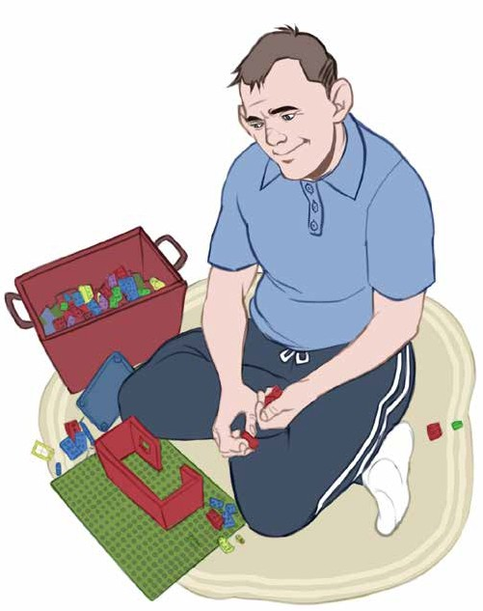
Derek has
two obsessions. One is building Lego bricks and the other is
feeding the birds.
Derek lives in a medium sized
apartment close to the docks. He is twenty nine
years old and has a severe learning disability. He
lives with his
elderly mother, who still tends to his every
need. She is now seventy seven years old and it is true to say
her whole life revolves around Derek. She makes his breakfast, his dinner, his tea, his sandwiches and his supper. She does the shopping, buys his clothes, washes them and irons them. She
even shaves him, washes his hair and cuts his nails.
Derek loves his Lego. There are boxes and boxes of it in

the spare room, Derek’s play room. He builds ships, he builds
houses, he builds skyscrapers and he builds robots; you name it, he builds it. Indeed, he has quite a talent for it and contentedly spends hours and hours in his Lego room, as he likes to call it.
Whenever he completes something, he invites his mother in to have a look and whatever he has made, she always says it’s fantastic. He then leaves it intact for one or two days, before
slowly deconstructing it, and starting all over again on some new construction.
Derek’s other obsession is feeding the birds, usually pigeons.
His apartment is on the third floor and when he opens the
kitchen window, the pigeons often flock towards it. Since he was a small child Derek has been feeding the pigeons and has become rather fond of them.
Feeding those birds is one of his few chores and every
morning he precisely places the breadcrumbs on the window ledge, usually around ten o’ clock, then stands some distance back, and observes them descend from every direction. It’s
almost as if they know when it’s feeding time. Sometimes the birds fight each other to get to the breadcrumbs and, when this
happens Derek becomes upset and chastises them, and tells them to behave.
The neighbours below don’t complain anymore. They know Derek is special and has his own peculiar ways. At first, his
mother used to tell him to stop feeding the birds, because they
were dirtying the whole place, but not anymore. She understands how it is part of his daily routine and now frequently helps him

prepare the breadcrumbs. Normally, she too quietly watches the flapping, flustered birds, as they greedily gobble up every single crumb.
Sometimes it is Derek she secretly watches and, secretly worries what will become of him, when she passes on. He has never had anyone else looking after him. For the most part,
Derek’s mother is very happy with her lot in life, as she says herself, “I wouldn’t trade him for all the gold in the world.
Haven’t I enjoyed a wonderfully rich life, in the company of my beautiful boy!”

Questions

- What are Derek’s two obsessions?
- What is Derek’s disability?
- List some of the things Derek cannot do for himself.
- List some of the things Derek builds with the Lego bricks.
- What usually happens when Derek opens the kitchen window?
- Why did Derek’s mother at first tell him to stop feeding the birds?
- If the pigeons fight, what does Derek do?
- What does Derek’s mother worry about?
- Draw or describe one of the images which you can see in the above story

Listening and Speaking

- Do you know anyone with a serious learning disability?
- Do you have any obsessions? Explain

Vocabulary from the story

- Derek has two obsessions
- One is building Lego bricks
- Derek lives in a medium sized apartment close to the docks
- He has a severe learning disability
- Her whole life revolves around Derek
- He builds skyscrapers and even robots
- He has quite a talent for it
- He leaves it intact for one or two days before slowly deconstructing it
- Construct – construction
- Deconstruction – destruction
- The pigeons often flock towards his window
- He precisely places the breadcrumbs on the window ledge
- He observes them descending from every direction
- When the pigeons fight, Derek becomes upset and chastises them
- The neighbours know Derek is special and has his own peculiar ways
- She understands how it is part of his daily routine
- She too watches the flapping flustered birds

- As they greedily gobble up every crumb
- I wouldn’t trade him for all the gold in the world

Dictionary Work

Explain each of the following words and write them in sentences which clearly show their meanings.

  - patron
  - flagrant
  - mundane
  - rowdy
  - combustion
  - ignite
  - controversial
  - allegation
  - menace
  - oral

Writing

- Write a list of ingredients you would need to make vegetable soup.
- Describe your favourite meal and how you would prepare it.

Single to plural

For most plurals, you just add an “s”, but these are different.

ash - ashes fly - flies goose - geese foot - feet
branch - branches country - countries shelf - shelves child - children deer - deer
trench - trenches loaf - loaves church - churches sheep - sheep woman - women thief - thieves
leaf - leaves potato - potatoes tomato - tomatoes fireman - firemen mouse - mice penny - pennies knife - knives tooth - teeth
story - stories dish - dishes scissors - scissors glass - glasses lady - ladies
box - boxes baby - babies

Scaffolding - Write a review of a film you liked!

Re-view means to look back over and reflect on – to give your feelings and thoughts on a film or book you saw or read.

Paragraph 1 – Write down the name of the film and briefly say why you liked it. For example, I loved watching the film Shrek because it is really humorous, has a good storyline, and the relationship between Shrek and donkey – played by Eddie Murphy - is brilliantly portrayed.

Paragraph 2 – The initial setting. Describe where the film is set and how it starts, for example the film Shrek – played by Mike Myers - starts off in a swamp – where Shrek has his home. He likes his home and is very protective of it.

Paragraph 3 – The central characters. Describe what Shrek looks like and describe his character. For example, he was supposed to be scary and fierce, but in reality he was sad and lonely. Lord Farquaae – the bad guy, played
by John Lithgow - was rather short, selfish and generally nasty. Fiona, the maiden in distress – played by Cameron Diaz – was gorgeous, beautiful and a perfect companion for Shrek.

Paragraph 4 – The plot. A classic story where boy meets girl and they fall in love, where a princess needs to be liberated, where good versus evil, where the bad guy gets what’s coming to him – but perfectly illustrated through animated characters.
Paragraph 5 – The conclusion – Do Shrek and Fiona live happily ever after, and what happens to Lord Farquaae? When reviewing a film (or a book), we normally don’t say too much about how it ends.

Paragraph 6 – Your opinions and recommendations. What were your favourite parts of the film? Was it when all the Disney characters arrive at the swamp? Was it the tender loving relationship between Dragon and

Donkey? Was it when Fiona changed from the beautiful princess into an ogre? Finally, state if you enjoyed the film, how many marks you would give it out of ten, and whether or not you would recommend viewing it.

Please read over everything you have written, and check that you put in all the full stops and capital letters. Also try to enrich and improve your vocabulary.

Unit 32

Nightmare Holiday

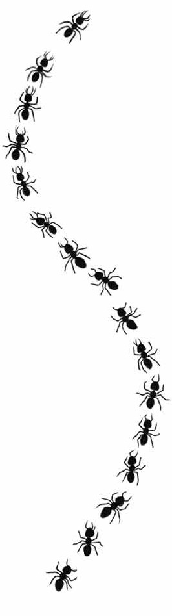
Last summer Mam decided that we
all badly needed a sun holiday. The whole family was going and when I say the
whole family, I mean the whole family.
This motley group comprised my brother, my parents, my three grandparents, my
three uncles, three aunts and seven
cousins. They are a jolly rowdy bunch, so a lot of fun was guaranteed.
We were going to Spain, the south of
Spain to be exact, which would take about three hours on the plane. We all met up
at the airport, cheerfully and smoothly checked in our luggage and our holiday began.
We had a pleasant enough journey and landed to glorious blue skies and
gleaming sunshine, and as we journeyed to our apartments, the white buildings, palm trees and lack of greenness was in
sharp contrast to dear old Ireland. It took us under an hour to reach our apartments and on balance, our excitement definitely outweighed our exhaustion. However, our

troubles had only begun.
When we opened the apartment door, we were met by
complete darkness, because no one had bothered to open the curtains, and when we did open them, we realised the beds hadn’t been made and the sheets hadn’t been changed. Dirty
dishes were still in the sink and the floor was filthy. Worst still, a nasty smell pervaded the whole apartment.
Suddenly and without warning, Mum emitted a piercing
scream. There was a look of absolute horror on her face as she pointed to a long column of ants merrily marching up and down one of the walls. When we finally managed to calm her down
and had her sitting comfortably on the bed, Dad noticed the
cockroaches, and that was when we literally ran out of the place.
It was the same for the rest of the family. We promptly raced over to reception and demanded an explanation. Unfortunately
the receptionist didn’t speak English. We phoned our tour representative and it was only then that we discovered the
cleaners were on strike. We asked to be moved to a new hotel but were persistently told it was the high season and no alternative
accommodation was available. We just had to shut up, put up and clean up. The fun was rapidly going out of this holiday.
We did our best. We bought new sheets, insecticide and lots of bleach and diligently set to work, and this was supposed to be a holiday!
To cap it all, the daily temperature rose to over 40 degrees Celsius. Spain was in the grip of a heat wave and poor Nana Sweeney nearly lost her life. She is eighty four and found the

heat intolerable. We bought her an electric fan as there was no air conditioning in any of the apartments. Ultimately, she had
to be taken to the local hospital until such time as a flight home could be arranged.
Mum and I were the lucky ones, because we were allowed
travel home with her. The others had to stay put for the duration of their holiday.
Next year we hope to go to Florida. Things can only get better.

Questions

- How many people in total went on the holiday?
- How long did the journey on the airplane take?
- What did the group see as they journeyed to their apartments which was in sharp contrast to dear old Ireland?
- List four things that were wrong when they opened the door of their apartment.
- Why did Mum emit a piercing scream?
- Why was the apartment not cleaned?
- What is insecticide?
- What is bleach and what is it used for?
- Why was Nana Sweeney taken to hospital?
- Where do the family hope to go to next year?
- Draw or describe one image which you can see in the above story.

Listening and speaking.

- Describe your worst holiday ever.
- Describe your best holiday ever.
- Describe your dream holiday.

Vocabulary from the story

- This motley group comprised ......
- They are a jolly rowdy bunch, so a lot of fun was guaranteed
- We cheerfully and smoothly checked in our luggage
- We landed to glorious blue skies and gleaming sunshine
- The white buildings, palm trees and lack of greenness was in sharp contrast to dear old Ireland
- On balance, our excitement definitely outweighed our exhaustion
- A nasty smell pervaded the whole apartment
- Mam emitted a piercing scream
- She pointed to a long column of ants merrily marching up and down one of the walls - Dad noticed the cockroaches
- We literally ran out of the place
- We promptly raced over to reception and demanded an explanation
- We were persistently told it was the high season and no alternative accommodation was available
- We just had to shut up, put up and clean up

- We bought insecticide and lots of bleach, and diligently set to work
- To cap it all, the daily temperature rose to over 40 degrees Celsius
- Spain was in the grip of a heat wave
- Nana found the heat intolerable
- There was no air conditioning in any of the apartments
- Ultimately she had to be taken to the local hospital

Dictionary Work

Explain each of the following words.

  - revolution
  - austere
  - unequivocal
  - fidelity
  - moral
  - immoral
  - conspiracy
  - consecutive
  - verdict
  - irrigation

Focus on - Similes

A simile is a comparison of two different things. A simile uses the words “like” or “as” to compare the different things.Write the following unfinished sentences into your copy and complete them.

As white as……….
As busy as……….
As strong as……….
As quick as………..
As tall as………..
As smart as………..
As cold as………..
As gentle as……….
As wise as………..
As slippery as……….
As sweet as………..
As hungry as………..
As mad as………..
As green as……….
As clear as………..
As stubborn as…………
As happy as……….
As poor as……….
As angry as……….
As rich as……….
As fresh as………..
As black as………..
As proud as………..
As kind as…………
As mean as…………
As beautiful as………….
As tired as……….
As interesting as……….
As dull as……….
As grumpy as……….
As joyful as……….

Writing

Write about your best and worst holiday experiences.

Scaffolding - Write about your
best and worst holiday experience.

One of my best ever holidays or one of my worst ever holidays! Paragraph 1 – Where did you go and who did you go with? Why did you choose that particular destination? Describe the preparations, the excitement, your fears and the journey to your destination.

Paragraph 2 – Describe what you saw on arrival at your holiday destination. Was it absolutely fabulous, with glorious sunshine and magnificent swimming pools? Or was it horrible, with paint peeling off the walls, dirty toilets and dirty sheets, with insects everywhere? Please describe the scene in detail.

Paragraph 3 – What else starts to go wrong? Did you start fighting with each other, or with staff from the hotel? Did some of you get severe sunburn or suffer from food poisoning? Did someone break a leg or get a bad sting from a jellyfish and have to be rushed to hospital? Did someone get drunk or end up in a fight? Did you experience the most amazing tropical storm?
Or did you have the most wonderful time of your life? Fabulous food, fabulous facilities, fabulous entertainment, fabulous company and fabulous fun! Describe it all in detail.

Paragraph 4 – How did the bad situation finally work out? Did someone end up in a wheelchair or have to spend the entire holiday in hospital? Did you have to come home early? Was someone arrested? Did someone die?

Or if you are talking about a really positive holiday experience, then maybe describe your normal daily routine - when you got up, where you went every day, the fun activities and where you ate every evening. Maybe you fell in love and had the most wonderful holiday romance, maybe you got engaged, maybe you decided to stay and got employment in the local area, maybe
you made lifelong friends? Maybe you built beautiful relationships and memories within your family!

Paragraph 5 – Say how you felt when you got back home and write down what you would change about that holiday.

Finally read back over everything you have written and check if you have put in all the full stops and capital letters. Also maybe change some of the words for better words!

The Anniversary

Unit 33

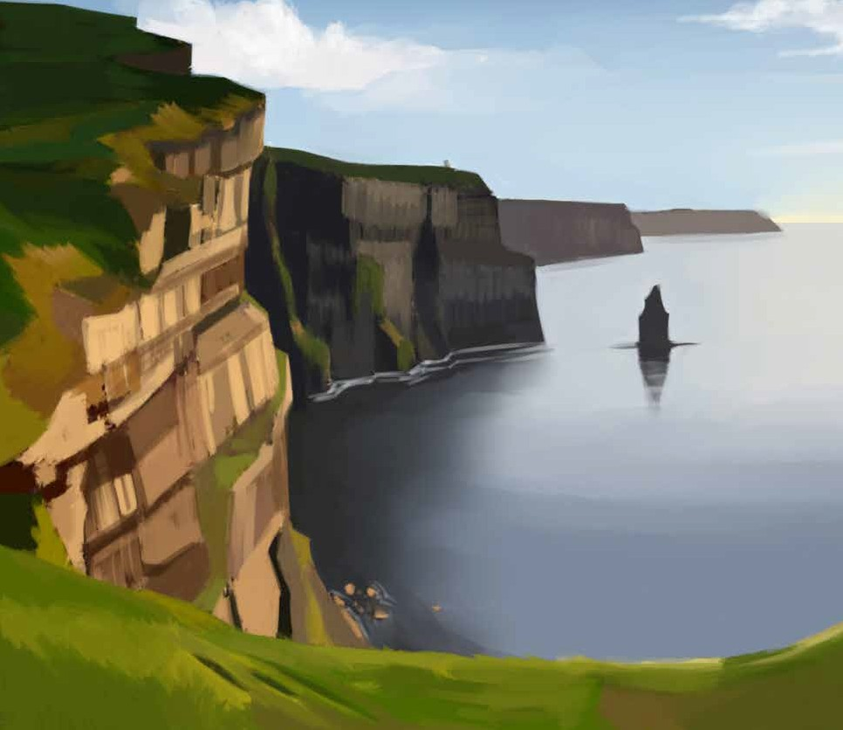
Mum and Dad had been together fifteen years and wanted to celebrate by bringing us to a posh hotel. It was only for two
nights. The deal was two nights bed and breakfast, and one evening meal. The hotel was outside Galway, in the west of
Ireland and for me the best part was the fact that the hotel had a swimming pool and a Jacuzzi.
We set off on a Friday afternoon, around three o’ clock and

were slow getting out of Dublin because the traffic on the M50 was heavily congested. When we reached the dual carriageway, heading west past Liffey Valley, we quickly made up for lost
time. We used the toll road.
To pass the time, my brother and I counted all the bridges
going across the dual carriageway between Dublin and Athlone.
When we crossed over the river Shannon, Mum informed us it
was the longest river in Ireland. We looked down and saw dozens of immaculate white cruising boats.
We diverted into Ballinasloe for a toilet break, bought tea
and sandwiches at a garage, and ate them on the side of the road, overlooking the green where the well known annual horse fair is held.
We finally arrived at our hotel - shortly after seven - both
exhausted and excited. My brother and I instantly jumped out of the car and raced to reception without our parents, because we wanted to get a swim before dinner. The receptionist informed
us that the pool was closed for children after seven o’ clock,
but decided she would make an exception, considering we had travelled all the way from Dublin.
In the pool, we splashed, did somersaults and raced each
other. Mum and Dad eventually joined us and it was wonderfully refreshing. We all got into the Jacuzzi, even though children
weren’t supposed to. It was my first time ever in a Jacuzzi. The heat and the bubbles were brilliant, pure luxury!
We reluctantly left the pool at 8.00, as we were booked into the fancy hotel restaurant for dinner. The waiter showed us to

our table and held out the chair for Mum. Dad blushed, but Mum smiled, saying she could get used to this kind of chivalrous
treatment.
From the menu, we could order all kinds of mouth watering,
scrumptious food (with strange names), and of course my brother Keith let us down, as usual. All he wanted was sausages and
chips, which wasn’t on the menu. The waiter informed him it
would be no problem, and enquired if he would like some tomato ketchup with his sausages and chips. He even called him “Sir”.
And when the sausages and chips came, Dad had to cut them for him, even though he is over ten. Worst still he had to be told to use the fork and not his fingers.
I ordered salmon, with broccoli, carrots and chips. Mum had duck and I tasted a piece of it. It was delicious. Dad ordered
steak, with onions and chips. For dessert there was a choice of meringue, cheesecake, tiramisu and trifle. Keith requested ice cream and jelly, which wasn’t on the menu and I decided I’d
have the same. Afterwards my brother and I went to the games room to play snooker, while Mum and Dad headed for the bar.
The following morning we all had a large Irish fry for
breakfast. We then watched a bit of television, before again
going to the swimming pool. We now noticed that there was a Canadian Hot Tub outside.
The sign clearly said “For Adult Use Only”, but I decided that wasn’t going to stop me, so when the attendant wasn’t
looking, Keith and I sneaked outside and climbed in. It was truly blissful.
Normally I wouldn’t be into looking at views, but I have to

admit the view was magnificent and when Dad joined us, he
told us we were looking across the famous Galway Bay and the mountains on the far side of the bay were called the Burren. He explained it was a unique and special landscape.
This was the life! I asked if we could have a hot tub like this in our back garden and Mum and Dad just laughed. When the
attendant eventually spotted us, Keith ducked under the water and tried to hide, but he couldn’t hold his breath forever. When he came back up for air, the attendant ordered us children to
leave immediately.
For the afternoon, we went shopping in Galway city. I normally hate shopping, but as it was my Mum and Dad’s
anniversary, I made up my mind to be on my best behaviour. I
can’t say the same for Keith. He was thirsty, he was hungry and
he was tired. He demanded a drink, he demanded an ice cream and he demanded we go back to the swimming pool. He even asked
Mum to buy him new runners! At which point, I thought Mum was going to strangle him. Ultimately, Keith got his way and we
all arrived back in the swimming pool. There was a new attendant on duty and he didn’t ask us to leave the Canadian Hot Tub.
Later that night, Keith started making more demands.
However, this time, he was told by both Mum and Dad, in no uncertain tone, to disappear for at least two hours.
He went off in a huff, sulking. I told Mum and Dad not to worry, and assured them I would mind Keith. I told them to
enjoy themselves and as I walked away, Dad said I was the best boy in the whole world.

Questions

- Where did the family go to celebrate their anniversary?
- For how many years were Mum and Dad together.
- On what road in Dublin was the traffic heavy?
- What is the longest river in Ireland?
- What big fair is held in Ballinasloe every year?
- What did Keith order from the menu?
- What were the mountains on the other side of Galway Bay called?
- How did Keith try to avoid being asked to leave the Canadian Hot Tub?
- What adjectives would describe Keith?
- Describe the relationship between the two boys.
- Draw or describe one of the images which you can see in the above story.

Listening and speaking

- Have you stayed in any hotels in Ireland?
- What was the experience like?
- Name some places you would like to visit in Ireland.
- Explain why you would like to visit these places.

Vocabulary from the story

- They wanted to celebrate by bringing us to a posh hotel
- For me the best part was the fact that the hotel had a swimming pool and a jacuzzi
- The traffic on the M50 was heavily congested
- When we reached the dual carriageway, we quickly made up for lost time – we used the toll road
- We saw dozens of immaculate white cruising boats
- We diverted into Ballinasloe for a toilet break
- Where the well known annual horse fair is held
- The receptionist decided she would make an exception
- We splashed, did somersaults and raced each other
- It was wonderfully refreshing
- The heat and bubbles were brilliant, pure luxury!
- We reluctantly left the pool at 8.00
- Dad blushed, but Mum smiled
- Mum said she could get used to this kind of chivalrous treatment
- Chivalry
- We could order all kinds of mouth watering, scrumptious food
- For dessert there was a choice of meringue, cheesecake, tiramisu and
trifle
- We all had a large Irish fry for breakfast
- We noticed there was a Canadian Hot Tub outside
- It was truly blissful
- He told us we were looking across the famous Galway Bay
- And the mountains on the other side were known as the Burren

- He explained it was a unique and special landscape
- When the attendant on duty eventually spotted us, Keith ducked un- der the water
- As it was Mum’s and Dad’s anniversary, I made up my mind to...
- I thought Mum was going to strangle him.
- Ultimately, Keith got his way
- He was told in no uncertain tone, to disappear....
- He walked off in a huff, sulking
- I assured them that I would mind Keith

Dictionary Work

Explain each of the following words and write them in sentences which clearly show their meanings.

  - conceited
  - exuberant
  - defiant
  - grace
  - renaissance
  - verbal
  - aural
  - campaign
  - conference
  - anaesthetic

Project work

Research and view The Burren on the internet. Write down five interesting facts about it and say why you find them interesting.

Writing
Write a story entitled, “An Exciting Journey”.

Focus on – Syllabification
Say each of these words out loud. Make sure you understand what each word means – ask the teacher. Break each word into their syllables or parts. Finally write each word into sentences which clearly show the meaning of the word.

beginning adventure impossible
community remember vacancy
ceremony
spectacular listening
remainder secretary
september rehearsal collection
delicatessen perimeter archaeologist challenging embarrassing enjoyable
amazement delightful
determination defensive
amateur
professional courtesy surroundings environment menagerie
ferocious
entertainment habitat
location character
testimony perspective
achievement recently organisation anxiously
conclusion competition gigantic
megalithic proportion audition
perseverance promoting
marvellous
entrepreneur experience
transition participate
imagination dedication especially
facilities
unfortunately rewarding
appreciated absolutely particular
opportunity collection decorating
distinction specific
treasurer assistance
contribution invaluable
february throughout sentimental endeavour deserted
perspiration regretful
informal
documentation extinction
physical psychological quality quantity

Scaffolding - This summer………

Paragraph 1 – List some of the things you hope to do, or would love to do this summer. Then write in lots of detail describing these activities, for
example - will you be playing lots of sports during the summer - basketball, tennis, football, swimming, boxing, cross country running, etc. or will you be watching lots of sport on the TV? Maybe you hope to visit the Aviva Stadium or Croke Park in Dublin? Maybe you hope to watch a hurling match in Semple Stadium in Thurles, or participate in the Community Games, and take part in an athletics race in Santry?
Will you go for long leisurely walks with your friends or will you spend lots of time out on your bicycle? Will you attend a music festival or a fashion show or a summer school? List some of the summer schools you could attend!

Paragraph 2 – Working for the summer. In what ways will you help out around the house during the summer? Will you help with the cooking and washing up? Will you hoover and clean the house? Will you cut the lawns or clip the hedges? Will you plant summer bedding plants or wash the car? Do you help to mind someone who is ill in your house? Will you get a part time job and if so, then with whom? Will you be doing some babysitting or working in a restaurant? Will you be working on a farm – maybe picking strawberries or potatoes or vegetables? Are you a hard worker or very lazy?

Paragraph 3 – Will you get a week or two away from home, or even get away for a weekend break? Do you visit or stay with relations? Where do

they live? Will you be going abroad, or visiting somewhere beautiful in Ireland? Where will you be going, and who will you be going with? What is the most beautiful place you have ever being to in Ireland or abroad?

Paragraph 4 – Remembering last summer. List some of the things you did last summer! What was the weather like? Did you spend most of your time indoors or outdoors? What were the best and worst things about last summer? What do you hope to do differently this year? Did you attend any outdoor barbecues or parties or christenings or weddings? Did you go
abroad? Did you see any good films? Did you do any reading? What did you
read? Would your English teacher be proud of you?

Paragraph 5 – To conclude, if two of your wishes were to come true this summer, what would they be; that is, if you had lots of money, what would you really love to do?
P.S. Play the song “Summer time and the living is easy” - for your students!

Please read over everything you have written, and check that you put in all the full stops and capital letters. Also try to enrich and improve your vocabulary.

Where to find Exercises – First Year
Unit | Focus on
1. | Capital Letters
2. | The Full Stop + Betty Botter
3. | The Magic e
4. | Adjectives
5. | Social Sight Vocabulary
6. | The Comma + Writing Letters
7. | Verbs and Adverbs
8. | Our or Are? + Adding ‘ing’ to words which end with an e
9. | Blending Letter Sounds + Filling in a Personal Profile
10. | Was or Were? Is or Are? + Mice
11. | Witch or Which
12. | Were, Where or We’re? + More Adjectives
13. | Compound Words
14. | To, Too or Two?
15. | Christmas Words
16. | Tenses of Verbs
17. | Making out Banners
18. | More Magic e + Jimmy Miller
19. | More Compound Words
20. | Verbs
21. | Focus on Feelings
22. | Contractions
23. | Key Words in Maths 1+2
24. | The Silent W + Occupations
25. | Prepositions
26. | Of or Off?
27. | Homophones
28. | Words ending in ‘ful’ + A Potty Tale
29. | Did or Done
30. | Spelling Rules + Writing a Report
31. | Single Words to Plural
32. | Focus on Similes
33. | Syllabification Exercises

